Integrating Resources:

A Cataloging Manual

Appendix A to the BIBCO Participants’ Manual

and

Module 35 of the CONSER Cataloging Manual

February 11, 2015 revision

Program for Cooperative Cataloging
Washington, D.C.
2015

Table of Contents

Introduction 1
Objectives 1
References 2
Definitions used in this module 4
IR.1 What is an integrating resource? 6
IR.1.1 Concept of mode of issuance and integrating resources 6
IR.1.2 Distinguishing integrating resources from monographs and serials 7
IR.1.2.1 Print resources 7
IR.1.2.2 Electronic resources 8
IR.1.3 Types of integrating resources 13
IR.1.3.1 Updating loose-leafs 13
IR.1.3.2 Updating databases 14
IR.1.3.3 Updating websites 15
IR.1.4 Changeable aspects of integrating resources and impact on cataloging 16
IR.2 Identifying manifestations and items 18
IR.2.1 Basis for identification of the resource and sources of information 18
IR.2.1.1 Basis for identification of the resource 18
IR.2.1.1.2 Basis for identification of the resource: Print 18
IR.2.1.1.3 Basis for identification of the resource: Online 19
IR.2.1.1.4 Basis for identification of the resource: Additional factors to consider for online resources available from multiple providers 19
IR.2.1.1.5 Online integrating resources in multiple languages 20
IR.2.1.2 Sources of information 23
IR.2.1.2.1 Sources of information: Updating loose-leafs 23
IR.2.1.2.2 Sources of information: Online 23
IR.2.2 Title and statement of responsibility area 24
IR.2.2.1 Title proper 24
IR.2.2.1.2 Introductory words not considered part of the title proper 24
IR.2.2.1.3 Typographical errors 26
IR.2.2.1.4 Full forms vs. acronyms or initialisms 26
IR.2.2.1.5 Common titles and section titles 27
IR.2.2.1.6 Change in title proper 28
IR.2.2.1.7 Parallel titles 29
IR.2.2.1.8 Other title information 29
IR.2.2.1.9 Statement of responsibility 30
IR.2.3 Edition statement 31
IR.2.3.1 Updating loose-leafs 31
IR.2.3.2 Electronic resources 32
IR.2.4 Publication, distribution, manufacture, and copyright date 33
IR.2.4.1 Place of publication 33
IR.2.4.2 Publisher’s name 34
IR.2.4.3 Date of publication 35
IR.2.4.4 Copyright dates 37
IR.2.4.5 Use of the repeatable 264 field to record changes in publication 38
IR.2.4.6 Relationship of imprint information to fixed field 008 39
IR.2.5 Series statements and series access points 39
IR.2.6 Notes 41
IR.2.6.1.1 Scope of applicability 41
IR.2.6.1.2 Language of notes 42
IR.2.6.1.3 Order of notes 42
IR.2.6.2 Note on title 42
IR.2.6.2.1 Title source and iteration used as the basis for identification 42
IR.2.6.2.2 Title variations, inaccuracies, and deletions 43
IR.2.6.2.3 Recording changes in the title proper 44
IR.2.6.2.4 Minor changes in title proper 45
IR.2.6.2.5 Parallel titles and changes to parallel titles 45
IR.2.6.2.6 Other title information and changes in other title information 46
IR.2.6.3 Statement of responsibility 46
IR.2.6.4 Edition statement 47
IR.2.6.5 Publication statement 47
IR.2.6.6 Frequency 48
IR.2.6.6.1 Frequency of updates 48
IR.2.6.6.2 Determining and recording frequency of updates 48
IR.2.6.6.3 Changes in frequency of updates 49
IR.2.6.7 Language of expression 49
IR.2.6.8 Physical description 50
IR.2.6.9 Intended audience 50
IR.2.6.10 Related manifestations 51
IR.2.6.11 Indexes and supplementary content 52
IR.2.6.12 Summary 52
IR.2.6.13 Changes in content characteristics 52
IR.3 Describing carriers 53
IR.3.1 Media type 53
IR.3.2 Carrier type 54
IR.3.3 Extent 54
IR.3.4 Dimensions 55
IR.3.5 Digital file characteristics 56
IR.4 Providing acquisition and access information 57
IR.4.1 Uniform Resource Locator 57
IR.4.2 Changes requiring the addition, revision, or deletion of a Uniform Resource Locator 58
IR.5 Identifying works and expressions 60
IR.5.1 Authorized access points 60
IR.5.2 Recording changes in access points 60
IR.5.3 Authorized access points representing works and expressions 62
IR.5.3.1 Preferred title for the work 62
IR.5.3.2 Additions to authorized access points representing works 62
IR.5.4 Recording content type 64
IR.6 Recording relationships between works, expressions, manifestations, and items 65
IR.6.1 Identifier for the related resource 65
IR.6.2 Authorized access point for the related work or expression 65
IR.6.3 Linking entries 66
IR.6.3.1 Fields for linking entries 66
IR.6.3.2 Form of note in linking entry field 69
IR.6.4 Guidelines about certain situations 71
IR.7 Fixed field coding 73
IR.7.1 Leader: Type of record (06) 73
IR.7.2 Leader: Bibliographic level (07) 75
IR.7.3 Leader: Descriptive cataloging form (18) 75
IR.7.4 006 – Additional material characteristics: computer file 75
IR.7.5 006 – Additional material characteristics: continuing resource 75
IR.7.6 007 – Physical description 75
IR.7.7 008 – Type of date/Publication status (008/06) 76
IR.7.8 008 – Dates (008/07-14) 76
IR.7.9 008: Place of publication, etc. (008/15-17) 77
IR.7.10 008: Type of continuing resource (008/21 or 006/04) 77
IR.7.11 008: Form of original item (008/22 or 006/05) 77
IR.7.12 008: Form of item (008/23 or 006/06 for continuing resources & music; 008/29 or 006/12 for maps and visual materials) 77
IR.7.13 008: Entry convention (008/34 or 006/17) 77
IR.7.14 008: Cataloging source (008/39) 77
IR.8 Subject analysis and classification 81
IR.8.1 Classification 82
IR.8.2 Subject heading assignment 82
IR.8.2.1 Form and topical subdivisions; Genre/form terms 82
IR.8.3 Change in content of an integrating resource 85
IR.9 How many bibliographic records? 86
IR.9.1 What changes in an integrating resource require a new bibliographic record? What changes are handled by updating the existing record? 86
IR.9.2 How are loose-leaf services handled? 88
IR.9.3 Duplicate records 91
IR.9.3.1 LC monograph records for integrating resources 91
IR.9.3.2 Selecting the record to retain 92
IR.9.3.3 Deleting and reporting duplicate authenticated continuing resource records 92
IR.10 Provider-neutral record for online integrating resources 93
IR.10.1 Guidelines for record creation and record consolidation: provider-neutral record 93
IR.10.2 Some examples of original source creator (publisher, society, institution, etc.) vs. service provider or host 95
IR.11 Full record examples 100
Appendix A: Print integrating resources RDA MARC record cheat sheet 132
Appendix B: Online integrating resources RDA MARC record cheat sheet 136

Introduction

An integrating resource is “a resource that is added to or changed by means of updates that do not remain discrete but are integrated into the whole (e.g., a loose-leaf manual that is updated by means of replacement pages, a website that is updated continuously).” (RDA Glossary). Integrating resources represent a mode of issuance different from that of monographs and serials.

For a long time, most integrating resources were in printed text form as updating publications in loose-leaf format. These resources had always been somewhat problematic to catalog because such resources exhibit characteristics of both monographs and serials. Prior to the 2002 revision of AACR2, catalogers used the manual Cataloging Instructions for the Description of Looseleaf Publications by Adele Hallam.

With the dramatic increase in integrating resources available on the Internet, it became clear that more formal guidance on how to catalog resources with this mode of issuance was needed. Chapter 12 of AACR2, renamed “Continuing Resources” in the 2002 revision, was revised to incorporate instructions for both serials and integrating resources.

Additions to the MARC 21 Format for Bibliographic Data for integrating resources included a new bibliographic level and specific codes in the fixed fields. Several existing fields in the format formerly used only for serials began to be used in records for integrating resources when the 2002 revision ofAACR2 was implemented.

In general, AACR2 descriptive practices and MARC 21 coding for integrating resources have been carried over to the implementation of RDA.

This module represents LC/PCC practice. Any differing LC practices are noted; PCC libraries are not obligated to follow any LC-specific instructions.

Objectives

This module will discuss:

- What constitutes an integrating resource
- Creation of a bibliographic record for an integrating resource, including MARC 21 fields
- Updating of the bibliographic record when the integrating resource changes
- Areas where integrating resource cataloging differs from monograph or serial cataloging
- Special considerations in the cataloging of integrating resources

References

Anglo-American Cataloguing Rules, 2nd edition, 2002 revision. Chicago, Ill.: American Library Association, 2002-2005.

BIBCO Participants’ Manual. Third edition, June 2014 http://www.loc.gov/aba/pcc/bibco/documents/bpm.pdf

CONSER Cataloging Manual, 2006 cumulation. Washington, D.C.: Library of Congress Cataloging Distribution Service, 2006-

CONSER Editing Guide, C7.4 Reporting Duplicate Records (update 19, 2009)

CONSER RDA Cataloging Checklist, working draft dated July 25, 2012. http://www.loc.gov/aba/pcc/conser/documents/CONSER-RDA-checklist.doc

Differences Between, Changes Within. Chicago: ALCTS, 2007. http://www.ala.org/ala/mgrps/divs/alcts/resources/org/cat/differences.cfm

Digital Library Federation, Electronic Resources Management Initiative (ERMI). Electronic Resource Management: Report of the DLF ERM Initiative. Washington, D.C.: Digital Library Federation, 2004. http://www.diglib.org/pubs/dlf102/

Introduction to Cataloging Electronic Integrating Resources: An Online Training Presentation. Online Audiovisual Catalogers, Inc., Cataloging Policy Training Committee, c2007.
http://www.olacinc.org/drupal/capc_files/ir.ppt

Library of Congress. “Descriptive Cataloging Manual: Public Sections” in Cataloger’s Desktop. Washington, D.C.: Library of Congress Cataloging Distribution Service, 1994-

Library of Congress. Descriptive Cataloging Manual, Z1: Name and Series Authority Records. Washington, D.C.: Policy and Standards Division, Library of Congress. http://www.loc.gov/catdir/cpso/dcmz1.pdf

MARC 21 Format for Authority Data: Including Guidelines for Content Designation, 1999 ed. Prepared by Network Development and MARC Standards Office. Washington, D.C.: Library of Congress, 1999-

MARC 21 Format for Bibliographic Data: Including Guidelines for Content Designation, 1999 ed. Prepared by Network Development and MARC Standards Office. Washington, D.C.: Library of Congress, 1999-. Authority: http://www.loc.gov/marc/authority/ecadhome.html; Bibliographic: http://www.loc.gov/marc/bibliographic/ecbdhome.html

PCC RDA BIBCO Standard Record (BSR) Metadata Application Profile. January 01, 2013 revision. http://www.loc.gov/aba/pcc/scs/documents/PCC-RDA-BSR.pdf

PCC RDA CONSER Standard Record (CSR). Draft dated December 18, 2013. http://www.loc.gov/aba/pcc/conser/documents/CONSER-RDA-CSR.doc

Provider-Neutral E-Resource MARC Record Guide: P-N/RDA version. January 1, 2013 revision. http://www.loc.gov/aba/pcc/scs/documents/PN-RDA-Combined.docx

RDA Toolkit. Chicago: American Library Association; Ottawa: Canadian Library Association; London: Chartered Institute of Library and Information Professionals (CILIP), 2010- http://www.rdatoolkit.org

Resource Description and Access. Chicago: American Library Association; Ottawa: Canadian Library Association; London: Chartered Institute of Library and Information Professionals (CILIP), 2010–. In: RDA Toolkit. http://www.rdatoolkit.org

SCCTP Integrating Resources Cataloging Workshop.
http://www.loc.gov/acq/conser/scctp/ir-trainmaterials.html

Source of Title Note for Internet Resources. Online Audiovisual Catalogers Association, Cataloging Policy Committee, 3rd revision 2005. http://www.olacinc.org/drupal/?q=node/20

Subject Headings Manual, 2008 ed. Washington, D.C.: Library of Congress, Cataloging Policy and Support Office, 2008-

Summary Notes for Catalog Records. Online Audiovisual Catalogers Association, Cataloging Policy Committee. 2002. http://www.olacinc.org/drupal/?q=node/21

Definitions used in this module

Blog. An abridgment of the term web log. A website, usually maintained by an individual, with regular entries of commentary, descriptions of events, or other material such as graphics or video. Entries are commonly displayed in reverse chronological order. "Blog" can also be used as a verb, meaning to maintain or add content to a blog. (Excerpted from: Wikipedia, November 30, 2013)

Carrier Type. A categorization reflecting the format of the storage medium and housing of a carrier in combination with the type of intermediation device required to view, play, run, etc., the content of a resource (RDA)

Continuing resource. A bibliographic resource that is issued over time with no predetermined conclusion. Continuing resources include serials and ongoing integrating resources. (AACR2)
Note: Although not a concept in RDA, this terminology is still used in PCC and CONSER documentation.

Database. A collection of logically interrelated data stored together in one or more computerized files, usually created and managed by a database management system. (MARC 21)

Digital resource (see also: Electronic resource). A resource (data and/or program(s)) encoded for manipulation by a computerized device. The resource may require the use of a peripheral device directly connected to a computerized device (e.g., a CD-ROM drive), an application program (e.g., a media player, an image viewer), and/or a connection to a computer network (e.g., the Internet). (RDA)

Direct access (Electronic resources). The use of electronic resources, via carriers (e.g., discs/disks, cassettes, cartridges) designed to be inserted into a computerized device or its auxiliary equipment. See also Remote access (Electronic resources). (AACR2) Note: Although not a term used in RDA, this word is still used in the LC-PCC PS for RDA 0.0 and elsewhere in PCC and CONSER documentation.

Electronic resource (see also: Digital resource). Material (data and/or program(s)) encoded for manipulation by a computerized device. This material may require the use of a peripheral directly connected to a computerized device (e.g., CD-ROM drive) or a connection to a computer network (e.g., the Internet). (AACR2) Note: Although not a term used in RDA, this word is still used in the LC-PCC PS for RDA 0.0 and elsewhere in PCC and CONSER documentation.

Finite resource. A bibliographic resource issued once or over time with a predetermined conclusion (completed within a finite number of parts or iterations). Includes monographs and finite integrating resources. Note: Although not a concept used in RDA, this terminology is still used in the LC-PCC PS for RDA 0.0 and elsewhere in PCC and CONSER documentation.

Integrated entry. Cataloging convention in which a record is cataloged under its latest (most recent) title and/or responsible person or corporate body. (MARC 21)

Integrating resource. A resource that is added to or changed by means of updates that do not remain discrete but are integrated into the whole; a loose-leaf manual that is updated by means of replacement pages and a website that is updated continuously. (RDA)

Iteration. An instance of an integrating resource, either as first released or after it has been updated. (RDA)

Loose-leaf service. A publication issued in several component parts, often in a combination of updating loose-leaf and bound volumes, containing both primary and secondary source material. Sometimes a loose-leaf service is called a reporter. (LC-PCC PS for RDA 0.0)

Media Type. A categorization reflecting the general type of intermediation device required to view, play, run, etc., the content of a resource. (RDA)

Provider. An agency that supplies access to a resource, but which may not be the original creator or publisher of the resource. A publisher may serve a dual role as original creator of the resource and as provider. There may be several providers offering access to the same resource.

Remote access (Electronic resources). The use of electronic resources via computer networks. See also Direct access (Electronic resources). (AACR2) Note: Although not a term used in RDA, this word is still used in the LC-PCC PS for RDA 0.0 and elsewhere in PCC and CONSER documentation.

Updating database. A collection of logically interrelated data stored together in one or more computerized files, updated in an integrating manner, usually created and managed by a database management system. (MARC 21)

Updating loose-leaf. An integrating resource that consists of one or more base volumes updated by separate pages that are inserted, removed and/or substituted. (RDA)

Web archiving. Web archiving is the process of preserving portions of the World Wide Web for future use. One of the largest Web archiving organizations or services is the Internet Archive, which strives to maintain an archive of the entire Web. (excerpted from: Wikipedia, November 30, 2013)

Webpage. A document formatted according to Hypertext Markup Language (HTML, XHTML), accessed and transported via the Internet using Hypertext Transfer Protocol (HTTP). (excerpted from: article for Website, Wikipedia, January 18, 2014)

Website. Also written as Web site, web site, or simply site, a set of related pages stored on a web server and accessed remotely via a network such as the Internet. (Excerpted from Wikipedia, January 18, 2014)

IR.1 What is an integrating resource?

IR.1.1 Concept of mode of issuance and integrating resources

RDA does not refer to “continuing resources;” only “serials” and “integrating resources,” or more generally, “resources” (which refers to manifestations). But the RDA definition of an integrating resource is basically the same as in AACR2:

“A resource that is added to or changed by means of updates that do not remain discrete but are integrated into the whole (e.g., a loose-leaf manual that is updated by means of replacement pages, a website that is updated continuously).” (RDA 1.1.3)

The world of bibliographic resources can be divided into two main categories: finite resources and continuing resources. A finite resource is a bibliographic resource that is issued once, or, if issued over a period of time, has a predetermined conclusion (i.e., is completed within a finite number of parts or iterations). By contrast, a continuing resource is a bibliographic resource that is issued over time with no predetermined conclusion.

An integrating resource may be either finite or continuing. This distinction is not essential because the cataloging instructions are the same regardless of whether the resource is finite or continuing. The main characteristic of an integrating resource is that the updates are integrated into the resource as a whole and do not remain as discrete parts. This characteristic distinguishes it from a serial, the other type of continuing resource, which is issued in a succession of discrete parts.

Each instance of an integrating resource, either as it is first published/released or subsequently updated, is referred to as an iteration.
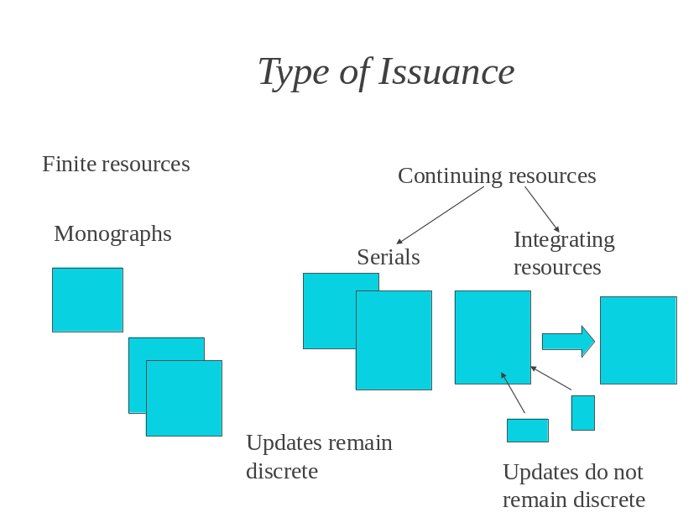

IR.1.2 Distinguishing integrating resources from monographs and serials

IR.1.2.1 Print resources
If a resource is issued in a single volume or over time but with a set conclusion (e.g., a resource to be completed in 10 volumes), the resource is a monograph. The single-part monograph or multipart item may be supplemented, but the supplements remain discrete.

A resource issued in one or more base volumes and updated over time with new pages that are incorporated into the main volume is an updating loose-leaf (i.e., an integrating resource). If the updates are intended to be continued indefinitely, the resource is a continuing integrating resource. If the updates have a predetermined conclusion, the resource is a finite integrating resource.

Not every resource published in loose-leaf format is intended for updating. Look for an indication from the publisher about updates before assuming the resource is an integrating resource. If the updates are added to a binder but remain as discrete entities, then it is a serial or a monograph rather than an integrating resource.

Monographs issued in loose-leaf format:
- Publications that are complete in one or more volumes but are issued in binders. For example, conference proceedings, course materials, or training manuals are often issued in binders for ease of use by participants.
- Publications that are issued in binders with updates or supplements that are filed together at the beginning or end of the binder.

Serials issued in loose-leaf format:
- Resources meeting the definition of serials issued in loose-leaf format to allow issues to be stored in a binder; the successive issues remain discrete.
- Resources which are issued successively even though the contents filed into each binder may be updated in integrating fashion until the next binder is issued.

Example: Resource issued in loose-leaf format is cataloged as a serial because of presence of numbering and issues remain discrete

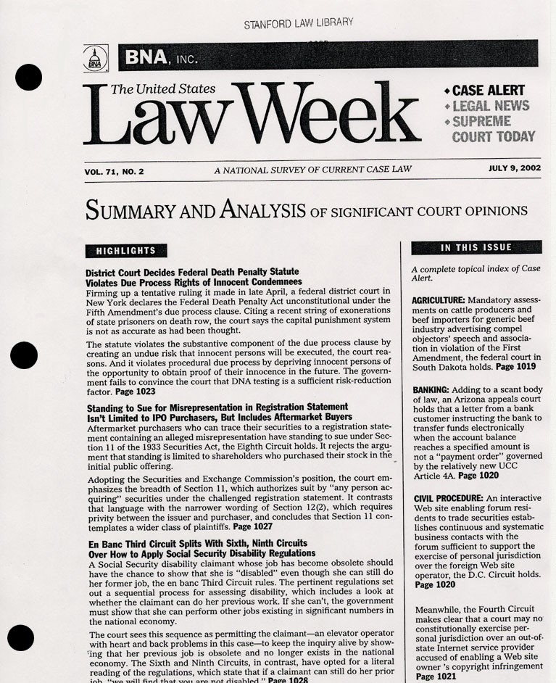

IR.1.2.2 Electronic resources
Online electronic resources may be monographs, serials, or integrating resources. The cataloger must examine each resource to determine the mode of issuance:

Is the resource a fixed, static site, not likely to be updated? If so, then it is a monograph. Possible, but not conclusive, clues that the site is a fixed, static one are the presence of only a single date of publication or copyright, a statement that there is a print counterpart to the site, the fact that the resource is a single PDF file, or the presence of a fixed edition statement that is associated with the resource.

Examples: Print monographs issued online in a “database” format: Catalog them as e-books because there is no evidence the content will be updated, they have single publication dates, edition statements that match the print versions, and/or e-ISBNs.

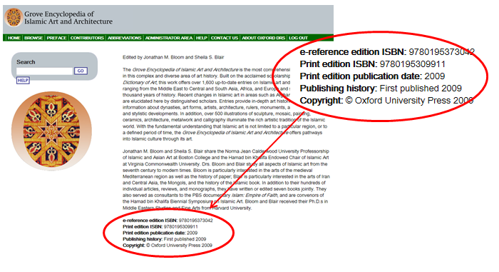

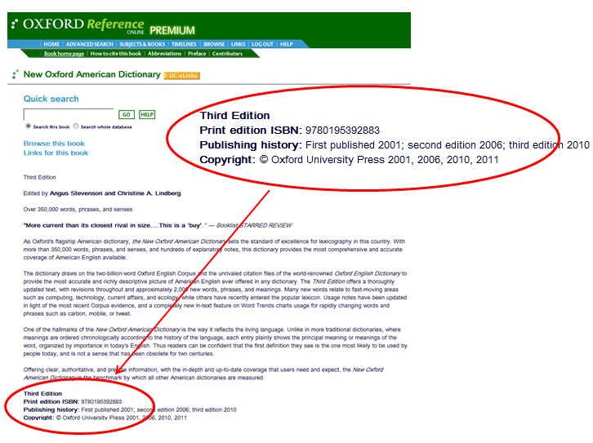
PCC members have agreed to follow a provider-neutral approach to cataloging electronic integrating resources. The scope and guidelines for applying the provider-neutral approach is provided in more detail in section IR.10 of this manual. This policy is limited to remote access electronic resources that are available simultaneously from two or more different electronic service providers (one of which may or may not be the original publisher or society) but are essentially the same resource and consist of the same content.

Example: Digitized graphic – catalog as a monograph.



Example: Digitized text of A History of the Crusades. Catalog as a monograph if there is no indication that the site will be updated.

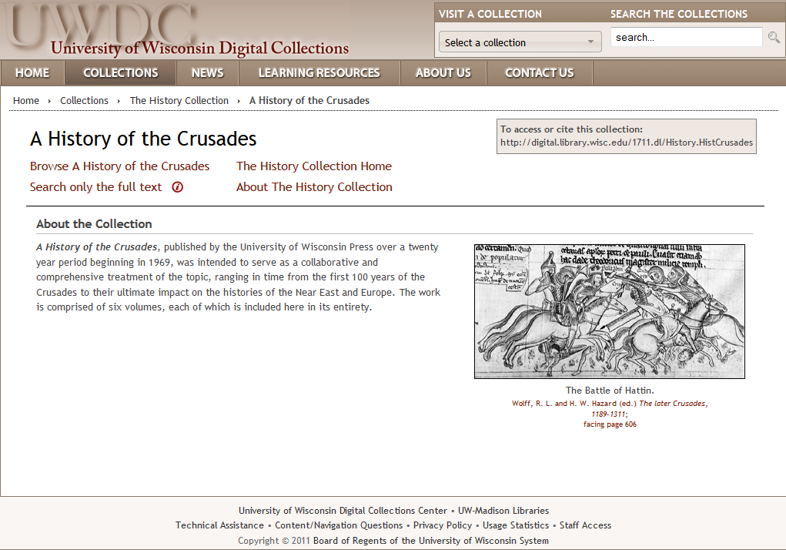

If the site is dynamic and is updated, is each update discrete? Can earlier issues or parts be accessed? If so, treat the resource as a serial or multipart item.

Example: A journal with current and back issues available on the site—catalog as a serial.

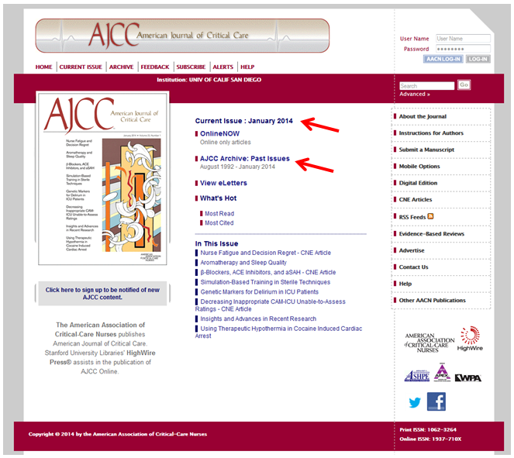

If the site is updated and the changes are integrated into the resource and the earlier iterations are no longer available, the resource is an integrating resource. Possible, but not conclusive, clues that a site is an integrating resource are the presence of a range of publication or copyright dates, presence of a “what’s new” section on the page, or the appearance of latest update information.

Example: Website. Note the presence of “News headlines,” “Event calendar,” and evidence of current information “today.” Catalog as an integrating resource.

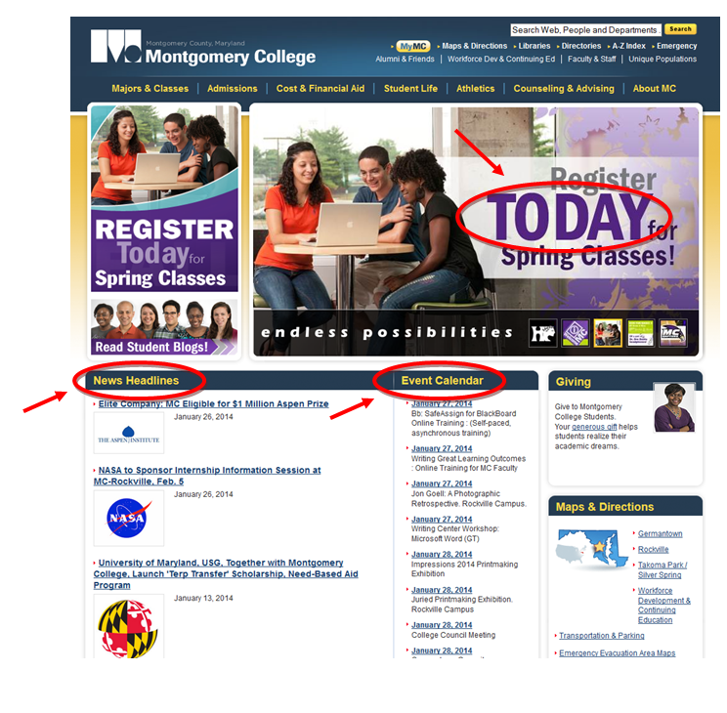

Some serials in print format become integrating resources when issued online because they are continually or frequently updated and previous iterations no longer exist as discrete issues. (If the current issue is available online as a separate issue but back issues no longer exist as discrete issues, still catalog the resource as a serial.) When determining the mode of issuance of the electronic resource, base the decision on the resource being cataloged, not on another manifestation.

Example: Website continuously updated, with previous iterations no longer available – catalog as an integrating resource.

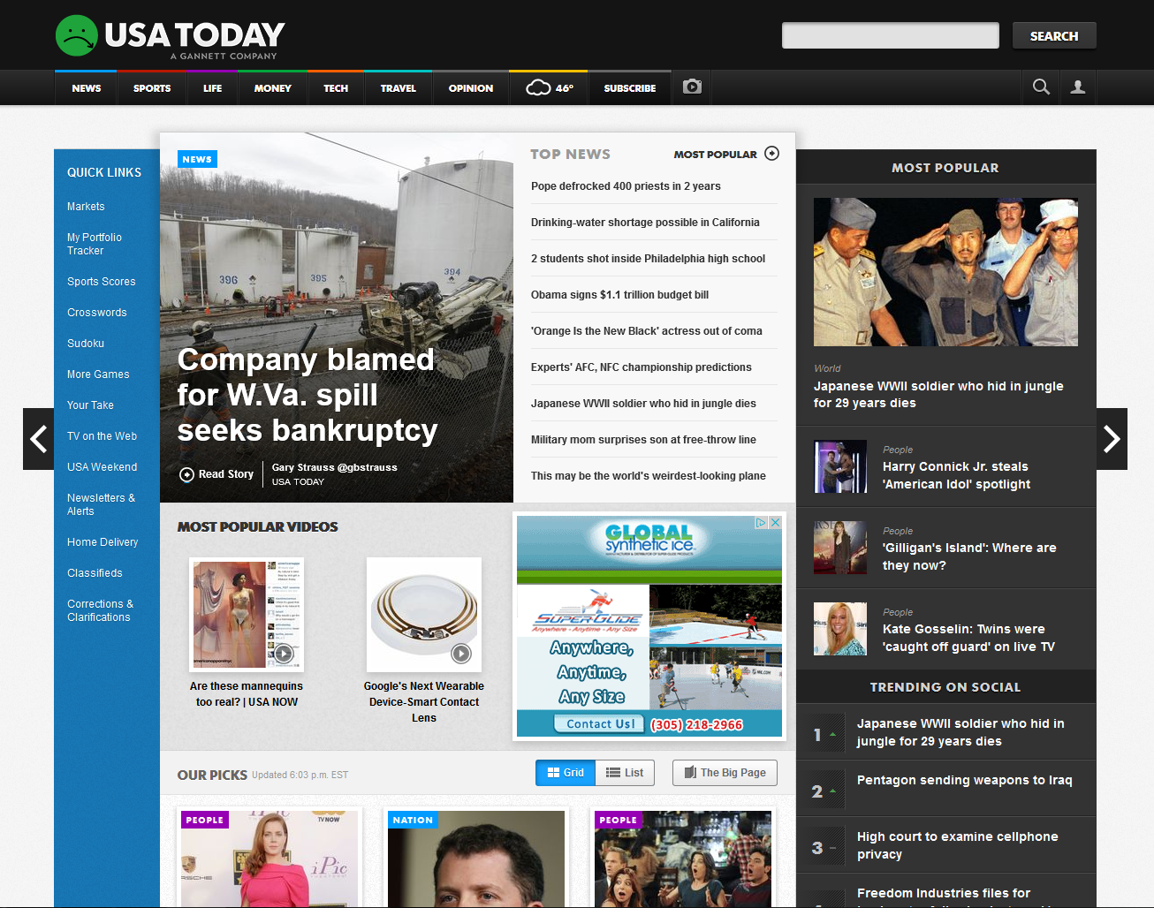

IR.1.3 Types of integrating resources
The three most common types of integrating resources are updating loose-leafs, updating databases, and websites.

IR.1.3.1 Updating loose-leafs
An updating loose-leaf is “an integrating resource that consists of one or more base volumes updated by separate pages that are inserted, removed, and/or substituted.” (RDA Glossary).
The loose-leaf service is a more complex bibliographic resource. The loose-leaf service is issued in several component parts, including updating loose-leaf materials, bound volumes, and newsletters, etc., containing both primary and secondary source material. This type of loose-leaf service may be called a “reporter.” Create a single bibliographic record for the service as a whole, with a note describing component parts (see LC-PCC PS 0.0).

IR.1.3.2 Updating databases
An updating database is “a collection of logically interrelated data stored together in one or more computerized files, usually created and managed by a database management system that is updated in an integrating manner.” (MARC 21 Format for Bibliographic Data)

Example: An updating database: U.S. Energy Information Administration’s U.S. States, state profiles and energy estimates.

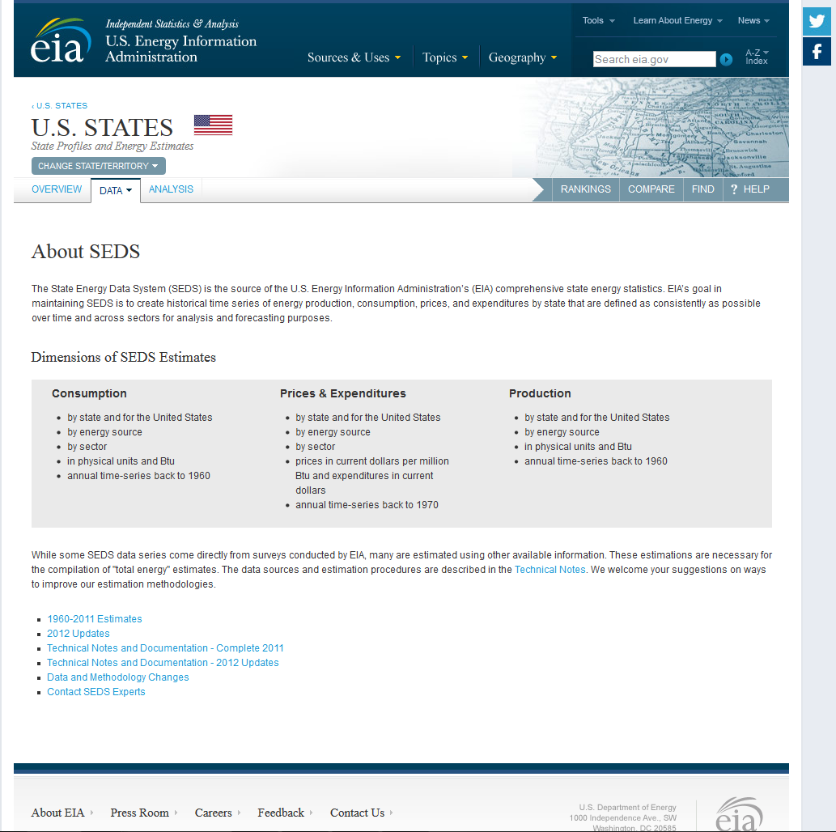

IR.1.3.3 Updating websites
A site is considered an updating website when the updates are done in an integrating manner (for example, newer content replacing or being added to existing content). Personal or organizational home pages are examples of websites.

Example: An updating website: Library of Congress website

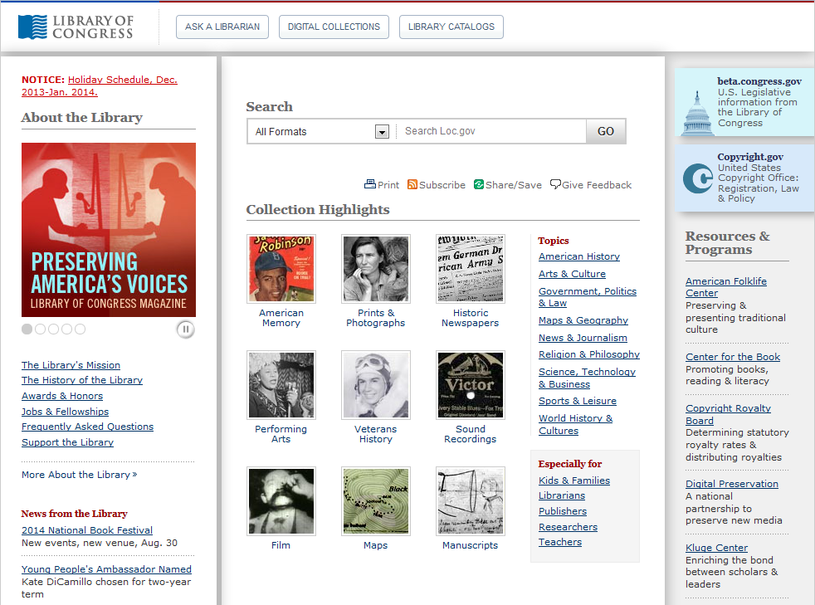

Although integrating resources are most often continuing resources, some are issued over time but are intended to be completed in a finite number of iterations or after a period of time. Integrating resources that have ceased being updated are still cataloged as integrating resources. There are no differences in the cataloging of finite and ongoing integrating resources.

Example: A finite website: 2014 XXII Olympic Winter Games website (updated only until completion of the Games)

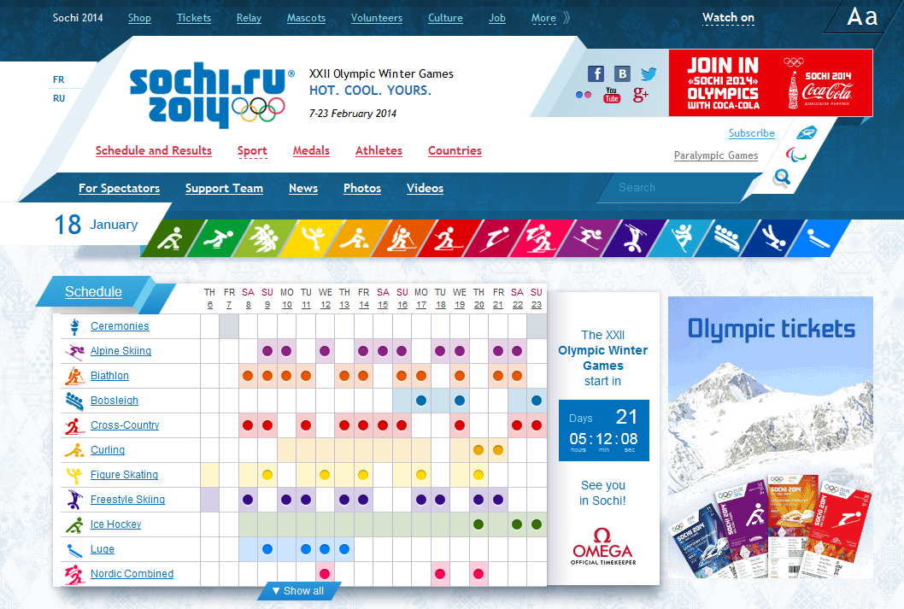

IR.1.4 Changeable aspects of integrating resources and impact on cataloging

Cataloging a single-part monograph is a fairly straightforward procedure: the cataloger describes the item in hand and the record is considered complete. Cataloging continuing resources can be more challenging because with each issue or iteration, there is the possibility of changes that need to be accommodated in the bibliographic description. Integrating resources present the biggest challenge. Unlike a serial, where the cataloger can go back and look at the earlier issues, the earlier iterations of the integrating resource have vanished or been subsumed into the current iteration. Therefore, description can only be based on the current iteration and information about earlier iterations must be moved to notes and/or access points, if considered to be important.

When a search of the catalog does not retrieve a record matching the resource being cataloged, a cataloger may think the resource is not represented in the catalog and create a new record. However, there may be a record for an earlier iteration of the resource not yet updated to reflect the current iteration.

For an updating loose-leaf, identification of changes in the current iteration requires that staff checking in the updates notice and act upon such changes. Unless check-in staff can view the bibliographic information easily during the check-in process and are trained to identify such changes, the changes may pass unnoticed until retrieval is affected or there is a new edition. Publishers may provide full replacement volumes in order to reflect a change of publisher name. These replacement volumes may or may not be considered a new edition. See IR.9 for guidance in determining if a new record is required.

For online integrating resources, once they are cataloged, it is unlikely that the cataloger and/or technical services support staff will see later iterations. Catalogers may only become aware of changes when questioned or notified by users or other library staff.

IR.2 Identifying manifestations and items

IR.2.1 Basis for identification of the resource and sources of information

The instructions for determining the basis for identification of the resource and sources of information are in RDA 2.1 and 2.2. The basis of identification for an integrating resource is different than that for a monograph or serial; however, the processes of choosing the sources of information and recognizing the preferred sources are the same.

Note that LC-PCC PS 0.0 and 2.1 give the same guidance for determining the mode of issuance when the choices are between integrating resource and serial and integrating resource and monograph.

IR.2.1.1 Basis for identification of the resource

Once the decision has been made that a comprehensive description of an integrating resource is being prepared, choose a source of information identifying the current iteration of the resource as a whole (RDA 2.1.2.4). If there is no source of information identifying the current iteration of the integrating resource as a whole, treat the sources of information identifying the current iteration of its individual contents as a collective source of information for the current iteration as a whole.

Base the description on the current iteration because the first iteration is no longer available once the integrating resource has been updated; the description is updated as the resource changes and notes are given in the record for earlier data elements considered to be important. (In contrast, the basis of description for multipart monographs and serials is the first or earliest part or issue because the first/earliest part or issue is available as a discrete unit; notes are added as data elements change over time.)

For an analytical description of an integrating resource, see RDA 2.1.3.4. An analytical description is used to describe a part of a larger resource, such as one chapter in an administrative manual issued as an updating loose-leaf volume, or a discussion paper on a regularly updated website, etc. (RDA 1.5.3.d).

IR.2.1.1.2 Basis for identification of the resource: Print
The preferred source of information for updating loose-leafs is the latest title page or title page substitute (RDA 2.2.2.2). Specify the source used as a title page substitute in a note (RDA 2.17.2.3). (See also: IR 2.6.2.)

If the resource has more than one title page, use the first occurring of these as the preferred source (RDA 2.2.3). When the resource has title pages in more than one language or script, choose the title page in the order of preference given by RDA 2.2.3.1 (main points of the instruction summarized below):

- If the resource has title pages in more than one language or script, choose the title page that is in the language or script of the main part of the resource.
- If the resource contains translations, and translation is the purpose of the resource, choose the language of the translation.

If information traditionally given on the title page is given on facing pages, with or without repetition, treat the two pages as the title page (See the RDA Glossary definition of title page).

IR.2.1.1.3 Basis for identification of the resource: Online
Base the description on the current iteration of the resource as a whole (RDA 2.1.2.4).

It is CONSER practice to always give a note on the iteration used as the basis for identification of the resource (RDA 2.17.13.4). This note is combined with the source of title note (RDA 2.17.2.3) and note identifying the date on which the resource was viewed (RDA 2.17.13.5). (See also: IR 2.6.2.)

IR.2.1.1.4 Basis for identification of the resource: Additional factors to consider for online resources available from multiple providers

A digitized integrating resource offered in multiple provider packages requires another cataloging decision: Which version will be used as the basis of description to represent all versions of the integrating resource in a provider-neutral record? The following list in preferred order is offered as general guidance to making decisions. Individual catalogers may need to use a particular version because they do not have access to other sources in the list. Other factors such as institutional policies and variations in how the title is presented by various distributors may also influence the source selected. (See also: IR.10.)

- Original publisher's/organization’s site
- Provider versions (electronic service providers and digitizers that are not the originators or creators of the content, but are licensed to provide access to the resource normally via their own interface)

The note on the iteration used as the basis for identification of the resource (RDA 2.17.13.4) should cite the provider version used. This note is combined with the source of title note (RDA 2.17.2.3) and note identifying the date on which the resource was viewed (RDA 2.17.13.5).

IR.2.1.1.5 Online integrating resources in multiple languages
Deciding when to create separate records for language editions or translations involves the following considerations:

- Does each language version have its own ISSN? Does the publisher formally present the language versions with statements such as German Edition? What is the intent of the publisher?

- Are all the different language versions available on the same hosting website or domain name? If so, are they published, distributed, or produced together or separately?

Example: http://documents.un.org/
Different language versions on the same website.



- The aspect of the resource being described will determine the type of description (a comprehensive or an analytical description, RDA 1.5), and the resulting number of bibliographic records that may be created.

- Is the text of the content primarily in one language with content offered in other languages on the same hosting site?

- Is the complete equivalent content of each language version available from the same hosting sites?

The flowchart below can help catalogers determine whether to catalog online integrating resource language versions separately or as part of a combined resource:

DOES THE WEBSITE CARRY SEPARATE ISSN FOR THE SEPARATE LANGUAGE VERSIONS?
-OR-
ARE THERE SEPARATE FORMAL STATEMENTS IDENTIFYING LANGUAGE VERSIONS?

Consider separate records
WHAT IS BEING CATALOGED? ARE THE LANGUAGE VERSIONS PUBLISHED, DISTRIBUTED, OR PRODUCED INDEPENDENTLY FROM THE COMBINED WEBSITE?
Consider separate records

IS THE TEXT OF THE CONTENT PRIMARILY IN ONE LANGUAGE WITH CONTENT OFFERED IN OTHER LANGUAGES?
IS THE COMPLETE EQUIVALENT CONTENT OF EACH LANGUAGE VERSION AVAILABLE FROM THE SAME HOSTING SITE?
Prefer one record, make notes for available language versions

Prefer one record, make notes for available language versions
Consider separate records

YES
YES
YES
YES
NO
NO
NO
NO
Examples:

One record for language versions:

775 | 08 | $i Also issued in Spanish: $a …
OR
500 | ## | $a Also issued in Spanish, French, and German.

Separate records: Choose one edition to serve as the “primary edition” and use that as the authorized access point for the other editions.

245 | 00 | $a Primary language edition.
130 | 0# | $a Primary language edition. $l Spanish.
245 | 00 | $a Edición Primary idioma.

For online integrating resources with interfaces in multiple languages, add a note:

Example: European Union website

546 | ## | $a Website interface available in 23 languages.
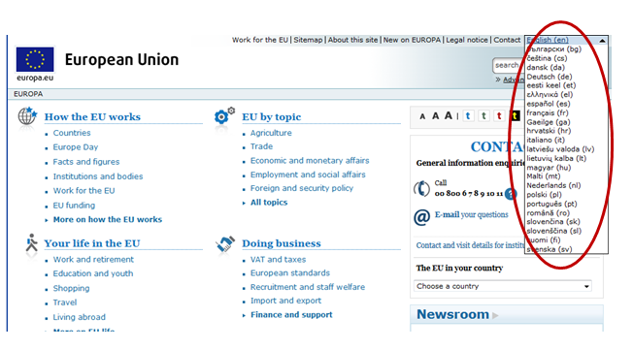

IR.2.1.2 Sources of information

For each area of the description, preferred sources of information are given in corresponding segments of RDA Chapter 2, Identifying Manifestations and Items. For the transcribed elements listed in RDA 2.2.4, use square brackets to indicate when that information is taken from outside the resource itself (RDA 2.2.4). Take notes and standard numbers from any iteration and any other source, i.e., no brackets are required.

IR.2.1.2.1 Sources of information: Updating loose-leafs
The preferred sources of information for updating loose-leafs are given below.

Elements | Preferred sources of information
Title and statement of responsibility | Title page or title sheet, cover, caption, colophon (in order of preference) (RDA 2.2.2.2; 2.4.2.2)
Edition statement | Same source as title (RDA 2.5.1.2)
Place of publication, Publisher’s name | Same source as the title (RDA 2.8.4.2; 2.8.2.2)
Date of publication | Same source as the title (RDA 2.8.6.2)
Series | Series title page, analytical title page, cover, caption, colophon (RDA 2.12.2.2)
Carrier type | The resource itself (RDA 3.1.1)
Extent | The resource itself (RDA 3.4.1.2)
Note | Any source
Standard number and terms of availability | Any source

IR.2.1.2.2 Sources of information: Online
Because the current iteration as a whole is the basis of identification for integrating resources (RDA 2.1.2.4), very little information will be bracketed in a bibliographic record for an online integrating resource.

According to RDA 2.2.2.4.2, the preferred source of information of an online integrating resource is the first of the following with a title:

- textual content
- embedded metadata in textual form that contains a title

An example of textual content with a title is a title screen. Examples of embedded metadata for titles are a banner GIF or an HTML header. If none of the sources above has a title, use any other part of the resource as the preferred source of information, giving preference to sources in which the information is formally presented (RDA 2.2.2.4.2).

Take from the preferred source of information the title proper, statement of responsibility, edition statement, place of publication, publisher’s name, and series statement.

Take the beginning and/or ending date of publication from the first and/or last iteration, or from another source (RDA.2.8.6.2).

Take from the resource itself the Carrier type and extent.

Take Notes, Standard number and terms of availability from any source.

IR.2.2 Title and statement of responsibility area

General rules for transcription of title and statement of responsibility are in RDA 2.3 and RDA 2.4 respectively.

If information is added, deleted, or changed on a subsequent iteration of an integrating resource, change the title and statement of responsibility area to reflect the current iteration. Make a note for a change in title proper and make a note for other changes if considered important (see separate data elements below and IR.2.6).

IR.2.2.1 Title proper

Transcribe the title proper from the current iteration in the 245 field. For notes relating to the title, see IR.2.6.2.

IR.2.2.1.2 Introductory words not considered part of the title proper

Omit from the title proper those words that serve as an introduction and are not intended to be part of the title. However, give the introductory words plus the title proper in a note (RDA 2.3.1.6).

Examples: Introductory words not considered part of the title proper

Example 1:

245 | 00 | $a Biodiversity information online.
246 | 1# | $i Title appears on Web page as: $a Welcome to biodiversity information online
300 | ## | $a 1 online resource



Example 2:

245 | 00 | $a Weeds gone wild : $b alien plant invaders of natural areas.
246 | 1# | $i Title appears on home page as: $a Plant Conservation Alliance’s Alien Plant Working Group presents -- Weeds gone wild : $b alien plant invaders of natural areas
300 | ## | $a 1 online resource



IR.2.2.1.3 Typographical errors

Correct obvious typographical errors on a resource when transcribing the title. Give the incorrect title in a note. If considered important for identification or access, record the incorrect title as a variant title (246 field). In case of doubt as to whether the spelling of the word is an error, transcribe the spelling as found on the resource (RDA 2.3.1.4).

Examples:

245 | 00 | $a Housing starts.
246 | 1# | $i Title on home page: $a Housing sarts $f <December 15, 2002>
300 | ## | $a 1 online resource

OR

245 | 00 | $a Housing starts.
300 | ## | $a 1 online resource
500 | ## | $a Title appears on home page as: Housing sarts

But in case of doubt:

245 | 00 | $a Band connexion.
246 | 1# | $a Band connection
300 | ## | $a 1 online resource

IR.2.2.1.4 Full forms vs. acronyms or initialisms

When the title appears in a full form and as an acronym or initialism on the preferred source, choose the full form as the title proper (RDA 2.3.2.5). The acronym or initialism may be recorded as other title information or as a variant title (see also IR 2.6.2.2).

CONSER practice: Record the acronym or initialism as a variant title in field 246 rather than as other title information in the 245 field, using the coding 246 1#.

Example: Full form chosen as title proper. Per CONSER practice, the initialism is recorded only in the 246.

110 | 2# | $a Financial Accounting Foundation. $b Governmental Accounting Standards Board, $e author.
245 | 10 | $a Governmental Accounting Standards Board.
246 | 1# | $a GASB
300 | ## | $a 1 online resource

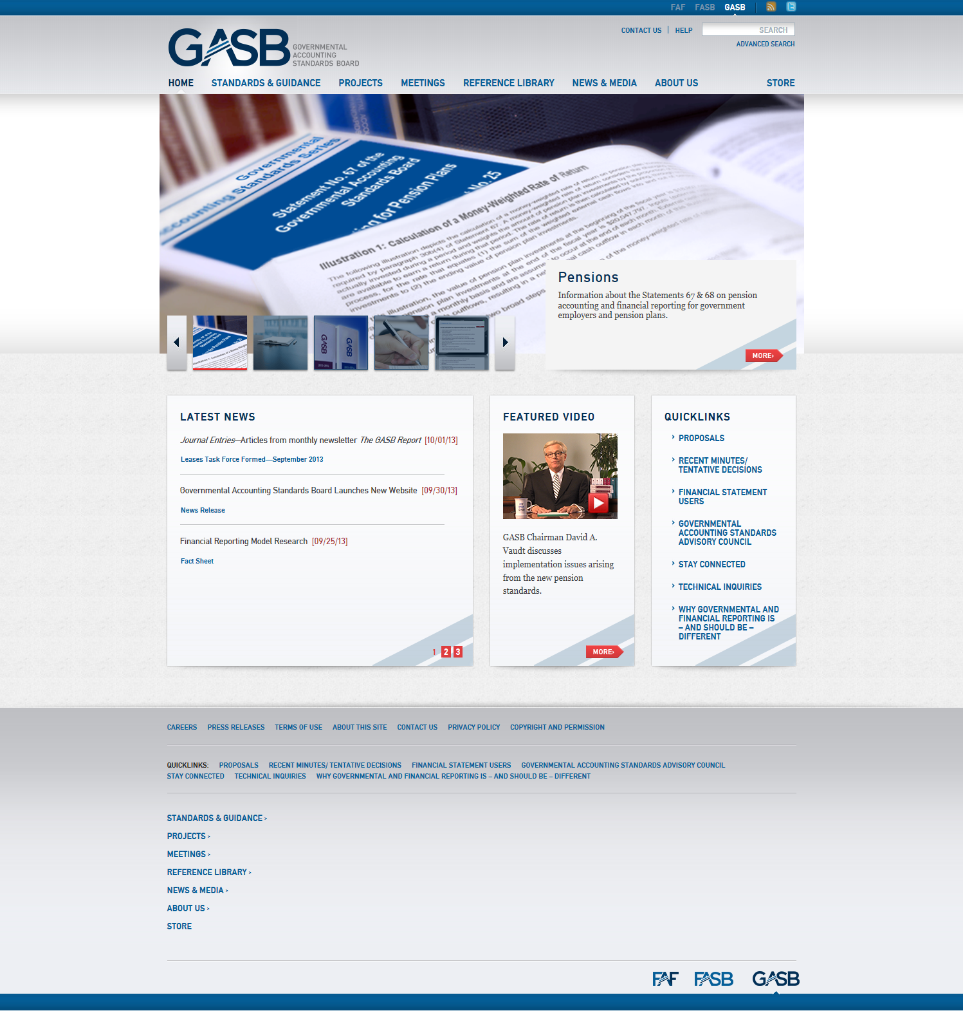

IR.2.2.1.5 Common titles and section titles

When cataloging an online integrating resource, determine if what at first appears to be a common title is instead a different data element. If it is represented by a series authority record, record it as part of the series statement. Is it the name of a corporate body, is it a statement of responsibility, or does it appear on the site as a “brand” for the site? Is the “section title” dependent, and therefore needs a common title to be meaningful? (RDA 2.3.1.7)

Example 1:

245 | 00 | $a STFC Chemical Database Service. $p Spectroscopy.

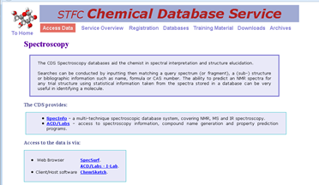

Example 2:

245 | 00 | $a STFC Chemical Database Service. $p CrystalWeb : $b Web access to full range of crystallographic databases.

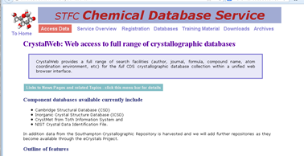

If a word or phrase is not a common title/section title, it may be provided in a 246 field if considered important for identification or access.

IR.2.2.1.6 Change in title proper

If the title proper changes on a subsequent iteration, change the title proper to reflect the current iteration, and give the earlier title in a 247 field (RDA 2.3.2.12).

The 247 field is both a note and an access point. Indicate the range of dates of the former title proper if that information is available (247 $f). When that information isn’t available (the most common situation), use the date or designation on which the earlier iteration of the title was recorded, enclosed in angle brackets (i.e., < >). If the title proper changes again, update the 245 field and give the former title proper in a second 247 field. See also IR.2.6.2.3.

Example: Change in title proper on later iteration. Note the resource is distributed by only one provider so the provider-neutral record approach is not reflected here:

Bibliographic record when first cataloged on June 16, 2012:

110 | 2# | $a Association of American Economics, $e author.
245 | 10 | $a Membership directory of the Association of American Economics.
588 | ## | $a Description based on contents viewed on June 16, 2012; title from HTML header.

Bibliographic record after changes seen on August 30, 2013:

110 | 2# | $a Association of American Economics, $e author.
245 | 10 | $a Association of American Economics online directory of members.
247 | 10 | $a Membership directory of the Association of American Economics $f <June 16, 2012>
588 | ## | $a Description based on contents viewed on August 30, 2013; title from HTML header.

If information about former titles proper cannot be given succinctly in multiple 247 fields, and if they are considered important for identification or access, add a 547 field to give a complex former title note (RDA 2.17.2.4). Do not give a 547 field just because there are multiple 247 fields.

IR.2.2.1.7 Parallel titles

Record parallel title(s) on the current iteration. Take parallel titles proper anywhere from the resource itself (RDA 2.3.3.2). If a parallel title is added, deleted, or changed on a subsequent iteration and an existing record contains a parallel title in the 245 (because it was deemed necessary to record it in $b of the 245 when the record was created), change the 245 field to reflect the current iteration; if considered to be important, give any earlier parallel titles in a 246 field for access. See also IR.2.6.2.5.

CONSER practice: It is not required to record parallel titles in 245 $b. They may be recorded in 246 and coded 246 11.

IR.2.2.1.8 Other title information

Other title information is not core in RDA (RDA 2.3.4).

CONSER practice: Generally it is not required to transcribe other title information unless it provides clarification or support to a title proper that would be unclear or otherwise misleading without the other title information. Other title information on the current iteration may be omitted according to this practice, or recorded in 245 $b if it is helpful to the user.
Because of the dynamic nature of integrating resources, consider when it may be helpful not to transcribe other title information to avoid the need for numerous changes to the cataloging record. Always omit other title information that consists solely of words relating to the currency of the content or frequency of updating. Consider the usefulness for identification of the resource and user needs in making the judgment to transcribe other title information in other cases.

Example: Updating loose-leaf

100 | 1# | $a Schnapf, Lawrence P., $e author.
245 | 10 | $a Managing environmental liability : $b business transactions and Brownfield redevelopment / $c Lawrence P. Schnapf.

For online integrating resources, consider transcribing other title information in the following situations:

- Other title information contains terms that help clarify or amplify the scope of an unclear or “generic” title
- Other title information contains terms that might prove useful in keyword searches

Example: Online resource

245 | 10 | $a Animal info : $b information on endangered mammals / $c by Paul Massicot.
300 | ## | $a 1 online resource

If other title information is recorded in the 245 field and that information changes on a later iteration, decide if the other title information is important enough to be recorded in the 245 field. (RDA 2.3.4.7.3). If it is, change the 245 field to reflect the current iteration; if it isn’t, delete the existing other title information in the 245 field. If considered important for identification or access, give a specific note about earlier other title information in a 246 field or a general note in a 500 field (RDA 2.17.2.4). See also IR.2.6.2.6.

IR.2.2.1.9 Statement of responsibility

The first statement of responsibility is core for RDA (RDA 2.4.1). (There is an exception for serials by which a statement of responsibility identifying an editor is only required if it is considered important for access, but this exception does not apply to integrating resources.)

Transcribe a statement of responsibility appearing prominently on the current iteration in 245 $c. If the statement of responsibility is already transcribed as part of the title proper or other title information, don’t include an additional statement of responsibility unless such a statement also appears separately on the chief source of information.

According to LC-PCC PS for RDA 20.2.1.3, PCC participants record contributors if they are considered important for identification. For print integrating resources, the editor is generally considered to be important for access, and if information about an editor appears on the source or sources of information, transcribe it. If not present on the source or sources of information but considered important, a note may be given about the editor. See RDA 2.17.3 for recording notes on statements of responsibility.

For online integrating resources, do not transcribe statements that represent only the electronic service provider of a resource.

If a statement of responsibility is added, deleted, or changed on a subsequent iteration, change the 245 field to reflect the current iteration; if considered to be important, give any earlier statement of responsibility in a note (RDA 2.17.3.6.3). See also IR.2.6.3.

IR.2.3 Edition statement

Transcribe an edition statement as it appears on the source of information (RDA 2.5.1.4). If there is a parallel edition statement, record it. If there is more than one parallel edition statement, transcribe them in the order indicated by the sequence, layout, or typography of the statements on the source or sources of information (RDA 2.5.7.3). Do not transcribe statements indicating regular revision as edition statements, e.g., “Revised edition issued every 6 months” (RDA 2.5.2.5). These are recorded as frequency (see RDA 2.14.1.3). Do not transcribe edition statements unique to one digital provider’s version of a resource.

If edition information is added, deleted, or changed on a subsequent iteration and this change does not require a new record according to RDA 1.6.3.4, change the edition area to reflect the current iteration (RDA 2.5.1.6.3). Make a note to record the earlier edition information if considered to be important for identification of the resource (RDA 2.17.4.5.3). See also IR.2.6.4.

IR.2.3.1 Updating loose-leafs

If the resource consists of multiple issues or parts, and there are edition statements relating to the whole as well as to parts, then record only the edition statements relating to the whole resource.
Make a note giving edition statements relating to issues or parts if considered important for identification (RDA 2.5.1.5).

Example:

250 | ## | $a Fourth edition.
500 | ## | $a Updated to fourth edition, <July 2012>.

Some updating loose-leafs are published as gradual replacement editions. At some point the author or publisher considers the work to constitute a new edition, although a new base volume is not issued. Instead, a replacement title page carrying the new edition statement is received with a shipment of updates. Do not create a new bibliographic record. Instead, update the edition statement in the existing record and add a note to explain the change in the edition statement (RDA/LC-PCC PS 2.17.4.5.3).

When a change in an edition statement indicates a significant change to the scope or coverage of an integrating resource, create a new description (RDA 1.6.3.3). See IR.11 for situations when the issuance of a new edition requires creation of a new description.

IR.2.3.2 Electronic resources

Do not always consider “version” information that commonly appears on websites to be equivalent to a formal edition statement. Use judgment in determining where to record version information. This type of data may change frequently and should not necessarily be transcribed in the edition area (see also IR.2.6.6). In cases where frequent updates are made, consider giving version information in conjunction with the resource described note.

Examples:

588 | ## | $a Description based on: Version 3.5 (viewed on November 4, 2012); title from home page.
588 | ## | $a Description based on: Version 8.11.2013 (viewed on December 2, 2013); title from title screen.

Some resources are issued simultaneously in different editions. In these cases, give the edition statements in the 250 field of the bibliographic record for each integrating resource.

Example: True edition statement present on electronic integrating resource

245 | 00 | $a WebElements periodic table.
250 | ## | $a Professional edition.
300 | ## | $a 1 online resource



If the “scholar edition” were selected for cataloging in the library, a separate bibliographic record would be created.

Create a new description only when the change in an edition statement is also accompanied by a change in the scope or coverage of an integrating resource (RDA 1.6.3.4).

IR.2.4 Publication, distribution, manufacture, and copyright date

The place of publication, publisher's name, and date of publication are RDA core elements for published resources. Give information about the place and name of publisher based on the current iteration (RDA 2.8). Use the repeatable 264 field (see IR.2.4.6). PCC implemented this practice in August 2012 and guidelines for applying the 264 field (including working with existing 260 fields in pre-RDA records) can be found at: http://www.loc.gov/aba/pcc/documents/264-Guidelines.doc.

If a place of publication, publisher’s name, and date of publication are not identified, the distribution statement (RDA 2.9) or manufacture statement (RDA 2.10) become RDA core elements. Give complete distribution or manufacture statements in lieu of missing publication or distribution elements, respectively (LC-PCC PS 2.9-2.10). Copyright date is a RDA core element if neither the date of publication nor the date of distribution is identified. (RDA 2.11), but it is not an LC-PCC core element for integrating resources.

If a place or name is added, deleted, or changed on a subsequent iteration, update the publication, distribution, and/or manufacture areas to reflect the current iteration (RDA 2.8.1.5.3, 2.9.1.5.3, and 2.10.1.5.3).

For online integrating resources, transcribe publication information applicable to all online versions and not reflective of one digitizer or provider.

IR.2.4.1 Place of publication

The place of publication is a RDA core element (RDA 2.8.2). If more than one place of publication appears on the source of information, only the first recorded is required.

Take places of publication from the following sources (in order of preference) from the latest iteration:

a) the same source as the publisher's name (see RDA 2.8.4.2)
b) another source within the resource itself (see RDA 2.2.2)
c) one of the other sources of information specified at RDA 2.2.4.

If the place of publication is not identified in the resource, supply the place of publication or probable place of publication enclosed in brackets (RDA 2.8.2.6). Apply the instructions in this order of preference:

a) known place (see RDA 2.8.2.6.1)
b) probable place (see RDA 2.8.2.6.2)
c) known country, state, province, etc. (see RDA 2.8.2.6.3)
d) probable country, state, province, etc. (see RDA 2.8.2.6.4).

Record Place of publication not identified, enclosed in brackets, if neither a known nor a probable local place or country, state, province, etc., of publication can be determined.

264 | 31 | $a [Place of publication not identified]

Whenever possible, supply a probable place of publication rather than give [Place of publication not identified] (LC-PCC PS 2.8.2.6).

Give the place of distribution if there is no place of publication. The place of distribution is a core element for a resource in a published form if the place of publication is not identified. If more than one place of distribution appears on the source of information, only the first recorded is required (RDA 2.9.2). Use field 264 with 2nd indicator value 2 for coding elements relating to the distribution of a resource.

264 | 31 | $a [Place of publication not identified] : $b ABC Publishers, $c 2013-
264 | 32 | $a Seattle : $b Iverson Company

Give the place of manufacture, if there is no place of publication or place of distribution. The place of manufacture is a RDA core element for a resource in a published form if the place of publication or place of distribution is not identified. If more than one place of manufacture appears on the source of information, only the first recorded is required (RDA 2.10.2). Use field 264 with 2nd indicator value 3 for coding elements relating to the manufacture of a resource.

IR.2.4.2 Publisher’s name

The publisher’s name is a RDA core element (RDA 2.8.4). If more than one publisher's name appears on the source of information, only the first recorded is required.

Take publishers' names from the following sources (in order of preference) from the latest iteration:

a) the same source as the title proper (see RDA 2.3.2.2)
b) another source within the resource itself (see RDA 2.2.2)
c) one of the other sources of information specified at RDA 2.2.4.

Record publisher not identified, enclosed in brackets, if no publisher is named within the resource itself and the publisher cannot be identified from other sources (see RDA 2.8.4.7).

264 | 31 | $a New York, NY : $b [publisher not identified]

If a publisher’s name is not identified, the distributor's name becomes a RDA core element (RDA 2.9). If more than one distributor's name appears on the source of information, only the first recorded is required (RDA 2.9.4). Record the distributor’s name in field 264 $b with 2nd indicator value 2.

264 | 31 | $a New York, NY : $b [publisher not identified]
264 | 32 | $a Ann Arbor, MI : $b ProQuest

If neither a publisher’s name nor a distributor’s name is identified, the manufacturer’s name becomes a RDA core element (RDA 2.10). If more than one manufacturer's name appears on the source of information, only the first recorded is required (RDA 2.10.4). Record the manufacturer’s name in field 264 $b with 2nd indicator value 3.

264 | 31 | $a Indianapolis, IN : $b [publisher not identified]
264 | 33 | $a La Vergne, TN : $b Ingram Publisher Services

IR.2.4.3 Date of publication

The date of publication is a RDA core element (RDA 2.8.6). Take the beginning and/or ending dates of publication from the first and/or last iteration, or from another source (RDA 2.8.6.2). Take dates of publication from the following sources (in order of preference):

a) the same source as the title proper (see RDA 2.3.2.2)
b) another source within the resource itself (see RDA 2.2.2)
c) one of the other sources of information specified at RDA 2.2.4

If the first iteration of an integrating resource is available, record the date of publication of the iteration, followed by a hyphen (RDA 2.8.6.5).

264 | 31 | $a New York : $b Harper, $c 1994-
264 | 31 | $a Chicago : $b Holt, $c [2003?]-

If the resource has ceased or is complete and the first and last iterations are available then record the dates of the iterations, separated by a hyphen (RDA 2.8.6.5).

264 | 31 | $a Eagan, MN : $b Thomson Reuters, $c 2009-2013.

If the resource has ceased or is complete and the last iteration is available, but not the first then record the publication date of the last iteration, preceded by a hyphen.

264 | 31 | $a Eagan, MN : $b Thomson Reuters, $c -2013.

Supply the date of the last update, if considered important for identification (RDA 2.8.6.5).

Example: First and last published iterations of an updating loose-leaf available; date of last update known.

264 | 31 | … $c 1995-1998 [updated 1999].

If the first and/or last iteration is not available, supply an approximate date or dates, enclosed in brackets. Approximate and probable dates can be inferred from the copyright date, date of manufacture, and date of distribution (in that order). (See IR 2.2.4.)

Example: First/last iteration is not available for cataloging. Beginning and ending dates are inferred from the copyright dates:

264 | 31 | … $c [1970?-1998?]
OR
362 | 1# | $a Began in 1970?; ceased in 1998?

If you can reasonably estimate a start/end publication date, put it in the 264 $c; otherwise use a 362 1# note.

Example: First iteration is not available for cataloging.

264 | 31 | … $c [2003?]-
OR
362 | 1# | $a First posted on March 13, 2003?

Example: First iteration not available but beginning date is available:

264 | 31 | $a New York : $b Harper, $c [1999]-

Example: First iteration available; last iteration not available but ending date information is taken from outside the resource itself:

264 | 31 | $a New York : $b Harper, $c 2004-[2013?]

If the date or dates cannot be approximated, do not record a date of publication (RDA 2.8.6.5). Do not supply a comma at end of the 264 $b if there is no $c.

Example: First iteration not available and no information about date of publication available:

264 | 31 | $a Charlottesville, Va. : $b LEXIS Publishing
[no 362 field]

When using an existing bibliographic record for copy cataloging, generally accept the date in the 264 $c. If the date is obviously incorrect, either change it to the correct date if known or delete it. (See IR.7.8 for 008 fixed field coding)

IR.2.4.4 Copyright dates

It is not required to record copyright dates for integrating resources (LC-PCC PS 2.11). If the resource lacks a publication date, approximate and probable dates can be inferred from the copyright date if it seems reasonable to assume that date is a likely publication date (LC-PCC PS 2.8.6.6).

An updating loose-leaf may have a range of copyright dates. It may not be clear if the range includes dates of previous editions/iterations and it may not be clear if the latest date refers to the current edition/iteration. Use cataloger’s judgment in deciding if research is necessary.

When cataloging online integrating resources, in most cases, it is unlikely that you are viewing the first iteration of the resource. Explicit publication date information may appear on the home page, login screen, menu, splash screen, etc., or in communications with the publisher/producer/supplier of the resource. Dates should be applicable to the original publisher’s content and not reflective of one digital service provider.

Examples of phrases that are considered explicit statements of publication:

Created in/on (date)
Institute mounted this page in (date)
Site no longer maintained after (date)
First posted on (date)

Websites often include many pieces of intellectual content that have different copyright dates. Therefore, it can be difficult to determine whether multiple or ranges of copyright dates reflect the date of the site or the copyright date for the content. The first date in a range of dates (e.g., c1999-2002) is not an explicit statement of the date of publication; it may be used to infer a possible beginning date given in a 362 1 field (RDA 2.17.5.3).

Do not take the final copyright date in a range as an ending date for the resource. That date just indicates that copyright continues to be held; the date may be updated annually to reflect the latest year.

Examples: No publication information about first iteration but copyright dates are available:

264 | 31 | … $c [1996?]-
OR
362 | 1# | $a Began in 1996?

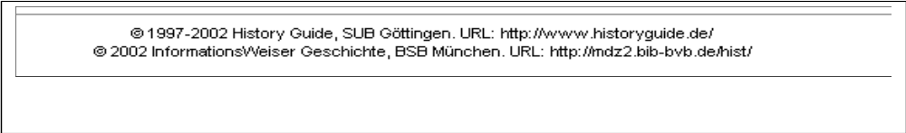

264 | 31 | … $c [1997?]-
OR
362 | 1# | $a Began in 1997?

Note that a single copyright date that appears on a later iteration of a resource cannot be considered the beginning date, because it usually indicates the current year.

Example: Website viewed in 2002, with a 2002 copyright date but with explicit information about beginning publication date.

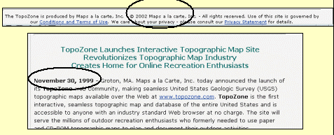

264 | 31 | $a Groton, MA : $b Maps a la Carte, Inc., $c 1999-
If no other information is available, a single copyright date may be used to infer the publication date.

Example: “©2000” on a later iteration

264 | 31 | … $c [2000?]-
OR
362 | 1# | $a Began in 2000?

IR.2.4.5 Use of the repeatable 264 field to record changes in publication

The MARC 21 Format for Bibliographic Data defines the 264 field as repeatable and lists specific indicator values for changes in publication information. Previously, earlier place and publisher name information were recorded in 500 fields.

Use the repeatable 264 fields to make notes on place of publication and/or publishers' names no longer present on the current iteration of an integrating resource, or that appeared in a different form on earlier iterations (RDA 2.8.1.5.3), if considered important for identification or access. If the changes have been numerous, make a general note (RDA 2.17.7.5.3).

When recording publication information changes that include dates, use angle brackets when exact dates are unknown. Do not do research to determine exact dates; use an update designation or a viewed date to locate the change in time.

When multiple 264 fields are used, the date(s) of publication reside(s) in the current publishing statement (264 31).

264 | #1 | $3 1990-1994: $a Salem, N.H. : $b Butterworth Legal Publishers
264 | 21 | $3 1995-<1996>: $a Charlottesville, VA : $b Michie
264 | 21 | $3 <1998>-1999: $a Charlottesville, VA : $b LEXIS Law Pub.
264 | 31 | $3 2000- : $a Huntington, NY : $b Juris Pub., $c c1990-

If the publisher is also the issuing body, update the publication statement and provide an authorized access point for the new issuing body in a 710 field if considered to be important (see also IR.5.2).

264 | 31 | $a Morrisville : $b American Economics Society, $c 1999-
710 | 2# | $a American Economics Society, $e issuing body.

264 | #1 | $3 1999-: $a Morrisville : $b American Economics Society
264 | 31 | $3 <August 30, 2000->: $a Morrisville : $b Association of American Economics, $c 1999-
710 | 2# | $a American Economics Society, $e issuing body.
710 | 2# | $a Association of American Economics, $e issuing body.

IR.2.4.6 Relationship of imprint information to fixed field 008

The current publication information recorded in the 264 $c (or the date in field 362) is the basis of coding the dates in fixed field 008, bytes 7-10 and the place of publication in fixed field 008, bytes 15-17 (see IR.7). When the place of publication changes on later iterations, update the 008 to reflect the current place of publication. When the integrating resource is complete, update the date information in the 008.

IR.2.5 Series statements and series access points

Record series information on the current iteration in the series statement (RDA 2.12 and its LC-PCC PS; core element). Guidance on transcription of series numbering in series statements is given in RDA 2.12.9, 1.7 and 1.8 and their associated LC-PCC PS. Due to recent MARC 21 changes, series statements for subseries may include two ISSN, one for the main series, and one for the subseries (RDA 2.12.8, 2.12.16; both are core elements for LC and PCC, when applicable).

CONSER practice: Do not give a series statement in the 490 field, unless the series information has changed in later iterations of the resource. Instead, if tracing the series, give only an authorized access point (AAP) for the series in the appropriate 8XX field.

In RDA, series are considered a type of work, and AAPs for series are formulated according to the instructions for related works (RDA Chapter 25). Specific instructions for series AAPs are given in RDA 25.1.1.3, LC-PCC PS 25.0. Form of numbering in series AAPs is discussed in RDA 24.6 and its associated LC-PCC PS. An ISSN may also be included in the 8XX $x (regardless of whether it already appears in a 490 field).

If a series is added, deleted, or changed on a subsequent iteration of an integrating resource, change the series statement to reflect the current iteration (RDA 2.12.1.6.2). If the series on an earlier iteration is a traced series, consider that series to be important and retain it in a 490 field with $3 to indicate when it was applicable (LC-PCC PS 25.0). When $3 is required to indicate that a series does not apply to all iterations covered by a record, it may be added to field 490 only, field 8XX only, or to both a 490 field and its corresponding 8XX, depending on the practices followed by the cataloging agency. Because practices may differ, catalogers should be mindful when working in a shared environment to maintain, but not to remove, valid data.

If the series has already been established, give the authorized access point for the series and the form of numbering as established in its series authority record. If establishing the series, consult the above cited instructions to determine the appropriate form of series AAP and numbering.

Example: Change in the series title on a later iteration

Earlier iteration:

490 | 1# | $a Federal practice series
830 | #0 | $a Federal practice series.

Later iteration:

490 | 1# | $3 1991-: $a Court rules series
490 | 1# | $3 1980-1990: $a Federal practice series
830 | #0 | $3 1991-: $a Court rules series.
830 | #0 | $3 1980-1990: $a Federal practice series.

(Note: older records may contain obsolete field 440, used previously to indicate the series statements and series access points when they were the same; when adding a series statement for the current iteration it may be necessary to re-tag earlier 440 fields to 490/830.)

IR.2.6 Notes

This chapter covers the most common notes used in bibliographic records for integrating resources. Notes are not a core element in RDA, but some notes are core for LC and PCC. For notes on describing carriers, see IR.3. For notes on providing acquisition and access information (i.e., electronic location and access), see IR.4.

Give notes for:

- Source of title (Core, LC-PCC PS 2.17.2)
- Issue, part, or iteration used as the basis for identification of the resource, where applicable (Core, LC-PCC PS 2. 17.13)
- Gradual replacements for updating loose-leafs (LC-PCC PS 2. 17.4.5.3)
- Publication statements (date of release or transmittal) (LC-PCC PS 2. 17.7)
- Information on changes in the bibliographic details of the integrating resource over time
- Other information related to the content of the integrating resource (e.g., data relevant to the content aspect of the integrating resource as opposed to its physical carrier)
- Information on the physical carrier or physical medium of the resource
- Information about relationships to other resources (see IR.5)

Take information for notes from any source and from any iteration of an integrating resource (RDA 2. 17.1.2; 7.1). Give succinct, useful notes. The style of notes generally is not prescriptive; do not rewrite notes found in existing records unless the information is inaccurate or no longer correctly describes the resource. Because all sources are prescribed sources for notes, do not use square brackets. Use angle brackets (< >) for uncertain dates or uncertain update information.

Not all notes are given in the 5XX range of MARC fields; see specific sections following for information about appropriate MARC fields. For example, notes about variations/changes in title may be general from fields that are also used for the variant access points (246 and 247), and notes about relationships to other resources may be generated from the linking entry fields (760-787). Prior to December 2002, some of these fields were used only in the cataloging of serials.

For guidelines on how to construct notes, see RDA 1.10, 2. 17. Refer to RDA Appendix A for guidelines on capitalization, punctuation, numerals, symbols, and abbreviations.

IR.2.6.1.1 Scope of applicability

Take information for notes from any source and from any iteration of an integrating resource (RDA 2. 17.1.2). If it is known that the note does not apply to the entire resource, identify the applicable part or iteration (RDA 1.10.5). Generally, don’t do research to determine exact dates of applicability or the exact date of a change. Use the update designation or date in an item described note to locate in time the information given in the note; record such a designation or date in angle brackets (< >).

Example: Change in editor

Earlier iteration:

245 | 00 | $a _________ / $c edited by Susan Thoreson.
588 | ## | $a Description based on: January 2002 update; title from cover.

Later iteration:

245 | 00 | $a _________ / $c edited by Mary Bellson.
500 | ## | $a Edited by Susan Thoreson <January 2002>.
588 | ## | $a Description based on: September 2013 update; title from cover.

IR.2.6.1.2 Language of notes

Give notes supplied by the cataloger in English. However, give the update number or the release date in the language in which it appears on the resource (RDA 1.4). For example, record the release date of a French-language resource as it appears on the resource (e.g., “juin 2002”).

IR.2.6.1.3 Order of notes

Refer to the table in RDA Appendix D.1.1 for the order of elements within the note area as specified in the preliminary consolidated edition of the International Standard Bibliographic Description (ISBD).

When updating existing records for integrating resources, add or modify notes in the most expeditious manner. Do not expend time and effort in rearranging existing notes to fit the order of elements as outlined in RDA Appendix D.1.1.

IR.2.6.2 Note on title

IR.2.6.2.1 Title source and iteration used as the basis for identification

Notes on title source (RDA 2.17.2) and the issue, part, or iteration used as the basis for identification of an integrating resource (RDA 2. 17.13; 2. 17.13.4) are core elements for LC/PCC. Always give these notes in a CONSER record (LC-PCC PS 2. 17.2; 2. 17.13). Catalogers not following CONSER practice will use a title source note only when the title proper is not taken from one of the sources given in RDA 2.17.2.3; LC-PCC PS 2.17.2.

Examples: Notes identifying the title source and the latest iteration consulted in preparing the description for an updating loose-leaf (RDA 2.17.13.4).

588 | ## | $a Description based on: 1994 ed. through update 10; title from title page.
588 | ## | $a Description based on: 2010 update; title from binder.

For online integrating resources, provide a note documenting the source of the title proper (RDA 2.17.2.3), the latest iteration used as the basis for identification (e.g., specific date of update) (RDA 2.17.13.4), and a date when the resource was last viewed (RDA 2.17.13.5). For online resources available from multiple providers, include the version (digitizer/provider or original publisher version) on which the cataloging is based. If considered useful, add the file format of the resource viewed.

588 | ## | $a Description based on contents viewed on June 24, 2013 (Alexander Street Press); title from database home page.
588 | ## | $a Description based on contents viewed on November 1, 2012; title from HTML header.
588 | ## | $a Description based on: 2012 update (publisher’s website viewed on December 19, 2012); title from PDF caption.

When a description has been updated to reflect the current iteration, replace the "viewed on" date in the record with the current date.

IR.2.6.2.2 Title variations, inaccuracies, and deletions

Make notes on title variations, inaccuracies, and deletions appearing on the resource and any changes to those titles if considered important (RDA 2.17.2.4-5).

Specific notes on variant titles may be made with $i of the 246 field. Catalogers may follow other practices for the coding of indicators, e.g., the CONSER and BIBCO standard record guidelines, at their discretion (LC-PCC PS 2.3.6.3).

Example: CONSER coding used for parallel title and variant title for an online searchable database:

245 | 00 | $a Nazi crimes on trial online.
246 | 11 | $a Justiz und-NS Verbrechen im Internet
246 | 1# | $a Justiz und-NS Verbrechen

Example: Note for variant title on an updating loose-leaf (CONSER coding not used):

245 | 00 | $a California juvenile dependency practice.
246 | 13 | $a Juvenile dependency practice

Example: Change in other title information thought to be important by library updating the record. Note that CONSER options were not used in this record; the coding is accepted as is without changing it.

245 | 00 | $a Checklist of amphibian species and identification guide : $b an online guide for the identification of amphibians in North America north of Mexico / $c North American Reporting Center for Amphibian Malformations.
246 | 1# | $i Former subtitle: $a Online guide for amphibians in the United States and Canada $f <August 11, 1998>
300 | ## | $a 1 online resource

Make a note on the source or basis for the variant title (RDA 2.17.2.3) if considered important for identification or access (RDA 2.3.6.3).

IR.2.6.2.3 Recording changes in the title proper

Change the title proper to reflect the current iteration of an integrating resource if there is a change on a subsequent iteration (RDA 2.3.2.12.3). Record the earlier title as an earlier title proper (LC-PCC PS 2.3.7 core element) unless the changes are minor or numerous (see IR.2.6.2.4).

Record the earlier title proper in a 247 field which generates both a note and an added entry. Make a note on the publication dates to which the earlier title proper applies (see RDA 2.17.2.3) in 247 $f. If there was an ISSN for the earlier iteration, move it from the 022 field to $x of the 247 field. The 247 field is repeatable; if the title proper changes again on a subsequent iteration, update the 245 field again and move the previous title proper to an additional 247 field. Give the 247 fields in order from earliest to most recent.

245 | 00 | $a Federal income taxation of intellectual properties and intangible assets.
247 | 10 | $a Taxation of intangible assets $f <Release 4, published 1997>
588 | ## | $a Description based on: Release 12, published 2002.

For online resources, instead of a note on publication dates, make a note on the date the earlier title proper was viewed (see RDA 2.17.13.5).

245 | 00 | $a Youth club : $b pop culture engineering.
247 | 10 | $a PYMCA : $b photographic youth music culture archive $f <January 25, 2011>
588 | ## | $a Description based on contents viewed on June 7, 2012; title from home page.
Use the 247 field only for a change in the title proper. For any changes in variant titles (e.g., parallel title, other title information), use the 246 field (see IR 2.6.2.5-6).

If the changes in title proper are more complex than can be explained by the information in the multiple 247 fields, give an explanation in a 547 note field in addition to those 247 fields. Do not use the 547 note field routinely. When including a 547 field in the bibliographic record, use a second indicator of “1” in the 247 fields to suppress the generation of a display note.

IR.2.6.2.4 Minor changes in title proper

If the change in the title proper is only slight (e.g., the difference appears at the end of a long title) and access to the previous title isn’t affected, or if the changes are numerous (RDA 2.3.7.3 alternative) make a general note instead of giving the former title proper in a 247 field (RDA 2.17.2.4).

Example: Existing record

245 | 00 | $a Federal income taxation of intellectual properties and intangible assets.
588 | ## | $a Description based on: Release 11, published 2002.

Example: After the record is changed to reflect a later iteration.

245 | 00 | $a Federal income taxation of intellectual properties and intangible assets.
500 | ## | $a Title varies slightly.
588 | ## | $a Description based on: Release 14, published 2003.

IR.2.6.2.5 Parallel titles and changes to parallel titles

Makes notes on parallel titles (i.e., titles in other languages or scripts) not already recorded in 245 field, including parallel titles given with variant titles, if considered to be important (RDA 2.17.2.4, 2.3.3.5.3).

CONSER practice: Recording parallel titles in the 245 is not required. When not recorded in the 245, the parallel title is recorded in the 246 with the coding 246 11.

Also make notes on parallel titles no longer present on the iteration being cataloged, if considered important (RDA 2.17.2.4, 2.3.3.5.3). Give the update designation or date of earlier iteration either in 246 $f or in the explanation in $i. If the changes are numerous or complex, make a general note.

245 | 00 | $a Geographical names of Canada / $c Centre for  Topographic Information = Toponymie du Canada / Centre d’information topographique.
246 | 11 | $a Toponymie du Canada
246 | 1# | $i Title in HTML header: $a Canadian geographical names = $b Noms géographiques du Canada
246 | 1# | $a Noms géographiques du Canada

IR.2.6.2.6 Other title information and changes in other title information

Take other title information from the same source as the title proper (RDA 2.3.4.2). Make notes on other title information to reflect the current iteration of an integrating resource if considered important for identification or access.

If other title information was recorded in the 245 $b and it disappears from or is different on the current iteration, change the other title information to reflect the current iteration and give the earlier other title information in field 246 if considered to be important (RDA 2.3.4.7.3). Give the update designation or date of earlier iteration either in $f or in the explanation in $i. Retain other title information in a note when:

- The earlier other title information includes descriptive terms useful in keyword searches
- The earlier other title information includes words clarifying a title proper

245 | 00 | $a Managing environmental liability : $b business transactions and Brownfield redevelopment.
246 | 1# | $i Subtitle: $a Law & strategy for businesses and corporations $f 1990-1997
246 | 1# | $i Subtitle: $a Managing environmental risks in corporate/real estate transactions and Brownfield redevelopment $f 1998-2001
588 | ## | $a Description based on: Update 25, 2002; title from title page.

If the changed other title information is not considered important for identification or access, delete the other title information.

IR.2.6.3 Statement of responsibility

Make notes on statements of responsibility not already recorded in the title and statement of responsibility area if considered to be important. Use the 550 field for information about issuing bodies; use the 500 field for information about persons.

Revise the statement of responsibility to reflect the current iteration of an integrating resource if a statement of responsibility is added or changed on a subsequent iteration. Make notes on statements of responsibility no longer present on the current iteration of an integrating resource or that appeared in a different form on earlier iterations, if considered important for identification or access (RDA 2.17.3.6.3).

If the changes are numerous or complex, make a general note (RDA 2.17.3.6.3 alternative).

500 | ## | $a Editor varies.
CONSER practice: Notes are not required to justify an access point when an authority record already exists but are given to provide applicable date information about changed or new access points.

IR.2.6.4 Edition statement

Give notes on edition statements:

- Relating to parts that differ from the edition statement relating to the resource as a whole (RDA 2.17.4.3).

- For other details relating to an edition statement, if considered important for identification or access (RDA 2.17.4.4).

- No longer present on the current iteration of an integrating resource or that appeared in a different form on earlier iterations, if considered important for identification (RDA 2.17.4.5.3).

- If the edition statement changes often, or if the information is not considered to be important (RDA 2.17.4.5.3, alternative).

- For a gradual replacement edition of an updating loose-leaf (RDA 2.17.4.5.3, alternative).

500 | ## | $a Updated to 2nd ed., June 2001.
500 | ## | $a Replacement title pages carry successive edition statements, e.g., replacement title page received with fall 1999 supplementation carries the statement “Twenty-fifth edition.”

IR.2.6.5 Publication statement

Give notes on publications statements to provide information on:

- Details of the place of publication, publisher, or date of publication not recorded in the publication statement element, if considered important for identification or access (RDA 2.17.7.3).

- The beginning and ending dates of publication if the first and last iterations are not available for cataloging (RDA 2.17.7.3).

362 | 1# | $a Ceased in 2012.

- Suspension of publication, with the intention of resuming at a later date. If the resource resumes publication, include the dates or designations of the period of suspension (RDA 2.17.7.4).

515 | ## | $a Suspended in 2012; resumed in 2013.
515 | ## | $a No updates issued from 2009-2010.

For place of publication and/or publishers' names no longer present on the current iteration of an integrating resource, or that appeared in a different form on earlier iterations, use multiple 264 fields to record the changes if considered important for identification or access (see IR.2.4.6). If the changes have been numerous, make a general note (RDA 2.17.7.5.3, alternative).

IR.2.6.6 Frequency

IR.2.6.6.1 Frequency of updates

Give notes about frequency of updates to an integrating resource (RDA 2.17.12.3) if the information is provided by the original publisher/society, if it is readily ascertainable and even if the frequency is apparent from the content of the title proper and statement of responsibility area. Give notes about both the current frequency and earlier frequencies.

IR.2.6.6.2 Determining and recording frequency of updates

Determining frequency of updates for online integrating resources can be difficult. Take information on frequency from any source (RDA 2.14.1.2). Use the frequency “Continuously updated” only for online integrating resources updated more frequently than daily.

Some updating loose-leafs provide the frequency of updates on the filing instruction sheet for those updates.

Give the current frequency in a 310 field. Use wording such as “updated” or “updates” to clarify that the frequency statement applies to the updates, not to the resource itself. If the frequency is unknown, do not include a 310 field in the bibliographic record.

310 | ## | $a Updated quarterly
310 | ## | $a Monthly updates

When a 310 field is present, coordinate the information with the coding in the Frequency and Regularity elements in the fixed field 006 (bytes 01 and 02) or fixed field 008 (bytes 18 and 19).

CONSER practice: Coding of 006/008 bytes for frequency and regularity is optional; a fill character may be used for these elements.

IR.2.6.6.3 Changes in frequency of updates

Frequency is a core element for LC/PCC (LC-PCC 2.14). When the frequency of updates changes, move the older information in the 310 field to a 321 field. Add a $b to each frequency field for the applicable dates of that frequency. In most cases, the exact beginning of the frequency will not be known; use the designation or date of the current iteration in angle brackets in the 310 field. Use the designation or date in the item described note of the previous iteration in the 321 field being added to the record. Note: $b is used in a 310 field only if there is also a 321 field in the record; a 321 field can only be in a record when there is also a 310 field present.

Example: As viewed initially on May 15, 2011:

310 | ## | $a Updated quarterly

Same resource viewed on August 15, 2013:

310 | ## | $a Updated monthly, $b <August 15, 2013>
321 | ## | $a Updated quarterly, $b <May 15, 2001>

The 321 field is repeatable. If the frequency changes again, give multiple former frequencies in separate 321 fields, from earliest to latest (RDA 2.17.12.4), each with a $b. Give the current frequency in a 310 field. If the changes have been numerous, make a general note, e.g., “Frequency varies” (RDA 2.17.12.4 alternative).

In working with copy, if there is a former frequency in field 310, move the former frequency to field 321, and add the current frequency in field 310. Prefer to leave existing 321 fields on an existing record, even if there are more than three. Remember to change outdated fixed field information for frequency and regularity when adding a new frequency in the 310 field. Fixed field information can be replaced with fill characters or the new current frequency information.

The use of a note “Updated irregularly” or “Frequently updated” serves little purpose in the bibliographic record created for the first iteration of a resource. However, it may be useful when the frequency changes from a totally irregular or unknown pattern to a regular one, or vice-versa.

310 | ## | $a Updated biannually, $b <November 23, 2002>
321 | ## | $a Updated irregularly, $b <January 3, 2001>

310 | ## | $a Updated irregularly, $b <Release 2002/1>
321 | ## | $a Updated twice a month, $b 1999- <2001/12>

IR.2.6.7 Language of expression

The language or languages in which a work is expressed is a RDA core element (RDA 6.11). Always give language codes in fixed field 008 (character positions 35-37). If the resource is in more than one language, also record the language codes in field 041 as appropriate. In addition, record multiple languages and/or scripts of an expression in the 546 field, using an appropriate term or terms in English. Select terms from a standard list of names of languages, if available (RDA 6.11.1.3):

008 35-37 |  | eng
041 | ## | $a eng $a fre
546 | ## | $a Text in English and French.

IR.2.6.8 Physical description

Make notes on physical details that are not already included in the physical description area or given a separate description if considered important (e.g., location of accompanying material) (RDA 3.22.1).

500 | ## | $a CD-ROM included with last update for the year.
500 | ## | $a Erratum in back pocket.
500 | ## | $a Accompanied by supplementary pamphlets and by unnumbered newsletter volume.
500 | ## | $a Accompanied by Reference file (loose-leaf) containing related federal and state laws and acts.

Also make notes on physical details no longer present on the current iteration, if considered to be important. If the changes have been numerous, make a general note.

300 | ## | $a volumes (loose-leaf) : $b illustrations ; $c 24 cm
500 | ## | $a Forms volume replaced by CD-ROM, 2002-

If an updating loose-leaf contains both numbered and unnumbered volumes and the total number of volumes is recorded in the physical description area, make a note to record the details of unnumbered volume(s) if that information is considered important.

500 | ## | $a Includes unnumbered volume: European Union law update.

For instructions regarding notes describing carriers and other physical details (e.g., presence of sound or color, etc. for online integrating resources), see IR.3.

IR.2.6.9 Intended audience

Record the intended audience for the content if the information is stated on the resource or is readily available from another source. Provide this information if considered important for identification or selection (e.g., if the resource is designed for use by persons with disabilities) (RDA 7.7.1.3). Sometimes audience information and summary information will be combined in a single note.

521 | ## | $a This search engine is designed for piano teachers and students, as well as performing students.
521 | ## | $a Website designed for the general community, with special interest features for seventh-grade students. Features stories illustrated with graphics that include historic photos, video clips, and audio clips. Includes  an interactive game for kids and lesson plans for seventh-grade teachers.
521 | ## | $a Intended audience: Clinical students and postgraduate house officers.

Intended audience is a core element for LC for resources intended for children (LC-PCC PS 7.7).

IR.2.6.10 Related manifestations

Related manifestation is a core element for LC and PCC for reproductions (LC-PCC PS 27.1). Record a relationship to a related manifestation by applying the following general guidelines (LC-PCC PS 27.1.1.3):

- If the carrier of related manifestation is the same as the carrier of the original: use MARC field 775.

245 | 00 | $a Guo li gu gong bo wu yuan. $p Dian cang zi yuan.
775 | 08 | $i English edition: $t National Palace Museum. Collection $w …

- If the carrier of related manifestation is not the same as the carrier of the original: use MARC field 776.

Use a 776 linking field with a $i to provide notes about related manifestations (e.g., manifestations in other formats, continuations of the same title) when a linking field is being added to the record for the other resource.

776 | 08 | $i Also issued as an online database: $t USDA national nutrient database for standard reference $w ...
776 | 08 | $i Continued on CD-ROM: $t ...

A 530 field can be provided if no linking entry is being made or further clarification is needed.

530 | ## | $a Also issued on CD-ROM.
530 | ## | $a Also issued as an online database.

If the situation is complex (i.e., involves more than one relationship and $i in linking fields cannot be used to express the relationships), use the 580 field for this note.

580 | ## | $a Merged with … to form …

IR.2.6.11 Indexes and supplementary content

Make specific or general notes on the presence and nature of indexes and supplementary content if considered to be important (RDA 7.16.1.3).

555 | ## | $a Indexes supplied with every 10th update.
525 | ## | $a Erratum in back pocket.

IR.2.6.12 Summary

Make a note to provide a brief description of the content of the resource, unless it is apparent from the rest of the description. If the scope or content of the resource changes, consider
updating the summary note to reflect the current iteration (RDA 7.10.1.3).

520 | ## | $a Contains text of Canadian federal, provincial, and  territorial environmental and occupational safety and health laws and implementing regulations; also contains  guidelines, objectives, and codes of practice.

IR.2.6.13 Changes in content characteristics

Make notes on changes in the contents if the change is considered important (RDA 7.29.2.3.2).

546 | ## | $a In Spanish and German, 2010-2013.  (Website now only in Spanish)

IR.3 Describing carriers

RDA Chapter 3 provides general guidelines and instructions on recording the attributes of the carrier of the resource which include media type, carrier type, extent, dimensions, and digital file characteristics. These elements are considered manifestation and item attributes.

In general, base the description of the carrier or carriers on the current iteration of an integrating resource, and on evidence presented by the resource itself, or on any accompanying material or container. If additional information is considered important for identification or selection, take additional evidence from any source.

If the carrier details (e.g., extent, other physical details, dimensions, accompanying materials) change between iterations, change the carrier description to reflect the current iteration. Make notes on the changes if considered important for identification or selection. If the changes have been numerous, make a general statement instead.

If information about physical description details of an earlier iteration is considered important for identification or selection, give that information in a note (see IR.2.6.8). If the changes have been numerous, make a general statement instead.

IR.3.1 Media type

Media type (RDA 3.2) is not a RDA core element but it is a core element for LC/PCC. It reflects the general type of intermediation device required to view, play, run, etc., the content of a resource. Use one or more of the terms listed in RDA 3.2.1.3, table 3.1. If none of the terms listed in table 3.1 apply to the carrier of the resource being described, record other. If the media type or types applicable to the resource being described cannot be readily ascertained, record unspecified.

337 | ## | $a unmediated $b n $2 rdamedia (updating loose-leaf)
337 | ## | $a computer $b c $2 rdamedia (online integrating resource)
337 | ## | $a other $b x $2 rdamedia (no applicable terms in RDA 3.2.1.3, table 3.1)

Media types can vary within an integrating resource. For an updating online database of video files, you might record:

337 | ## | $a computer $b c $2 rdamedia
337 | ## | $a video $b v $2 rdamedia

If there is a change in the media type (i.e., from one type to another) in a subsequent iteration of an integrating resource, create a new description (RDA 1.6.3.2 and IR.9).

IR.3.2 Carrier type

Carrier type (RDA 3.3) is a RDA core element. It reflects the format of the storage medium and housing of a carrier in combination with the type of intermediation device required to view, play, run, etc., the content of a resource. See RDA 3.3.1.3 for a list of carrier type terms. If none of the terms in the list apply to the carrier or carriers of the integrating resource being described, record other. If the carrier type or types applicable to the integrating resource being described cannot be readily ascertained, record unspecified.

Record “online resource” as the carrier type for all online resources (RDA 3.1.5).

338 | ## | $a volume $b nc $2 rdacarrier (updating loose-leaf)
338 | ## | $a online resource $b cr $2 rdacarrier (online integrating resource)
338 | ## | $a unspecified $b zu $2 rdacarrier (unknown, cannot be ascertained)

Record other characteristics of the carrier, as applicable, if considered important for identification or selection (RDA 3.6-3.20). Such information can be given in 300 (Physical Description) $b (Other physical details). See IR.3.6 Digital file characteristics for more information.

300 | ## | $a 1 online resource (400 streaming video files) : $b QuickTime (online integrating resource, online database of streaming video files)

A note on changes in carrier characteristics is a core element for LC if carrier characteristics vary and a new description isn’t made (LC-PCC PS for 3.22.6).

If the carrier type or other characteristic of the carrier (RDA 3.6-3.20) is changed in a subsequent iteration or new characteristics are introduced, then change the carrier description to reflect the current iteration. Make a note on the earlier characteristics if the change is considered important for identification. If the changes have been numerous, make a general statement instead (RDA 3.22.6.3.2).

IR.3.3 Extent

Extent (RDA 3.4) is a RDA core element only if the resource is complete or if the total extent is known. Extent describes the number and type of units and/or subunits making up a resource. Record subunits only if readily ascertainable and considered important for identification or selection.

For updating loose-leafs, record the number of volumes followed by loose-leaf, in parentheses. If the loose-leaf is incomplete, or the total number of units issued is unknown, record the term indicating the type of unit without the number (RDA 3.4.1.10).

300 | ## | $a 3 volumes (loose-leaf)
300 | ## | $a volumes (loose-leaf) (extent not known or not yet complete)

(Note: Prior to December 1, 2002, the number of volumes was given for updating loose-leafs still in progress. Also, only numbered volumes were recorded.)

RDA 3.4.5.19 LC/PCC practice: If the updating loose-leaf includes transfer volumes, describe the extent in terms of "loose-leaf" and "transfer."

300 | ## | $a 2 volumes (loose-leaf), 1 volume (transfer)

For an online resource that is complete (or if the total extent is known), record the extent (RDA 3.1.5).

300 | ## | $a 1 online resource (extent not known or not yet complete)
300 | ## | $a 1 online resource (10 data files)
300 | ## | $a 1 online resource (72 photographs)
300 | ## | $a 1 online resource (400 streaming video files)

IR.3.4 Dimensions

Dimensions apply only to updating loose-leafs and tangible resources, and is core for LC-PCC. Record dimensions of the most current iteration in centimeters to the next whole centimeter up and use the metric symbol cm (e.g., if the height measures 17.2 centimeters, record 18 cm) (RDA 3.5.1.3).

If the integrating resource consists of one or more carriers, and the carriers are all of the same type and size, record the dimensions of a single carrier (RDA 3.5.1.6). If the carriers are of the same type but differ in size, record the dimensions of the smallest or smaller and the largest or larger size.

300 | ## | $a volumes (loose-leaf) ; $c 24-28 cm
300 | ## | $a 3 volumes (loose-leaf) ; $c 11 x 15 cm-12 x 17 cm

LC-PCC PS 3.5.1.6: If the carriers are all of two sizes, record both.

300 | ## | $a 2 volumes (loose-leaf) ; $c 8 x 13 cm and 10 x 15 cm

If they are of more than two sizes, record the dimensions of the largest followed by or smaller.

300 | ## | $a volumes (loose-leaf) ; $c 26 x 21 cm or smaller

Also give details of accompanying material (or related manifestations RDA 27.1) in this area or in a note.

300 | ## | $a volume (loose-leaf): $b forms ; $c 26 cm + $e 2 computer discs (4 3/4 in.)

If the dimensions of an integrating resource change, update the dimensions to reflect the current iteration. Make a note if the change is considered important for identification or selection (RDA 3.5.1.8.2).

IR.3.5 Digital file characteristics

Digital file characteristics apply only to online resources. A digital file characteristic is a technical specification relating to the digital encoding of text, image, audio, video, and other types of data in a resource. They include file type, encoding format, file size, resolution, regional encoding, encoded bitrate, data type, object type, number of objects, density, sectoring, etc.

Previously in AACR2, digital file characteristics may have appeared in a 256 field (now obsolete). The area was eliminated from the instructions with the deletion of rule 9.3 in the 2004 Update to AACR2. Generally retain the terms formerly used for this area (electronic data; electronic program(s); and, electronic data and program(s) and any details about files, statements, bytes, etc., when using existing records for copy cataloging if the information still characterizes the resource.

Such information now can be given in a 300 field (Physical Description) $b (Other physical details), 336 field, and/or 347 Digital file characteristics.

Record details of digital file characteristics as instructed at RDA 3.19.1.4.

IR.4 Providing acquisition and access information

The attributes of manifestations and items that support acquisition and access include terms of availability, contact information, restrictions on access, restrictions on use, and the Uniform Resource Locator (URL). None of these are RDA core elements and only the Uniform Resource Locator is a LC core element (LC-PCC PS 4.6). This section will focus on Uniform Resource Locators for online integrating resources.

In general, information about acquisition and access can be taken from any source (RDA 4.1.1). For guidelines and instructions on recording acquisition and access attributes other than the URL, refer to RDA Chapter 4.

IR.4.1 Uniform Resource Locator

The Uniform Resource Locator (URL), address of a remote access resource, is a core element for LC (LC-PCC PS 4.6). Take information on URLs from any source (RDA 4.6.1.2). Record the URL for the online resource being described. If there is more than one URL for a resource, record one or more according to the policy of the agency preparing the description described (RDA 4.6.1.3).

In recording the 856 field, ensure that the URL being transcribed is a universal one and matches the granular level of the resource being cataloged to the extent that this is possible. Do not include an institution/consortia-specific or passworded URL in a bibliographic record contributed as shared cataloging unless it is the only URL you have and it serves as the basis of the description. Catalogers may include an additional URL pointing to the publisher’s website (e.g., about the resource) (see 856 42 below).

If appropriate to the resource being cataloged and library policy, you may also include 856 $z and $3 to convey the following:

- Use $z to convey important information to public catalog users;

856 | 40 | $z Free registration required for access $u http://bibpurl.oclc.org/web/7557 $u http://www.add.scar.org/

- Use $3 to convey provider name if the resource is available from more than one provider;

856 | 40 | $3 USDA $u http://agricola.nal.usda.gov
856 | 40 | $3 EBSCOhost $u http://search.epnet.com/login

- If the URL applies to only part of the resource, code 2nd indicator “0” and add $3 to describe the content;

856 | 40 | $3 Table of contents $u http://www.igipz.pan.pl/zsigik-projekty-arp-tresc.html

- If the URL applies to a related resource (i.e., the URL does not point to the resource being described), code 2nd indicator “2” and add $3 to describe the content;

856 | 42 | $3 Visual history archive user guide $u http://vha.usc.edu/help/VHA_6.5_User_Manual.pdf
856 | 42 | $3 Publisher information $u http://alexanderstreet.com/products/academic-video-online-premium

For open access online integrating resources, PCC institutions cataloging in OCLC are encouraged to create a PURL (Persistent Uniform Resource Locator) and add it to the OCLC record. Then, if the actual URL changes, it will only need to be changed in the PURL server; institutions that have used the PURL will not need to do maintenance in their local catalogs. Any OCLC PCC participant can register to use the PURL server; the institution’s OCLC authorization number serves as the login. For more information, see the OCLC/PCC PURL Service documentation.

856 | 40 | $u http://bibpurl.oclc.org/web/7557 $u http://www.add.scar.org/

IR.4.2 Changes requiring the addition, revision, or deletion of a Uniform Resource Locator

Since online integrating resources are constantly changing, their Uniform Resource Locators (URLs) may also change. If a URL is added or changed, add or revise the URL as appropriate (RDA 4.6.1.4).

Generally speaking, URLs are not revised or deleted once they are added to records due to OCLC's indexing needs and its electronic address checking software. Catalogers are encouraged to correct URLs with obvious errors such as typos, but all other URLs can remain in the record. URLs that are invalid or no longer represent the resource are coded with an appropriate subfield $z note (see OCLC-MARC coding guidelines).

856 | 4# | $z Link no longer valid as of MM/DD/YYYY $u http://example.com

Catalogers may delete institution-specific access methods recorded in the 856 fields. However, do not delete such a URL if the record would contain no 856 field. In this case, record access information in $x/$z.

Changes that may require the addition of a URL include the following:

- Online integrating resources described under the provider-neutral guidelines may include multiple URLs for different providers on the same record. Add a URL for a new provider when appropriate. If consolidating duplicate records, transfer any appropriate universal URLs from records being reported for deletion.

- If an existing URL points to a less than ideal location, add a new URL for the location that best fits the description. Add a $z note to the existing URL if appropriate.

- If a URL changes and/or no longer provides access to the online resource, record this information in 856 $z with the last date that the resource was searched (LC-PCC PS 4.6.1.4). Record a URL that does provide access to the resource, if readily ascertainable (RDA 4.6.1.4). For the invalid or incorrect URLs, OCLC recommends coding 856 2nd indicator blank because utilizing any other display constant (0, 1, or 2) would be misleading. Using the blank 2nd indicator allows the explanatory $z to describe the situation exactly.

Example: The URL of an online integrating resource changes to a new iteration of the resource.

856 | 40 | $u http://new resource.com
856 | 4# | $z Link no longer valid as of MM/DD/YYYY $u http://example.com

- If the original URL is still active but now represents an entirely different resource (i.e., not a new iteration of the original resource), you may create a new record for the new electronic resource (see also IR.9).

Example: The presence of an online integrating resource is no longer available online and has been replaced by a new resource.

856 | 4# | $z Link no longer valid for this resource as of MM/DD/YYYY $u http://example.com

IR.5 Identifying works and expressions

This section provides guidelines on constructing and recording access points to identify and represent works and expressions for integrating resources (RDA 6.27-6.30). This section also includes instructions on recording content type, an identifying attribute of expressions. (See also IR.6.)

The following RDA sections and their LC-PCC PSs are most often consulted when considering access points to represent works and expressions for integrating resources:

- Preferred title for the work (RDA 6.2.2)
- Constructing access points to represent works and expressions (RDA 6.27)
- Additions to access points representing works (RDA 6.27.1.9)
- How to resolve conflicts (LC-PCC PS for RDA 6.27.1.9)
- Authorized access point representing an expression (RDA 6.27.3)
- Constructing access points to represent legal works and expressions (RDA 6.29)
- Constructing access points to represent religious works and expressions (RDA 6.30)

IR.5.1 Authorized access points

All authorized access points should be represented by authority records in the LC/NACO Authority File with two exceptions:

- The preferred title for the work (title or name/title) used on bibliographic records does not always need to be supported by an authority record (i.e., when there is no cross reference needed, or no research has been performed that needs to be recorded in an authority record)

- Related works (740 field—uncontrolled entry)

Consult the MARC 21 Format for Authority Data, the corresponding LC Guidelines Supplement (“blue pages”) and Section Z1 (“yellow pages”) of the LC Descriptive Cataloging Manual, and the NACO Participants’ Manual.

IR.5.2 Recording changes in access points

When there are changes in the persons or bodies responsible for the same integrating resource or to the title proper of the same integrating resource, do not make a new record; instead, change the description to reflect the current iteration and give the earlier information in a note if considered to be important. If there are changes in other data elements, also change the description to reflect the current iteration and give the earlier information in a note if considered important. Give additional access points if appropriate.

Example 1: Updating loose-leaf (change in title proper)

Existing record:

245 | 00 | $a Health profession opportunities.
588 | ## | $a Description based on: Update 5, published 2000.

Record updated for current iteration:

245 | 00 | $a Healthcare profession opportunities.
247 | 10 | $a Health profession opportunities $f update 5, published 2000
588 | ## | $a Description based on: Update 6, published 2000.

Record updated again for current iteration:

245 | 00 | $a Opportunities in the healthcare profession.
247 | 10 | $a Health profession opportunities $f update 5, published 2000
247 | 10 | $a Healthcare profession opportunities $f update 6, published 2000
588 | ## | $a Description based on: Update 7, published 2001.

Example 2: Online integrating resource (change in statement of responsibility)

100 | 1# | $a Thomas, Ellen, $e compiler.
245 | 10 | $a Early music resources on the web / $c compiled by Ellen Thomas.
588 | ## | $a Description based on contents viewed on January 5, 2012; title from HTML header.

Record updated for current iteration:

110 | 2# | $a Smith College, $e compiler.
245 | 10 | $a Resources for early music / $c compiled by the staff of Smith College.
247 | 10 | $a Early music resources on the web $f <January 5, 2012>
500 | ## | $a Compiled by Ellen Thomas <January 5, 2012>.
588 | ## | $a Description based on contents viewed on April 15, 2013; title from HTML header.
700 | 1# | $a Thomas, Ellen, $e compiler.

IR.5.3 Authorized access points representing works and expressions

IR.5.3.1 Preferred title for the work

The preferred title for the work is a RDA core element. It forms the basis for the authorized access point representing a work. A preferred title is also assigned when a serial changes to an integrating resource and vice versa. Variant titles for the work are optional (RDA 6.2.1).

The authorized access point may consist of the preferred title of the work, qualified by other elements such as the form (RDA 6.3), date (RDA 6.4), place or origin (RDA 6.5), content type (RDA 6.9), date of expression (RDA 6.10), language of expression (RDA 6.11) and/or other distinguishing characteristics (RDA 6.6).

Example: Authorized access point representing an expression:

130 | 0# | $a Bible. $l English. $f 1996
245 | 14 | $a The Bible in English.
264 | #1 | $a [Ann Arbor, Mich.] : $b ProQuest Information and Learning Co.

IR.5.3.2 Additions to authorized access points representing works

If two or more works are represented by the same access points, include one or more additional identifying elements (qualifiers) in the authorized access point representing the work (such as form of work, date, place of origin, or other distinguishing term) to differentiate the resource being cataloged. Also construct an authorized access point with a qualifier when a serial becomes an integrating resource (or vice versa) but doesn't change its title proper (LC-PCC PS 6.27.1.9).

Additions to authorized access points for different manifestations are not required (for example, to distinguish an online version from a print version). If the preferred title for the integrating resource is not the same as the title for a different work, you do not need to make additions to the access point.

- Conflict in the database: If the authorized access point is the same as the authorized access point of another work represented by a bibliographic record or name/series authority record, add a parenthetical qualifier to the access point.

Example:

Title already in database:

245 | 00 | $a Taking stock.
264 | #1 | $a [Seattle, Wash.]: $b The Journal, $c 2005-

Title being cataloged:

130 | 0# | $a Taking stock (North American Commission for Environmental Cooperation)
245 | 10 | $a Taking stock.
264 | #1 | $a Montréal : $b Commission for Environmental Cooperation of North America, $c 2002-2004.

- Choice of qualifying term

  - Use judgment in determining the most appropriate qualifier. Possible qualifiers are given in the list below; the listing is not prescriptive and is not in priority order.

    - corporate body
    - date of publication
    - descriptive data elements, e.g., edition statement
    - place of publication

If choosing the date of publication for a loose-leaf, choose the date of the first part published or the earliest part in hand, in that order of preference.

If choosing the place of publication and it is published in more than one place, choose as the qualifying term a place in this order of preference: the place that would be named first in the bibliographic record as the place of publication for the first part published, the first-named place of publication on the earliest part for which a place is known, or first-named place of publication on the earliest part in hand. If the name of the local place has changed, use in the qualifier the name the place had at the time the first/earliest part was published.

  - If none of these qualifiers is appropriate, use any word(s) that will serve to distinguish the one work from the other. Use more than one qualifier if needed.

- Form of qualifying term

  - Corporate body. Use the authorized access point.

130 | 0# | $a Diseases (United States. Superintendent of Documents)
130 | 0# | $a Bibliography of native North Americans (EBSCO Publishing (Firm))

  - Place of publication. Use the authorized access point minus any cataloger’s addition; record the name of the larger place preceded by a comma.

130 | 0# | $a Encyclopedia of popular music (London, England)

  - Multiple qualifiers. If more than one qualifier is needed, separate the qualifiers with a space-colon-space within one set of parentheses.

130 | 0# | $a Leader (Maxwell Air Force Base, Ala. : 2009)

IR.5.4 Recording content type

Content type, an identifying attribute of expressions, is a RDA core element (RDA 6.9). Record content type as a separate element (336 field), as part of an access point, or as both.

Take information on content type from any source (RDA 6.9.1.2).

For a list of content types, see RDA table 6.1. Record as many terms as are applicable to the resource being described, or record the content type that applies to the predominant or most substantial parts of the resource. If none of the terms listed in table 6.1 apply to the content of the resource being described, record other. If the content type applicable to the resource being described cannot be readily ascertained, record unspecified.

336 | ## | $a text $b txt $2 rdacontent
336 | ## | $a unspecified $b zzz $2 rdacontent
336 | ## | $a computer dataset $b cod $2 rdacontent

IR.6 Recording relationships between works, expressions, manifestations, and items

Recording relationships between resources is key in RDA (RDA 24-28). RDA allows considerable flexibility, and LC-PCC guidelines are still being developed in this area. Any of the following techniques are used (RDA 24.4):

- Identifier for the related resource, such as an ISBN, ISSN, URI, or LCCN

- Authorized access point representing the related work or expression

- Description of the related resource. The description may be either “structured” or “unstructured.”

- Structured description is a “full or partial description of the related resource using the same data that would be recorded in RDA elements for a description of that related resource.” The data is presented in the order specified by a recognized standard (normally ISBD, as given in RDA Appendix D.1). In MARC 21 terms, a structured description may appear in a 580 or 500 note, or a linking entry field (76X-78X). Structured descriptions often include identifiers.

- Unstructured description is a “a full or partial description of the related resource written as a sentence or paragraph.”

Relationship designators may be used with authorized access points (AAPs) and linking entries (RDA 24.5). It is PCC policy to include these designators whenever possible. A list of the relationship designators used for relationships between works, expressions, and manifestations is given in RDA Appendix J.

IR.6.1 Identifier for the related resource

Due to MARC limitations, LC/PCC policy is to refrain from using the identifier alone to indicate the relationship (LC PCC PS 24.4.1).

IR.6.2 Authorized access point for the related work or expression

In AACR2, authorized access points for related works were made only for some closely related works outlined in AACR2 21.8-21.28 (AACR2 21.30G). In RDA, no AAPs for related works are required, but PCC policy is to make related work/expression AAPs for the following types of resources (examples are given in RDA 25.1.1.3):
- Supplements, indexes
- Adaptations, major revisions

A related work AAP is most often made on the record for the resource being cataloged. A reciprocal AAP can also be made on the record for the resource being supplemented, indexed, adapted, revised, etc. When cataloging integrating resources with any of these relationships, however, make the appropriate reciprocal linking entries in addition to the related work authorized access point.

IR.6.3 Linking entries

In the AACR2 era, creating linking entry fields was the preferred method of relating integrating resources to other resources (AACR2 12.7B). Although RDA allows a variety of techniques (cf. IR6.1 above), the pre-existing PCC preference for linking entries has generally carried over into current practice. The types of relationships appropriate for linking entry fields include:

- Continuations (immediately preceding, immediately succeeding; also includes revised editions for print integrating resources)
- Mergers
- Splits
- Absorptions
- Translations
- Simultaneous editions
- Supplements

These linking entry fields should be reciprocal; a linking entry complexity note may also be necessary for clarification in some situations.

Important reminder: If changes are made to the authorized access point on a record for an integrating resource, remember to update linking fields in all related records!

IR.6.3.1 Fields for linking entries
Most MARC 21 reciprocal linking entry fields (760-787) have display constants, based on the choice of second indicator, which are generated with the content of the fields if the first indicator is set to “0.” In most cases, catalogers will want the text of these notes to display. If the relationship cannot be made clear with just linking entry fields, give an explanation of the relationship in a 580 field (Linking entry complexity note). This field is used for merger relationships.
CONSER practice: Prefer to use $i wherever it is available in linking entry fields, rather than to provide this information in other note fields. For example, use 776 08 $i rather than a 530 note, to describe any additional physical formats available. In $i, generally prefer to use relationship designator phrases from RDA Appendix J with linking entry fields, whenever an appropriate phrase exists. However, for linking print and online equivalent manifestations, CONSER best practice is to use 776 $i “Print version” and “Online version” rather than the phrase “Also issued as,” given in RDA Appendix J.4.2. Also, it is CONSER best practice to use 775 $i “English edition” rather than “Translation of.”

Additionally, the Standing Committee on Automation Task Group on Linking Entries Final Report, Feb. 2005 http://www.loc.gov/aba/pcc/sca/documents/tglnkentr-rpt05.pdf recommends that PCC catalogers set the first indicator in linking entry fields to 0 whether or not a 580 note is being added. This practice will allow the links to display in the OPACs that make use of the indicator, and provide hot links directly on the linking entry.

See the tables below for an indication of the most common relationships and the corresponding MARC fields. See the MARC 21 Format for Bibliographic Data for a complete discussion of the use of these linking fields and for information about relationships not included in the table (e.g., splits, absorptions).

If the type of relationship cannot be determined or cannot be expressed with any other linking entry field tag, use the 787 field (Nonspecific relationship). In case of doubt about possible relationships between resources, omit notes and any links from the records.

Most common relationships for integrating resources | Field(s) | Related work  Authorized access point?
Sequential relationships, including:  - Supersedes  - Superseded by  - Continues  d) Continued by  May be used for both work and expression level relationships. No relationship designators used in 780 and 785 fields. | 780 02  785 02  780 00  785 00  (reciprocal) | Not required, but may be helpful if a different creator is responsible for both works. Relationship designators may also be used from Appendix J in the related work AAPs.
Merged with ___ to form: ___  Merger of: ___ and: ___ | 785 07 and 580  780 04 and 580  (reciprocal) | Not required
Derivative expression relationships, including:  Translation of  Translated as | 765 0#  767 0#  (reciprocal) | Not required
Accompanying work relationships, including:  Has supplement:  Supplement to: | 770 0#  772 0#  (reciprocal) | Yes, for the main resource on the record for the supplement (not usually reciprocal). Relationship designators may also be used from Appendix J.
Other edition available, including:  a) Revision of:  b) Revised as:  (Use for expression level relationships). | 775 0# or 775 08 with $i Revision of:  (reciprocal for parallel editions) | Not required. Usually not made for related expressions, which will have the same basic access point.
Additional physical form:  - Print version  - Online version | 776 0# and 530 or  776 08 with $i  (reciprocal)  If combining information that would normally be given in the 580 field with that appropriate to a 530 field, use the 580 field. | Not required. RDA records for equivalent manifestations will have the same AAP.
[Non-specific relationship] | 787 0#  (reciprocal) | Not required
Derivative work or expression relationships, including:  Adaptation of (work)  Adapted as (work) | 787 08 with $i  (reciprocal) | Yes, for the original resource on the record for the adaptation (not reciprocal)

IR.6.3.2 Form of note in linking entry field
Cite the related resource by using the authorized access point under which the resource is found in the catalog against which the searching and cataloging is done. It is not required to re-describe in RDA the record for the resource being linked to, if it is represented by a non-RDA record. If cataloging in the OCLC environment, it is recommended to use OCLC’s “insert from cited record” command. Also apply these guidelines:

- Include edition information in $b if the information in the linking note would otherwise be the same as the AAP of the bibliographic record.
- For legal resources, include the title proper in addition to the authorized assess point for the creator and the preferred title, or the preferred title if there is no creator.
- Give an ISSN in $x and an ISBN in $z.
- Supply the LCCN and OCLC record control numbers in $w of the linking fields following MARC 21 guidelines, when available (do not include local record numbers).
- See the table below for content and subfields for different authorized access point situations.

Authorized access point of related resource | Field(s) from record of related resource | Subfields in linking field
Title proper, and edition if needed | 245  245/250 | $t  $t $b
Authorized access point for the creator/ title proper, and edition if needed | 1XX/245  1XX/245/250 | $a $t  $a $t $b
Authorized access point for the creator/preferred title | 1XX/240 | $a $s
Authorized access point for the creator/preferred title/title proper (legal, translations) | 1XX/240/245 | $a $s $t
Authorized access point consisting only of a preferred title | 130 | $t

Follow these conventions when giving linking entries:

  - Initial article: Omit unless filing on it.
  - Punctuation: Give ending periods only in $a and in $s; also give in $t if it is followed by $b.
  - Subfielding: Do not give internal subfielding in $a or in $t.
  - $i (if used): Give the $i as the first subfield in the linking entry. Prefer to use a term from RDA Appendix J if appropriate. End the subfield with a colon.
  - $a Surname, Forename, Date- $t Title.
  - $a Parent body. Subordinate body $t Title.
  - Relationship designators: Omit.
  - $t Common title. Section title.

Example 1: “Supersedes” and “Superseded by” with $b. Using reciprocal 775 fields with $i instead of 780/785 fields would also be an option.

Record created for new resource:

100 | 1# | $a Bittker, Boris I., $e author.
245 | 10 | $a Federal income taxation of individuals ...
250 | ## | $a Third edition.
780 | 02 | $a Bittker, Boris I. $t Federal income taxation of individuals. $b 2nd ed. $z 0791324036 $w (DLC) 95061349 $w (OCoLC)33270954

Existing record updated with linking entry:

100 | 1# | $a Bittker, Boris I., $e author.
245 | 10 | $a Federal income taxation of individuals ...
250 | ## | $a 2nd ed.
785 | 02 | $a Bittker, Boris I. $t Federal income taxation of individuals. $b Third edition. $z 0791345424 $w (DLC) 2002104288 $w (OCoLC)50445836

Example 2: “Translation of” and “Translated as”

Record for Spanish-language original expression:

245 | 00 | $a Manuali del paramedico.
767 | 08 | $i Translated as: $t Paramedic’s manual

Record for English language translation of the original Spanish-language expression. Since RDA collocates expressions of the same work under the same AAP, linking entries are optional in both records:

040 | 1# | $a eng $h spa
130 | 0# | $a Manuali del paramedico. $l English.
245 | 10 | $a Paramedic’s manual.
765 | 08 | $i Translation of: $t Manuali del paramedico

Example 3: Resource in simultaneous editions

Record for Professional edition:

245 | 00 | $a WebElements periodic table.
250 | ## | $a Professional edition.
775 | 0# | $a WebElements periodic table. $b Student edition

Record for Student edition:

245 | 00 | $a WebElements periodic table.
250 | ## | $a Student edition.
775 | 0# | $a WebElements periodic table. $b Professional edition

Example 4: Merger (complex relationship requiring 580 note)

Record created for new resource:

245 | 00 | $a Regulations for commercial and residential property.
580 | ## | $a Merger of: Regulations for commercial property, and: Regulations for residential property.
780 | 04 | $t Regulations for commercial property $w (DLC) 95012012
780 | 04 | $t Regulations for residential property $w (DLC) 96214789

Existing record for one of earlier resources updated:

245 | 00 | $a Regulations for commercial property.
580 | ## | $a Merged with: Regulations for residential property, to form: Regulations for commercial and residential property.
785 | 07 | $t Regulations for residential property $w (DLC) 96214789
785 | 07 | $t Regulations for commercial and residential property $w (DLC) 97587963

Existing record for other earlier resource updated:

245 | 00 | $a Regulations for residential property.
580 | ## | $a Merged with: Regulations for commercial property, to form: Regulations for commercial and residential property.
785 | 07 | $t Regulations for commercial property $w (DLC) 95012012
785 | 07 | $t Regulations for commercial and residential property $w (DLC) 97587963

IR.6.4 Guidelines about certain situations

- One online integrating resource in two or more languages.

When cataloging an online integrating resource with interfaces in more than one language, do not use the translation linking field for the language version(s) not being cataloged. Instead, give language information in a 546 field (see IR.2.6.7) and give a 246 field(s) for the title in the language(s) not given in the 245 field (See IR.2.6.2.5).

Example:

100 | 10 | $a Clamen, Stewart M., $e author.
245 | 10 | $a Canadiana : $b the Canadian resource page.
246 | 1# | $a Canadian resource page
246 | 11 | $a Canadiana : $b la page des resources canadiennes
246 | 1# | $a Page des resources canadiennes
546 | ## | $a Site also in French.

- Online supplements vs. whole/part relationship.

Use the 770/772 linking fields to express a stated supplementary relationship.

Example: Website indicates “supplements the 20-volume Encyclopedia of world history”

730 | 0# | $i Supplement to (work): $a Encyclopedia of world history
772 | 0# | $t Encyclopedia of world history

If cataloging a part of an online resource, follow your library’s policy on including a 773 field linking note in the bibliographic record.

Example: “Tagalog tools” is a part of the website: SEAsite

245 | 00 | $a Tagalog tools.
773 | 08 | $i Part of website: $t SEAsite

- More than one physical medium.

If a work is issued in more than one physical medium, such as CD-ROM and online, give information about the other available format(s) in the 776 field. When possible, give an explanation of the additional format in 776 $i to avoid the need for including an explanatory 530 field in the record. If the situation is complex, use the 580 field without $i in the 776 field(s). If combining information that is usually given in a 580 field with information that is appropriate for a 530 field, use just the 580 field alone to contain all the information.

Example: Use of 776 $i, no 530 field

776 | 08 | $i Issued also as an online database: $t USDA nutrient database for standard reference $w (OCoLC) 44340484

Example: Use of 580 field

580 | ## | $a Issued also on CD-ROM and as an online database with the title: USDA nutrient database for standard reference.
776 | 0# | $t USDA nutrient database for standard reference $w (OCoLC) 44340484

IR.7 Fixed field coding

This section covers some aspects of the following:

Leader:
 | Type of record (06)
 | Bibliographic level (07)
 | Descriptive cataloging form (18)
006 | Additional material characteristics: electronic resource/computer file
006 | Additional material characteristics: continuing resource/serial
007 | Physical description
008
 | Publication status (008/06)
 | Dates (008/07-14)
Place of publication, etc. (008/15-17)
Frequency (008/18-19 or 006/1-2)
 | Type of continuing resource (008/21 or 006/04)
 | Form of original item (008/22 or 006/05)
 | Form of item (008/23 or 006/06; 008/29 or 006/12)
Entry convention (008/34 or 006/17)
Language (008/35-37
 | Cataloging source (008/39)

Other aspects are the same as for monographs and serials. See MARC 21 Format for Bibliographic Data for complete information about fixed field coding.

IR.7.1 Leader: Type of record (06)

From 2002 to 2007 PCC records for integrating resources that were predominantly language material were coded type of record code = a, bibliographic level = m. This was an “interim” practice until all of the mechanisms for distributing records in a single continuing resources file to Cataloging Distribution Services subscribers were in place. Current instructions for coding new records for these resources are given below.

Most records for integrating resources that were originally coded as bibliographic level “m” under the interim practice have already been converted by OCLC to bibliographic level “i”.

Any unconverted non-LC record for integrating resources coded bibliographic level “m” under the interim practice can be converted to bibliographic level “i" in OCLC and authenticated by BIBCO and CONSER members. This may involve a two-step process, first replacing the record with bibliographic level “i”, and then adding any necessary validation coding. If successfully replaced, additional edits can be made in a second replace, including elements for authentication (042, 010) and coding of 008/39 source code “c”. If there are difficulties, OCLC staff can make the conversion.

When you need to make use of an LC record for an integrating resource that is coded bibliographic record “m” using the interim practice (or because it is a CIP record based on faulty information from the publisher), create or derive a new record in the continuing resources format. The continuing resource record you create and authenticate will become the PCC record for the resource. See IR 9.3.1 for detailed instructions for reporting to LC.

Examine online integrating resources carefully to determine the correct value for Type of record. This byte should reflect the predominant content of the resource rather than the carrier (see MARC 21 bibliographic data in table below for Type codes compatible with Bibliographic level (BLvl): i).

(NOTE: Books and Mixed materials formats cannot be combined with Bibliographic level: i)

OCLC Format | Type Code | Description
Continuing resources | a | Language material
Visual materials | g | Projected medium
 | k | Two-dimensional nonprojectable graphic
 | r | Three-dimensional artifact or naturally occurring object
 | o | Kit
Maps | e | Cartographic material
 | f | Manuscript cartographic material
Music | c | Notated music
 | d | Manuscript notated music
 | i | Nonmusical sound recording
 | j | Musical sound recording
Computer files | m | Computer file

The most common types are “a” (language material) and “m” (computer file). Use value “a” (language material) for the following categories of online integrating resources, in which the content is predominantly textual:

- Online texts, even when they include search software and hyperlinks
- Aggregator services
- Portal pages that are text-only links to other resources
- Online catalogs
- Numeric data presented solely in tabular form, that cannot be manipulated by a computer

Use value “m” (computer file) when the predominant content belongs to the following categories:

- Computer software (including programs, games, fonts)
- Numeric data that can be manipulated by a computer
- Computer-oriented multimedia
- Online systems or services

If no one type of content predominates, if the predominant content cannot be determined, or in case of doubt, use value “m.”

Even within these categories, if there is a significant aspect of the resource that causes it to fall into another Leader byte 06 value (e.g., vector data that is cartographic is not coded as numeric, but as cartographic), code the Type of record based on that aspect.

IR.7.2 Leader: Bibliographic level (07)
Code this value “i” for integrating resource.

IR.7.3 Leader: Descriptive cataloging form (18)
Code this “i” in RDA records. (All RDA records should also have 040 $e rda).

IR.7.4 006 – Additional material characteristics: computer file
When cataloging an online integrating resource not coded “m” in Leader byte 06, always add an Electronic resource 006 with form of material code “m”.

IR.7.5 006 – Additional material characteristics: continuing resource
When cataloging an online integrating resource not coded “a” in Leader/06, always add an Continuing resource 006 with form of material code “s”.

IR.7.6 007 – Physical description
When cataloging an online integrating resource, always include an Electronic resource 007 to describe the physical characteristics of the resource. Code at least the following positions:

007/00 (Category of material) | Always code “c” (computer file)
007/01 (Specific material descriptor) | Always code “r” (remote)

The field is optional for recording the physical characteristics of accompanying material (e.g., a computer disk accompanying an updating loose-leaf, a print manual accompanying an online integrating resource).

IR.7.7 008 – Type of date/Publication status (008/06)

Code with appropriate publication status value: “c” currently published, “d” ceased, “u” unknown.

IR.7.8 008 – Dates (008/07-14)

Give the date of the first iteration of the resource, taken from a publication statement 264 #1 $c or 260 $c, or from a 362 field, in bytes 07-10 (Date 1). If the resource is still ongoing, give “9999” in bytes 11-14 (Date 2). If the resource has ceased, give the date of the last iteration taken from 264 $c or 260 $c, or from a 362 field.

If the date of the first iteration and/or last iteration isn’t in the bibliographic record in a 264 #1 $c or 260 $c, or a 362 1 field, make a best guess as to the appropriate date. Use “u” as needed to indicate estimates (e.g., “199u” for some time between 1990 and 1999). An estimated date can be given based on the latest update information or the viewing date. If the date or dates cannot be approximated do not record a date of publication. (See IR 2.4.3-4)

264 #1 … $c 1999-  No 362 1# | 008/7-10 and 11-14: 1999,9999
264 #1 … $c [2002?]-  No 362 1# | 008/7-10 and 11-14: 2002,9999
264 #1 … $c -2004  No 362 1# | 008/7-10 and 11-14: uuuu,2004
264 #1 … $c -[2003]  362 1# $a Began in 1998? | 008/7-10 and 11-14: 1998,2003
No 264 $c  362 1# $a Began in 2001? | 008/7-10 and 11-14: 2001,9999
No 264 $c  362 1# $a Began in 1990s. | 008/7-10 and 11-14: 199u,9999
No 264 $c  362 1# $a Began between 2002 and 2004. | 008/7-10 and 11-14: 200u,9999

No 264 $c  No 362 1#  No information even to make a guess at date | 008/7-10 and 11-14: uuuu,9999

IR.7.9 008: Place of publication, etc. (008/15-17)
If the publisher changes, remember to update the corresponding place of publication in the fixed field to reflect the current iteration.

IR.7.10 008: Type of continuing resource (008/21 or 006/04)
Generally code print integrating resources as "l" (updating loose-leaf) and electronic integrating resources as either "d" (updating database) or "w" (updating website). If none of these codes apply, code type of continuing resource as "blank" (not specified by one of the other codes).

IR.7.11 008: Form of original item (008/22 or 006/05)
If the resource was originally published in print, leave this byte blank. If the resource was originally published online, use code "o" or leave this byte blank. In cases where the item is published simultaneously in more than one form, or when it is difficult to determine the originally published form, optionally code for the first item received or entered in the database.

CONSER practice: Not required to code for e-resources, newspapers, etc. Code only for original microforms.

IR.7.12 008: Form of item (008/23 or 006/06 for continuing resources & music; 008/29 or 006/12 for maps and visual materials)

Use value “o” (online) for all online integrating resources.

IR.7.13 008: Entry convention (008/34 or 006/17)
This code byte should be coded “2” to reflect integrated entry cataloging conventions.

IR.7.14 008: Cataloging source (008/39)
For CONSER-authenticated records, this code byte must be coded “c” under current OCLC validation instructions. For non-authenticated records, this code byte should be coded “d.”

Examples:

Example 1: Cataloger’s Reference Shelf

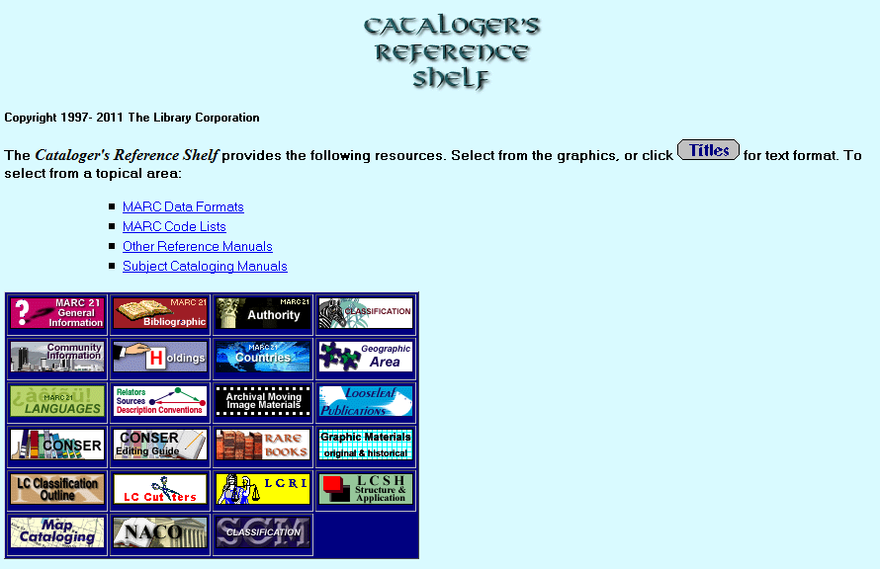
Cataloger’s Reference Shelf is an updating website, a portal site that provides primarily textual links to other sites (Type: a).

When cataloging an online integrating resource not coded “m” in Leader byte 06, always add an Electronic resource 006 with form of material code “m”.

006 (computer file):
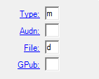

Use 007 to describe the physical characteristics (i.e., the physical carrier).

Type: | a | ELvl: | # | Srce: | c | GPub: | # | Ctrl: | # | Lang: | eng
BLvl: | i | Form: | o | Conf: | 0 | Freq: | # | MRec: | # | Ctry: | dcu
S/L: | 2 | Orig: | o | EntW: | # | Regl: | x | Alph: | #
Desc: | i | SrTp: | d | Cont: | # | DtSt: | c | Dates: | 2002, | 9999

006 | ## | $a m d
007 | ## | $a c $b r $d m $e n

Or, per the CONSER standard record coding options for fixed fields:

Type: | a | ELvl: | # | Srce: | c | GPub: | # | Ctrl: | # | Lang: | eng
BLvl: | i | Form: | o | Conf: | | | Freq: | | | MRec: | # | Ctry: | Dcu
S/L: | 2 | Orig: | | | EntW: | # | Regl: | | | Alph: | #
Desc: | i | SrTp: | d | Cont: | # | DtSt: | c | Dates: | 2002, | 9999

006 | ## | $a m (only required to code first byte)
007 | ## | $a c $b r (only required to code $a and $b)

Example 2: Everquest

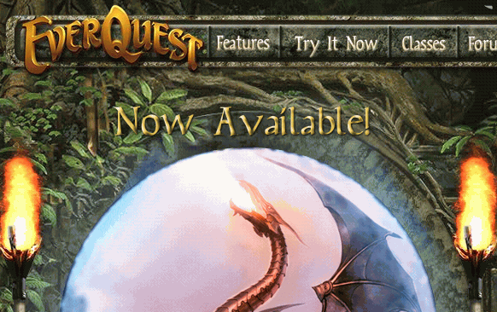

Everquest is an online game site, so the primary aspect is considered to be computer material (Type: m). Use 006 for Continuing Resources to bring out characteristics not covered in the fixed field (008) (Type: s).

006 (continuing resource):
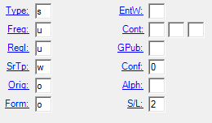

Use 007 to describe the physical characteristics (i.e., the physical carrier).

Type: |  | m |  | ELvl: | # | Srce: | c | Audn: | # | Ctrl: | # | Lang: | eng
BLvl: |  | i |  | File: | g | GPub: | # |  |  | MRec: | # | Ctry: | cau
Desc: |  | i |  |  |  |  |  | DtSt: | c | Dates: | 1999, | 9999
006 | ## |  | $a suu woo 0 2
007 | ## |  | $a c $b r $d m $e n

Example 3: Speech Archives

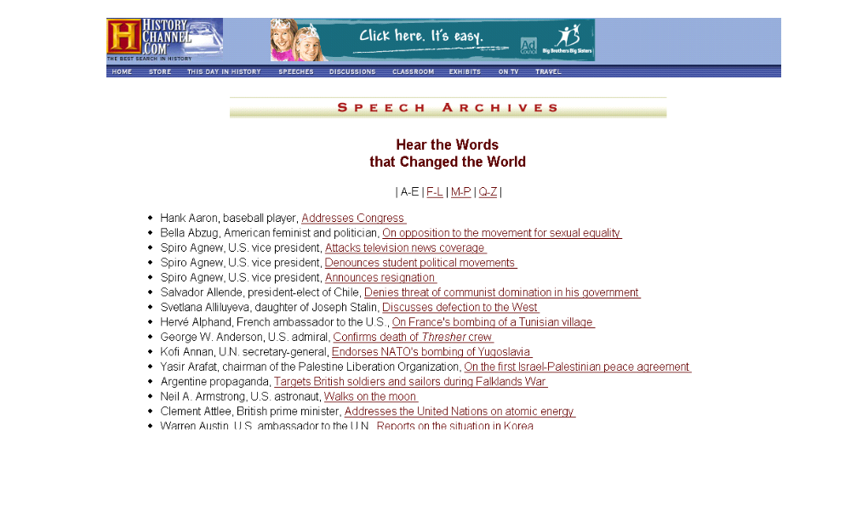

Speech Archives is an updating website that is primarily a sound resource (Type: i). When cataloging an online integrating resource not coded “m” in Leader byte 06, always add an Electronic resource 006 with form of material code “m”. Also code an additional 006 for the continuing resource characteristics.

006 (computer file): 006 (continuing resource):

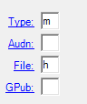
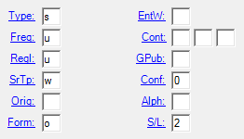

Use 007 to describe the physical characteristics (e.g., the physical carrier).

Type: | i | ELvl: | # | Srce: | c | Audn: | # | Ctrl: | # | Lang: | eng
BLvl: | i | Form: | O | Comp: | # | AccM: | # | MRec: | # | Ctry: | cau
 |  | Part: | # | TrAr: | #
Desc: | i | FMus: | # | LTxt: | # | DtSt: | c | Dates: | 1999, | 9999

006 | ## | $a m h
006 | ## | $a suu w o 0 2
007 | ## | $a c $b r $d m $e n $f a

IR.8 Subject analysis and classification

RDA contains “placeholder chapters on subject analysis: chapter 23 (General guidelines on recording the subject of a work, and related Chapters 33-37). However, as of early 2014, the Joint Steering Committee for RDA is still determining to what extent instructions for subject analysis should be included in RDA.

General guidelines are provided at RDA 0.6.7 “Recording subject relationships”:

“When recording relationships between a work and an entity that is the subject of that work, include as a minimum at least one subject relationship element. When using an access point to represent the subject entity, the access point may be formulated using either the preferred name, title, or term for the entity, or a classification number representing the entity. Formulate the access point representing the subject entity following the standards for subject access points and classification numbers used by the agency creating the data.”

Catalogers are expected to perform appropriate content analysis and to assign subject headings that accurately describe the content of the title being cataloged.

A library may use any subject heading scheme assigned a code in MARC 21 Format for Bibliographic Data.

For more information regarding the tools used and further guidance on subject analysis and classification, see the information below and refer to the appropriate sections of the BIBCO Participants’ Manual, the CONSER Cataloging Manual, and the Subject Headings Manual.

Names used as subjects must be represented by authority records in the LC/NACO Authority File. Newly-proposed LC subject headings that have been submitted as SACO proposals may be entered in bibliographic records even if they have not yet been approved by the Policy and Standards Division or do not yet appear in the LC/SACO Authority File.

IR.8.1 Classification

Provide a classification number for updating loose-leafs. Providing classification numbers for other types of integrating resources is optional, although for CONSER authenticated records, it is encouraged. A library may use any classification scheme assigned a code in MARC 21 Format for Bibliographic Data.

IR.8.2 Subject heading assignment

Assign headings that are both specific and broad enough to encompass future changes. However, assign subject headings primarily based on the current iteration because that is what is being cataloged. If the subject content changes later, change the subject headings to reflect the current iteration (see IR.8.3).

IR.8.2.1 Form and topical subdivisions; Genre/form terms
Include subject heading subdivisions as appropriate to the integrating resource being cataloged. For example, use the form subdivision $v Directories for resources that serve as directory listings.

Example: The form subdivision $v Directories is appropriate in the record for the site below.

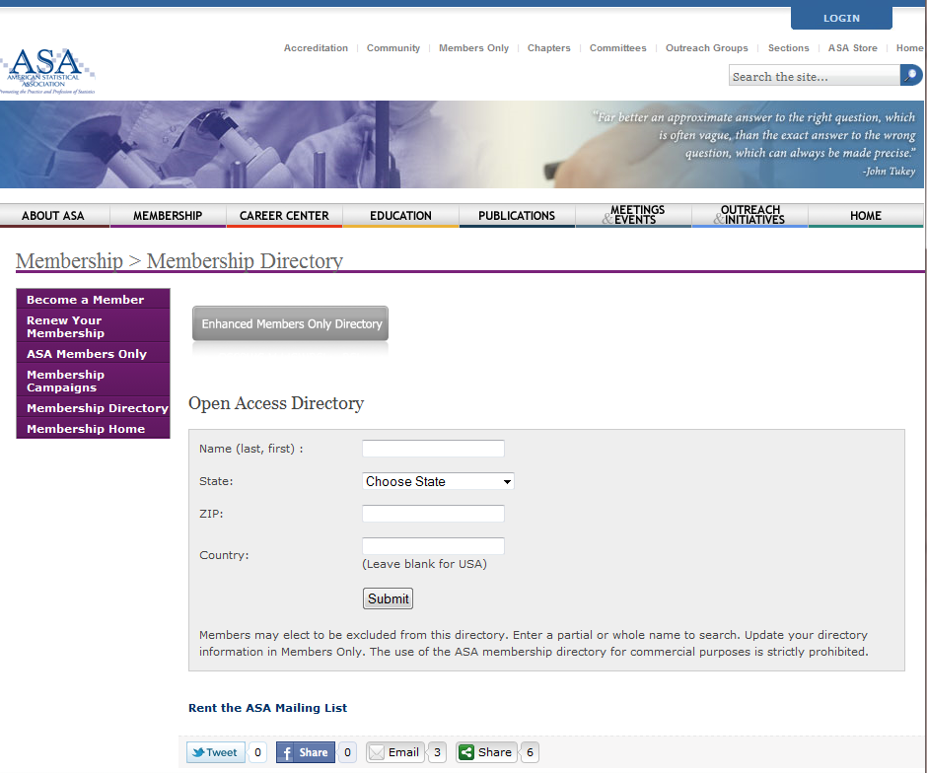

There are a few form subdivisions that are used only for electronic resources to bring out the form of the resource:

$v Blogs
$v Computer games
$v Databases (see below for more info)
$v Electronic discussion groups
$v Interactive multimedia
$v Juvenile software
$v Online chat groups
$v Software (see SHM H 2070)

The following subdivisions are authorized for use only as a topic, not as a form:

$x Computer network resources
$x Computer programs
$x Electronic information resources

Do not assign headings for the form of the resource (e.g., Online databases, websites) as topical subject headings. Such headings are used only for resources about these topics. Field 655 may be used for genre/form headings as follows:

- Authorized terms from the Library of Congress Genre/Form Terms for Library and Archival Materials (LCGFT): Use 655 with second indicator "7" and $2 lcfgt (e.g., 655 #7 Internet videos. $2 lcgft)
- Authorized terms from LCSH for disciplines that LCGFT has not yet incorporated (e.g., literature) and the LCSH scope indicates that it for works of a given type: Use 655 with second indicator "0" (e.g., 655 #0 Comic books, strips, etc.)

- Authorized terms from LCSH and the LCSH scope says that it is a heading used for works about (or on) a given topic: If a 655 is desired, use second indicator "7" with $2 local (e.g., 655 #7 Websites. $2 local)

Assign the free-floating form subdivision $v Databases only when the resource meets the following definition:

A database is a collection of logically interrelated data stored together in one or more computerized files, usually created and managed by a database management system. The data are encoded, and each file is designed with a high-level structure for accepting, storing, and providing information on demand. Typically, there is a set of definitions for the database that describe its various data elements and a set of codes to identify each element. The database may include the database management software that created the file, or it may include only the data.

Do not assign the subdivision $v Databases under subjects for electronic resources that are essentially textual in nature and are not formatted as databases, such as articles, conference proceedings, literary works, form letters.

Example: The form subdivision $v Databases is appropriate in the record for the site below. Even though the site is textual in nature, it is formatted like a database.

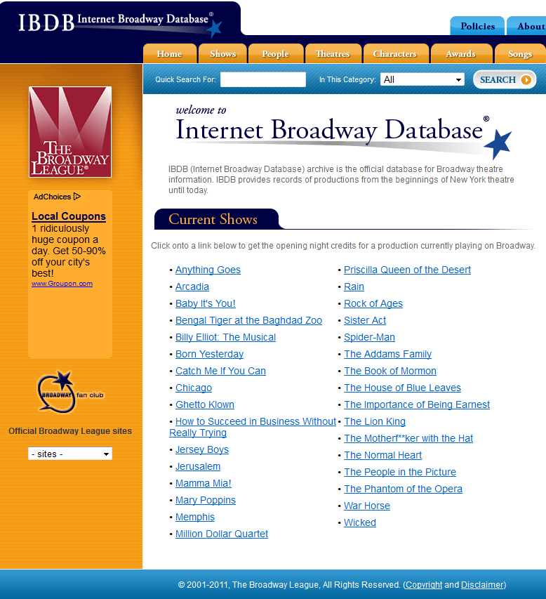
Additionally:

Do not use the subdivision --Databases for the following types of works: Computer files that have the structure of and present themselves as reference-type works, such as directories, bibliographies, catalogs, dictionaries, encyclopedias, indexes, or other similar types. Assign instead the pertinent form headings or form subdivisions under subjects.

Example: The form subdivision $v Databases is not appropriate in the record for the site below because it is an encyclopedia

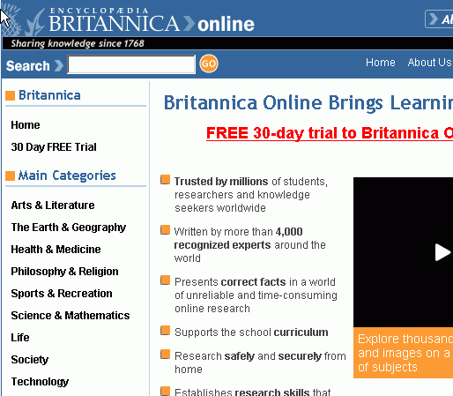

IR.8.3 Change in content of an integrating resource

When an integrating resource changes and the bibliographic record is being modified to reflect changes to the description, also check if the subject scope and content of the resource have changed.

If there are significant changes in the subject content, consider adding new subject headings to reflect the latest iteration, deleting headings no longer applicable to the current contents of the resource, and updating any contents or summary note.

IR.9 How many bibliographic records?

IR.9.1 What changes in an integrating resource require a new bibliographic record? What changes are handled by updating the existing record?

Most changes in subsequent iterations of integrating resources do not require the creation of new bibliographic records. Instead, change the bibliographic description to reflect the current iteration and retain information about the earlier iteration(s) in notes and/or access points, if considered important.

A new bibliographic record, or a new description, is also not required if a resource is subsequently or simultaneously offered by different digital service providers or publishers. Instead, add information about the other provider version(s) in notes and/or access points, if considered important, per the provider-neutral cataloging guidelines available at: http://www.loc.gov/aba/pcc/scs/documents/PCC-PN-guidelines.html. Supply dates viewed in the appropriate fields such as 246 $f.

A new bibliographic record is required in the following situations:

- A change in the mode of issuance, e.g., an integrating resource changes to a multi-part monograph or a serial (RDA 1.6.3.1)

- A change in the media type, e.g., an updating loose-leaf changes into an updating online database (RDA/LC-PCC PS 1.6.3.2)

- A new base volume or volumes is issued for an updating loose-leaf (RDA 1.6.3.3). Note: There is an extensive LC-PCC PS for 1.6.3.3 with guidelines for when to consider a reissue a new resource. Although the instructions conclude with the statement, “In case of doubt, do not make a new description,” be careful in considering the publisher’s intent.

- A change in an edition statement indicates a significant change in the scope or coverage of the integrating resource (RDA 1.6.3.4)

After creating the new record, give reciprocal linking fields in both records. See IR.6 for detailed instructions on how to enter the data in these fields.

Examples of changes in mode of issuance:

- An updating loose-leaf, called the “Second edition” of a work is reissued as a monograph, still called the “Second edition,” and now issued with pocket part supplementation.

- Updating loose-leaf was published through 2003. In 2004, publisher began issuing complete replacement volumes annually as a serial.

Example of a change in media type:
- A loose-leaf publication on international criminal law ceases in print. The publisher bases a new updating database on the last iteration of the print volumes.

Examples: Change in edition statement or issuance of new base volume or volumes

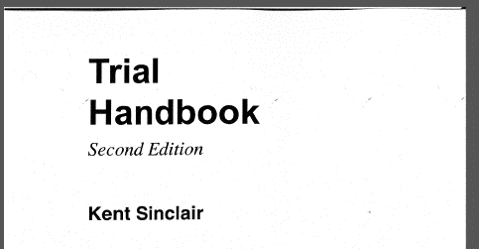

100 | 1# | $a Sinclair, Kent, $e author.
245 | 10 | $a Trial handbook / $c Kent Sinclair.
250 | ## | $a Second edition.
785 | 02 | $a Sinclair, Kent. $t Trial handbook. $b Third edition

New base volume received:

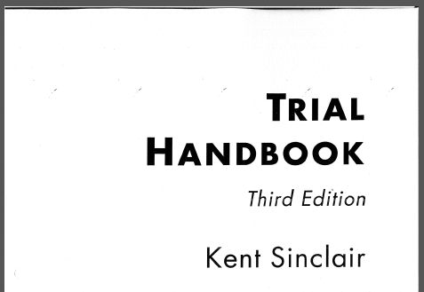

100 | 1# | $a Sinclair, Kent, $e author.
245 | 10 | $a Trial handbook / $c Kent Sinclair.
250 | ## | $a Third edition.
780 | 02 | $a Sinclair, Kent. $t Trial handbook. $b Second edition

Remember that a gradual replacement edition does not require a new record. This type of edition change occurs when the publisher issues a new title page with a new edition statement as part of an update, with no in toto replacement of the contents or issuance of a new base volume. In such a case, do not create a new record; change the edition statement to reflect the information on the current iteration and give a note about the change in edition information (see IR 2.3.1).

Example: Gradual replacement edition

250 | ## | $a Fourth edition.
500 | ## | $a Updated to fourth edition, <July 2012>.

IR.9.2 How are loose-leaf services handled?

A loose-leaf service is issued in several component parts, often in a combination of updating loose-leaf and bound volumes containing both primary and secondary source material. Sometimes a loose-leaf service is called a reporter.

Generally, consider the loose-leaf service as a whole to be an integrating resource and create only one bibliographic record for the service as a whole. Provide notes about the component parts in enough detail to identify them.

500 | ## | $a Service contains binders: Finding aids, Master index; Statutes, treaties; FCC rules & NPRMs; Cases; Digest.

500 | ## | $a The service includes: Decisions (later published in bound volumes as International trade reporter decisions); and BNA's international trade reporter (previously issued as International trade reporter and Current reports). In July 1984, International trade reporter's U.S. import weekly and International trade reporter's U.S. export weekly (earlier title: International trade reporter's survey and analysis of current developments) merged to form Current reports.

The following often comprise component parts of loose-leaf services:

- Pamphlets/paperbacks

Pamphlets and paperbacks received as part of a loose-leaf service subscription generally contain current information of temporary or permanent value. Such publications are keyed to a section or a service or to several services. In addition to individual, distinctive titles, they carry also the title of the service and the numbering of a section of the service (usually a supplementary bulletin, to which is added a further distinguishing characteristic such as the words "Extra," "Section 2," etc. (e.g., "Bulletin 35, Extra" or "Report bulletin 24, Volume LIII (Section 2)."

Although these publications are often indexed in the service, they are unsuitable for filing into the service. If such a publication is considered of permanent value, create a separate record for it. Apply cataloger judgement when considering inclusion of notes and/or authorized access points indicating a relationship to the service, e.g., pamphlet or paperback may be distributed to more than one service, in this case, a note and authorized access point in the bibliographic record for the pamphlet/paperback indicating the relationships to the services may not be appropriate.

PCC participants create a series-like phrase series authority record when these publications appear to be volumes in a monographic series (see LC-PCC PS 0.0 for details).

- Sections with independent numeric or chronological designations

Latest developments in a particular field are often reported and analyzed in special sections of a loose-leaf service. These sections are typically called Bulletin, Newsletter, Report bulletin, Report, etc., and are for the most part indexed in the service. They carry a numeric or chronological designation of their own. Information of permanent value from these sections is often later included in the main text and old issues can be periodically discarded or transferred.

Do not create a separate record for the sections. Instead give a note and an access point for the section(s) in the bibliographic record for the service.

500 | ## | $a Includes separately numbered section: Hospitals and health care organizations. Bulletin.
740 | 02 | $a Hospitals and health care organizations. $p Bulletin.

500 | ## | $a Includes master binder (1 v.) which contains indexes and separately numbered bulletin: Multistate tax report.
740 | 02 | $a Multistate tax report.

- Transfer volumes

A transfer volume is a bibliographic unit containing material of a permanent nature originally issued as a section or binder of a loose-leaf service. The material is transferred from the loose-leaf mode by one of the following methods: the material is reissued by the publisher in bound form and sent to the subscriber as part of a subscription or made available for separate purchase; the material is transferred from the original loose-leaf mode to permanent binders (sometimes supplied by the publisher); or the material is bound separately by the subscriber.

Generally, do not create a separate bibliographic record for the transfer material. Instead, on the bibliographic record for the service, give a note explaining the inclusion of transfer material of permanent value. If the transfer section has a title of its own or acquires a title of its own in its transferred/bound stage, cite the title in the note and give an access point.

500 | ## | $a Material of permanent value is removed periodically and bound in separate volumes.
500 | ## | $a Material of permanent value is transferred from time to time to storage binders.

500 | ## | $a Decisions from state and federal courts are removed periodically and issued in bound volumes with title: Copyright law decisions.
740 | 02 | $a Copyright law decisions.

If a separate bibliographic record is created for the transfer material, include an authorized access point and a note if needed to explain the relationship to the updating loose-leaf.

245 | 00 | $a Employment practices decisions.
500 | ## | $a The court decisions in these bound volumes are reprinted from the loose-leaf publication: Labor law reports: employment practices.
730 | 0# | $a Labor law reports. $p Employment practices.

IR.9.3 Duplicate records

Duplicate records are two or more bibliographic records describing the same bibliographic resource, ostensibly in the same manner. See section IR.10. 1 for specific guidelines on selecting an appropriate provider neutral record to authenticate and reporting duplicates for deletion.

When duplicate records of a type not permitted are discovered, PCC members should select which record to retain and take steps to report the duplicates for deletion.

Some types of multiple records for a resource are permitted in OCLC. Do not report as duplicates:
- A single part of an integrating resource that is cataloged separately from the resource as a whole (e.g., one sub-page of a larger website)
- Records cataloged in different languages for the same manifestation. These are considered parallel records.

IR.9.3.1 LC monograph records for integrating resources
The steps for replacing LC monograph records for integrating resources with PCC-authenticated continuing resource records involve a short period of overlap/duplication in OCLC. OCLC converts LC monograph records and reports them to LC. These records have instructions for PCC catalogers in the 936 field to notify LC with old/new LCCN. For these records, PCC catalogers are asked to:
- Add a new LCCN to 010 $a (leave any LCCN that are in $z of the 010)
- Add 042 with code "pcc"
- Edit the note in the 936 to say: Converted LC monograph record
- Report the new and old LCCN to srdcat@loc.gov
For LC monograph records that have not been converted by OCLC, PCC catalogers are asked to create, derive, or authenticate an existing integrating resource record and to report the OCLC and LCCN of this and the LC monograph record to LC at srdcat@loc.gov. LC will perform work necessary to remove the monograph record from the Cataloging Distribution Service (CDS) MDS-BOOKS file and will send a delete record transaction to OCLC. The deleted LC monograph record will appear as ELvl J in OCLC.
Detailed instructions for both of the above procedures are available at: http://www.loc.gov/aba/pcc/conser/issues/IR-form.html.
If the duplicate record is an authenticated record in the continuing resource format, catalogers should follow the steps in 11.3.3 to delete the duplicate from the continuing resources file distributed by CDS and report the duplicate to OCLC for deletion from WorldCat. If there is doubt about whether or which authenticated record should be deleted, the cataloger can consult with the PCC library that input the record in question. For example, a publisher may issue an annual volume of literary criticism and an integrating resource version in which the content is only retrievable by a search on article title, author, or keyword. A serial record representing a HathiTrust digitized version of the print resource would not be a duplicate of the record representing the publisher’s integrating resource version.

If the duplicate record is unauthenticated, report it and the corresponding preferred record directly to the OCLC Quality Control Section, whose staff will evaluate the report, delete any duplicate records, and merge the holdings of the duplicate record to the preferred record. Records may be reported to OCLC through the WorldCat and Authority Record Quality Control Request Webpage: https://www.oclc.org/forms/record-quality.en.html, via email to bibchange@oclc.org (with subject line: IR duplicates), and via the OCLC Connexion Report Error function. No accompanying documentation is necessary.

IR.9.3.2 Selecting the record to retain
- For textual integrating resources, prefer to choose records that are in the continuing resources format (Type code a, BLvl code i).
- For nontextual integrating resources (e.g., a sound recording), choose a record that is appropriate to the type of material (Type codes c, e, g, i, j, k, m, o, r).
- Choose an authenticated record: 042 = pcc
- Choose the record that adheres most closely to RDA description and access points.
- Choose the record that reflects the most current iteration.
- Choose the record with the most information.

IR.9.3.3 Deleting and reporting duplicate authenticated continuing resource records

Once it is clear that the record should be deleted, the duplicate record must be deleted from the CONSER file distributed by the CDS. All CONSER serial records and PCC integrating resource records are distributed through CDS and duplicates must be deleted through the following steps:

- Lock the record in OCLC. (Optional)
- Add field 012 $z d.
- Replace the record.
- Relock the record. (Optional)
- Remove field 042.
- Add field 936 "RECORD REPORTED FOR DELETION--USE # ..."
- Replace record and delete holdings.
- Report the record to OCLC for deletion.
- Record canceled LCCN in 010 $z of the record being retained.

IR.10 Provider-neutral record for online integrating resources

The provider-neutral record policy is limited to online integrating resources that are available simultaneously from two or more different electronic service providers (one of which may or may not be the original publisher) but are essentially the same resource and consist of the same content (see also IR.9.3 for identifying duplicate records). When there is a significant difference in the content of the online IRs to distinguish them as different works, the provider-neutral policy should not be applied. For example, search interfaces in another language or web pages with “translated” content equivalent to the main, original language should not be confused with separate language editions which have named editions or separate ISSNs (see IR.2.1.1.5).

The provider-neutral policy focuses on providing a bibliographic description of an integrating resource as issued by the publisher or other original source (such as a scholarly society or non-profit organization) of the content. The record representing the online version contains information applicable to all versions being distributed by all electronic service providers, including information specific to the original issuing body if the nature of the relationship between the body and the resource is significant (RDA 18.2).

The provider-neutral record does not contain information specific to electronic service providers with the exceptions of citing the source upon which the description was based and providing access points for variant titles that some providers use for the resource. Electronic service providers’ names are not given as authorized access points or as additions to authorized access points representing works or expressions, or mentioned in issuing body notes. Notes about access restrictions, format, or system requirements specific to particular providers also are not given. As CONSER/BIBCO catalogers consolidate existing multiple records for an online IR, the URL of all versions will be given on the remaining record.

The Provider-Neutral MARC Record E-Resource Guide can be found here:
http://www.loc.gov/aba/pcc/scs/documents/PN-RDA-Combined.docx

IR.10.1 Guidelines for record creation and record consolidation: provider-neutral record

Base a provider-neutral description on the following, in this preferred order:
- Original publisher's (creator of content) site
- Host (other provider version)

MARC field | Instructions
008 | Code as for any online IR.
040 | $e pn (following $b)
022 | Give the ISSN of the electronic integrating version in $a; give the linking ISSN in $l; give the ISSN of the print in $y
130/240 | Assign as for any IR, per LC-PCC PS 6.27.1.9
245 | Record the title from the preferred source of the current iteration.
246 | Record variant titles as for any IR
246 1# | $i Available from some providers with title: $a [Title]
246 11 | $a [German parallel title]
250 | Record only edition statements originating from the original publisher; ignore statements that pertain specifically to provider versions.
256 | Do not use in original cataloging. For copy cataloging, retain the information if it still characterizes the resource.
264 #1 or 264 31 | $a, $b, $c Record the first named place and publisher in the current online iteration (do not confuse an electronic service provider with an original publisher or other original source). The place/publisher should be applicable to all online versions and thus, should not reflect a particular digitizer or provider version or interface. Dates if given, as much as possible, should be based on content from the original publisher and be applicable to all provider versions.
310 | Generally include if the frequency of updates is dictated by the original publisher/society and is readily ascertainable
362 #1 | Record beginning and ending dates per instructions and CONSER/BIBCO practice. This information should be based on content from the original publisher and be applicable to all provider versions (see also 264)
490, 8XX | Do not treat provider names as series statements in the provider-neutral record.
500/520 | General notes for the most part should be applicable to all providers.
500 | Source of title note: See 588 field
500/550 | Do not note electronic service providers, e.g., providers that digitize the resource.
506 | Do not use, unless restrictions apply to all versions and formats of the IR. An example is a "classified" government document for which access is always restricted. If specific access restrictions are considered useful in the CONSER/BIBCO record, give in $z of field 856.
538 | Equipment or system requirement (RDA 3.20) Give equipment or system requirements notes only when all provider versions require special software or technical conditions.
588 | Iteration used as the basis for the identification of the resource (RDA 2.17.13.4); source from which the title proper is taken and date the resource was viewed (RDA/LC-PCC PS 2.17.2.3). These attributes are usually combined in one 588 field, e.g., Description based on contents viewed on June 14, 2013 (National Archives); title from caption on HTML home page.
710/730 | Do not give authorized access points for the name of electronic service providers.
776 | Add linking field for known versions in other formats when there is a record to link to. Include the corresponding ISSN when available.
856 | Give the applicable URLs for current iterations. Optionally, provider names and different coverage dates may be given in $3.

Record Consolidation and Deleting Duplicates

If multiple records exist for a title describing it as a part of several provider packages, one record should be selected for PCC authentication and the others reported for deletion. Note however in some instances online resources are issued by some providers as serials and by others as integrating resources. For example, the HathiTrust Digital Library may digitize encyclopedic volumes as discrete issues, while the original publisher of the print version may provide access to the electronic version as an integrating resource. In this case, both records are valid. If this is not the case, select one record to maintain.

- Prefer a PCC record if one is available. If there are multiple PCC records, prefer a record authenticated by NSDP or ISSN Canada (see also IR.9.3.2).

- If there is a CONSER serial record and a PCC authenticated record for the same resource treated as an integrating resource, consult with the authenticating library if necessary to determine if the resource being described meets the definition of a serial or an integrating resource.

- Add the URL of the provider version for which you are providing access and/or copy 856 fields from the records you are reporting for deletion to the record you are keeping. Follow PCC Provider Neutral Guidelines, using URLs ($u) that are general (not institution specific).

- Remove fields that are provider specific, e.g., 710/730 or 440 for provider names; notes which only apply to one provider.

- Authenticate the record if it is not a CONSER/BIBCO record; report the other records as duplicates (see IR.9.3).

IR.10.2 Some examples of original source creator (publisher, society, institution, etc.) vs. service provider or host

AGRICOLA (source: National Agriculture Library; also available via ProQuest, EBSCO, etc.)

Medline (source: National Library of Medicine; also available via OCLC, EBSCO, OVID, ProQuest)

PAIS international (source: Cambridge Scientific Abstracts; available via ProQuest and OCLC)

Art index/fulltext/abstracts (source: Wilson; also available via EBSCO)

Sociological abstracts (source: CSA; available via ProQuest)

ERIC (source: U.S. Department of Education; also available via EBSCO, OCLC, and ProQuest)

OCLC Connexion browse results for title “Agricola” to illustrate the present situation (multiple records)

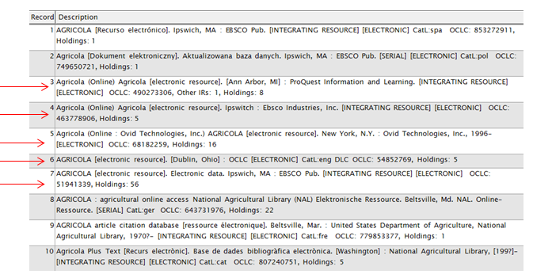

Mock-up of merged record to illustrate a record consolidation following provider-neutral guidelines. The bibliographic description is based on the original creator‘s version.

Type: |  | a |  | ELvl: | # | Srce: | c | GPub: | f | Ctrl: |  | Lang: | eng
BLvl: |  | i |  | Form: | o | Conf: | 0 | Freq: | d | MRec: |  | Ctry: | mdu
S/L: |  | 2 |  | Orig: |  | EntW: |  | Regl: | r | Alph:
Desc: |  | i |  | SrTp: | d | Cont: |  | DtSt: | c | Dates: | 1970, | 9999
006 | ## |  | $a m o e f
007 | ## |  | $a c $b r $d m $e n
040 | ## |  | $a CIN $b eng $e rda $e pn $c CIN $d GPO
010 | ## |  | $a 2013000000
042 | ## |  | $a pcc
050 | 14 |  | $a S494.5.A8
086 | 0# |  | $a A 17.2:Ag 8/3/
110 | 2# |  | $a National Agricultural Library (U.S.), $e compiler.
245 | 10 |  | $a NAL catalog / $c United States Department of Agriculture, National Agricultural Library.
246 | 33 |  | $a NAL catalog (AGRICOLA)
246 | 1# |  | $a AGRICultural OnLine Access
246 | 1# |  | $i Available from some providers with title: $a AGRICOLA
247 | 10 |  | $a AGRICOLA $f <December 4, 1998>
264 | 31 |  | $a [Beltsville, MD.] : $b National Agricultural Library, $c [1970]-
300 | ## |  | $a 1 online resource
310 | ## |  | $a Updated daily
336 | ## |  | $a text $b txt $2 rdacontent
337 | ## |  | $a computer $b c $2 rdamedia
338 | ## |  | $a online resource $b cr $2 rdacarrier
362 | 1# |  | $a Began in 1970.
520 | ## |  | $a The NAL Catalog (AGRICOLA) is organized into two bibliographic datasets: the NAL Online Public Access Catalog and the Article Citation database. The records describe publications and resources encompassing all aspects of agriculture and allied disciplines, including animal and veterinary sciences, entomology, plant sciences, forestry, aquaculture and fisheries, farming and farming systems, agricultural economics, extension and education, food and human nutrition, and earth and environmental sciences. Although the NAL Catalog (AGRICOLA) does not contain the text of the materials it cites, thousands of its records are linked to full-text documents online.
588 | ## |  | $a Description based on contents viewed on August 29, 2013 (NAL website); title from home page.
610 | 20 |  | $a National Agricultural Library (U.S.) $v Catalogs.
650 | #0 |  | $a Agriculture $v Indexes.
650 | #0 |  | $a Agriculture $v Bibliography.
856 | 40 |  | $u http://agricola.nal.usda.gov
856 | 40 |  | $3 EBSCOhost $u http://search.epnet.com/login.asp?profile=web&defaultdb=agr
856 | 40 |  | $3 ProQuest $u http://www.csa.com/htbin/dbrng.cgi?username=  dart72&access=dart7272&cat=Agricola
856 | 4# |  | $z Link no longer valid as of August 29, 2013 $u http://webspirs.silverplatter.com/cgi-bin/customers/c42839/c42839b.cgi
856 | 4# |  | $z Link no longer valid as of August 29, 2013 $u http://www.nal.usda.gov/ag98/

Original publisher source of information:

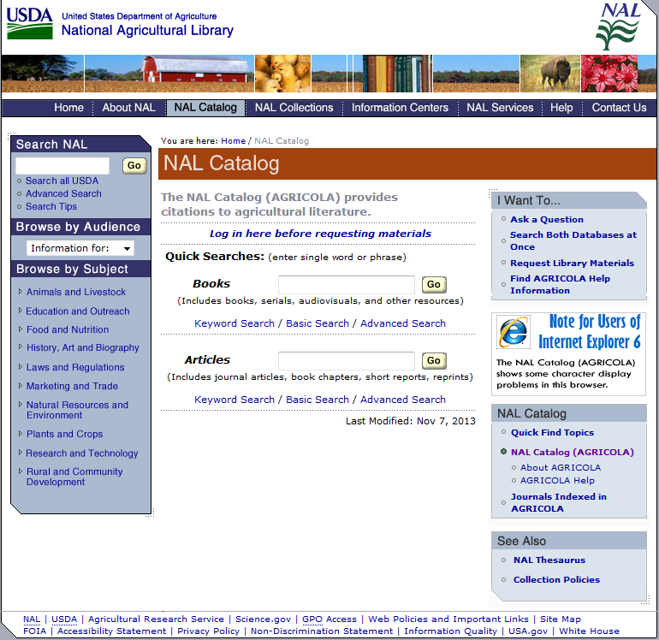

NAL About Page:

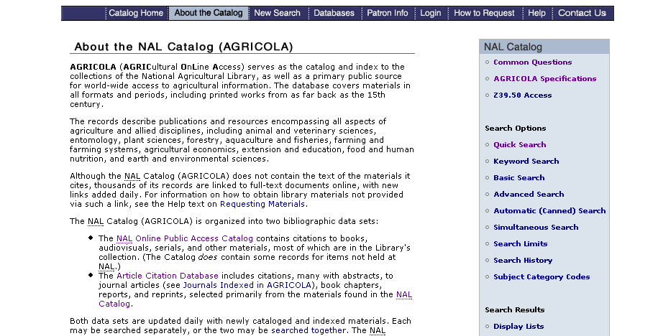

EBSCOhost version: Cataloger has access to this provider’s version; institution is paying for access. However, the original publisher version is freely available.

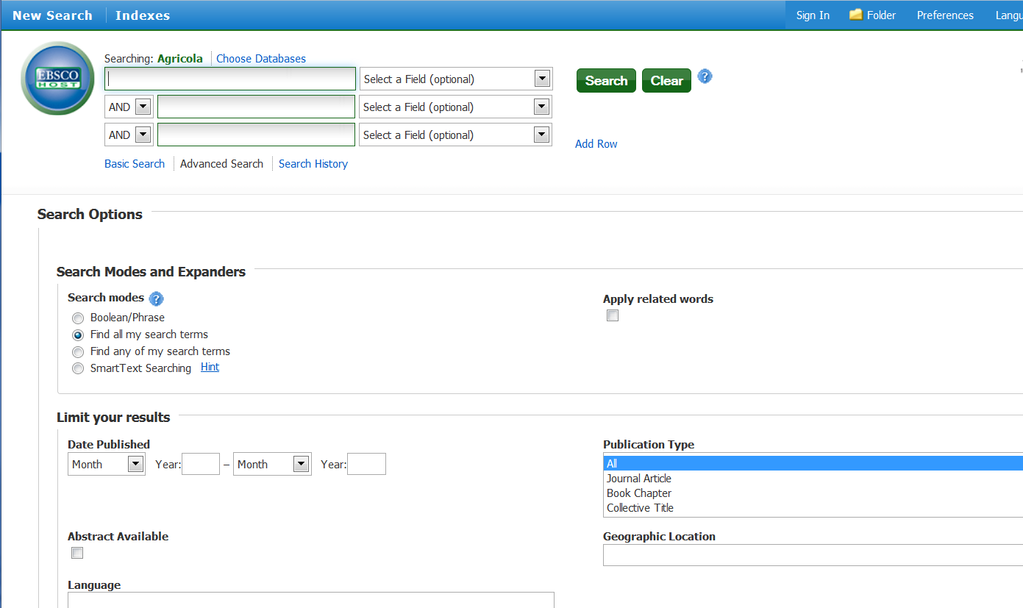

EBSCOhost About page:

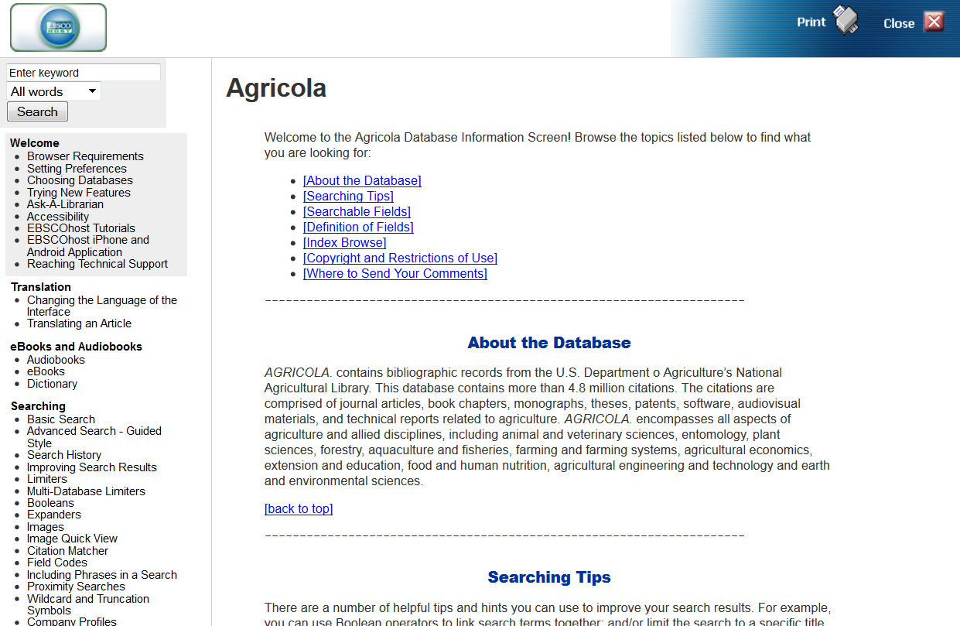

IR.11 Full record examples

Disclaimer:

The records that follow may or may not match current cataloging records in OCLC for the resources shown. These records have been purposely edited to illustrate common examples of cataloging issues for integrating resources. Do not use them as guides for cataloging, either for the resources being represented or for similar resources. Always refer to the instructions in RDA, the LC-PCC PSs (as applicable), and guidelines found elsewhere in this manual.

In the cataloging records provided here, when changes have been made to the bibliographic record, they appear in boldface.

Title: IMF eLibrary data
Online integrating resource cataloged as a computer file (original record, RDA)

Title: Africana.com
Online integrating resource with changes over time (original record, RDA)
(various iterations viewed via Internet Archive Wayback Machine)

Title: Canadian Curling Association
Online integrating resource with changes over time (AACR2 RDA)

Title: Rock’s back pages
Online integrating resource with text and audio files (original record, RDA)

Title: Formation and financing of emerging growth companies (original record, RDA)
Updating loose-leaf with accompanying material

Title: Manning on estate planning
Updating loose-leaf with change of edition requiring a new record (AACR2 RDA)

Title: Law of confessions
Updating loose-leaf with change in mode of issuance requiring a new record (AACR2 RDA)
Title: IMF eLibrary data
Online integrating resource cataloged as a computer file (original record, RDA)

Figure 1

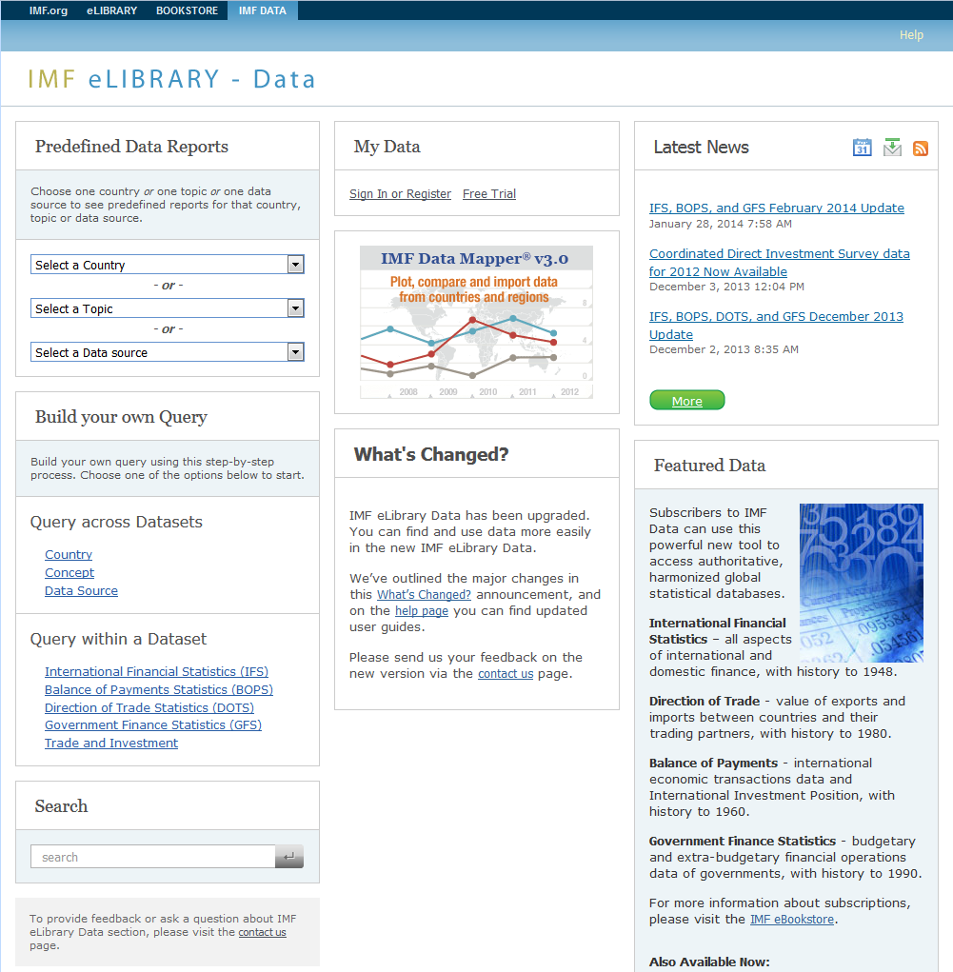

Description of resource:

This resource provides access to 4 statistical databases: International Financial Statistics, Balance of Payments Statistics, Direction of Trade Statistics, and Government Finance Statistics. The statistical data, which is mostly numeric, is available as predefined data reports or can be manipulated to create more customized reports or datasets.
Title: IMF eLibrary data
Online integrating resource cataloged as a computer file (original record, RDA)

Bibliographic record created for Figure 1:

Type: |  | m |  | ELvl: | # | Srce: | c | Audn: | # | Ctrl: | # | Lang: | eng
BLvl: |  | i |  | Form: | o | GPub: | # |  |  | MRec: | # | Ctry: | dcu
Desc: |  | i |  | File: | a |  |  | DtSt: | c | Dates: | 2011, | 9999
006 | ## |  | $a smr doos 0 2
007 | ## |  | $a c $b r
010 | ## |  | $a 2014XXXXXX
040 | ## |  | $a RRR $b eng $e rda $c RRR $d RRR $d CUS
042 | ## |  | $a pcc
050 | 14 |  | $a HG3881
110 | 2# |  | $a International Monetary Fund, $e compiler.
245 | 10 |  | $a IMF eLibrary data.
246 | 1# |  | $a International Monetary Fund eLibrary data
246 | 1# |  | $a IMF eLibrary statistics
246 | 1# |  | $a IMF data
247 | 10 |  | $a IMF eLibrary $f <April 12, 2011>
264 | 31 |  | $a Washington, D.C. : $b International Monetary Fund, $c [2011?]-
300 | ## |  | $a 1 online resource
310 | ## |  | $a Updated monthly
336 | ## |  | $a computer dataset $b cod $2 rdacontent
336 | ## |  | $a text $b txt $2 rdacontent
337 | ## |  | $a computer $b c $2 rdamedia
338 | ## |  | $a online resource $b cr $2 rdacarrier
506 | ## |  | $a Access restricted to subscribers.
520 | ## |  | $a Provides comprehensive access to International financial statistics (IFS), Balance of payments statistics (BOPS), Direction of trade statistics (DOTS), and Government finance statistics (GFS) databases. View and download predefined data reports or create and share your own views of IMF data.
588 | ## |  | $a Description based on contents viewed on January 28, 2014; title from home page.
650 | #0 |  | $a International finance $v Statistics $v Databases.
740 | 02 |  | $a International financial statistics.
740 | 02 |  | $a Direction of trade statistics.
740 | 02 |  | $a Balance of payments statistics.
740 | 02 |  | $a Government finance statistics.
856 | 40 |  | $u http://elibrary-data.imf.org

Comments:
The content of this site is primarily manipulable numeric data (Leader/06 value “m”) with some text. A 006 is added for the continuing aspects of the integrating resource and SrTp is coded “d” since this is an updating database. The content type (336 field) is recorded for both the numeric (primary) and textual (secondary) aspects of the database. If a cataloger had decided that the content was primarily textual, the Leader/06 value would be coded “a” and a 006 would have been added for the electronic aspects. In either case, the form subdivision $v Databases would be used with the subject headings.
Title: Africana.com
Online integrating resource with changes over time (original record, RDA)

Figure 1: November 8, 1999 iteration (viewed via Internet Archive Wayback Machine)

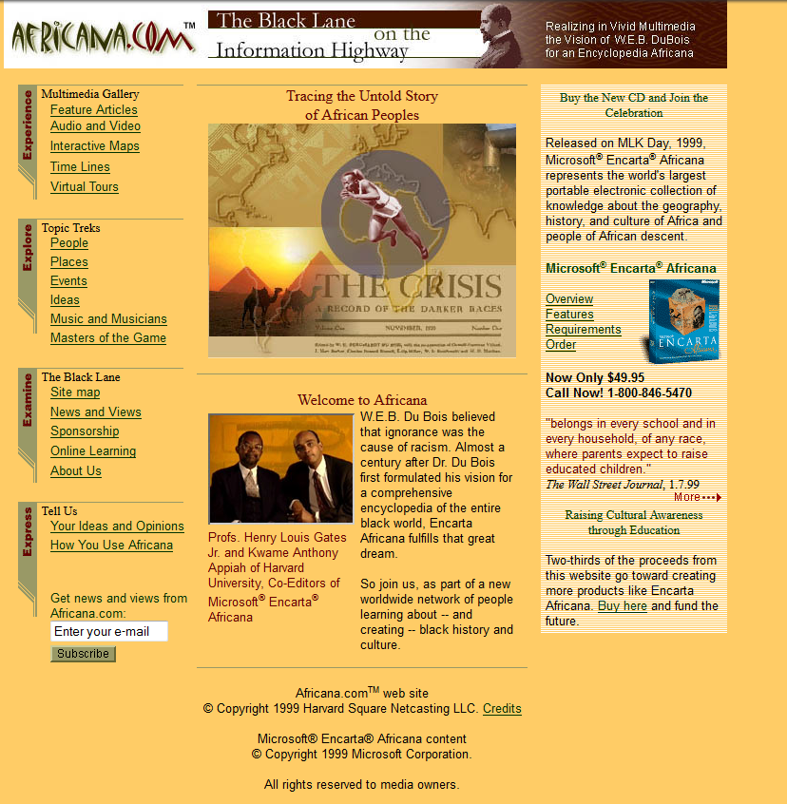

Description of resource:

This informational website contains links to interactive maps, and audio and visual material, but the primary content appears to be textual (language material).
Title: Africana.com
Online integrating resource with changes over time (original record, RDA)

Figure 2: August 14, 2000 iteration (viewed via Internet Archive’s Wayback Machine)

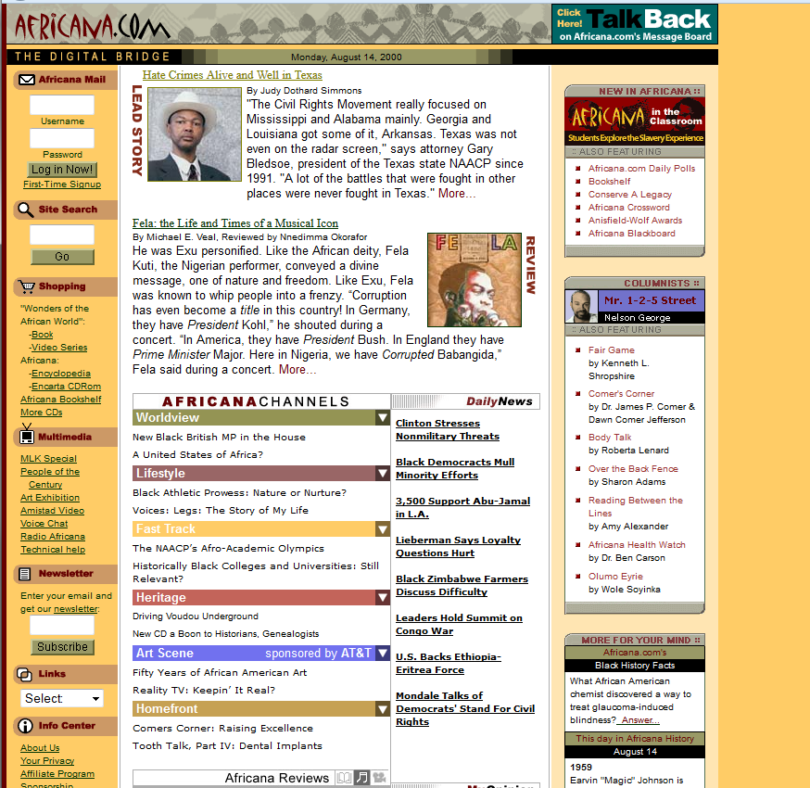

Description of resource:

This is a later iteration which shows a change in the subtitle.
Title: Africana.com
Online integrating resource with changes over time (original record, RDA)

Figure 3: Iteration viewed on January 27, 2014

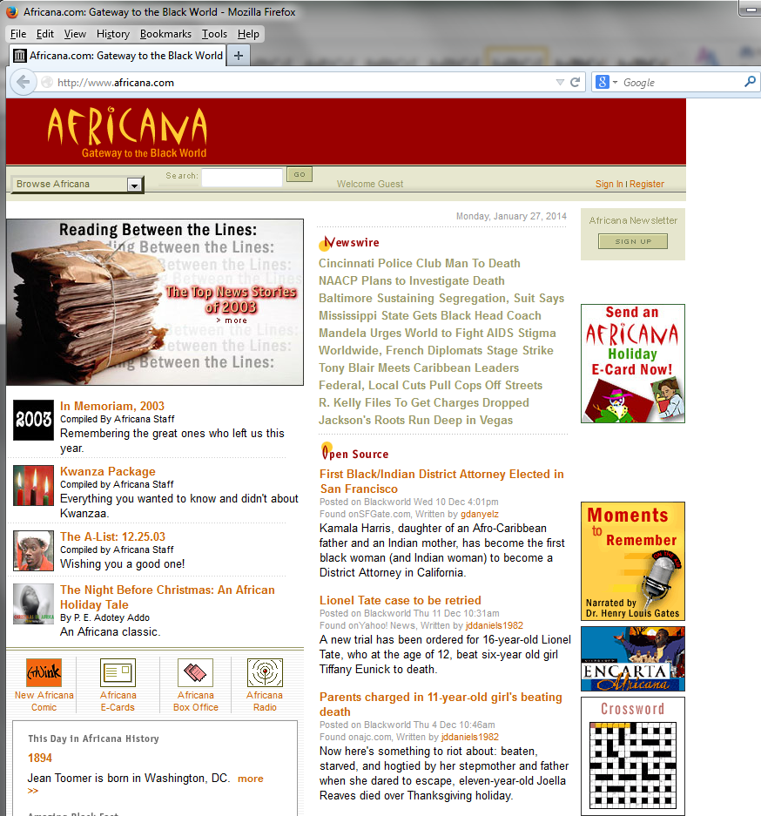

Description of resource:

This is yet a later iteration, in which both the title and the subtitle have changed.
Title: Africana.com
Online integrating resource with changes over time (original record, RDA)

Bibliographic record created for Figures 1-3:

Type: |  | a |  | ELvl: | # | Srce: | c | GPub: | # | Ctrl: | # | Lang: | eng
BLvl: |  | i |  | Form: | o | Conf: | | | Freq: | | | MRec: | # | Ctry:
S/L: |  | 2 |  | Orig: | | | EntW: | # | Regl: | | | Alph: | #
Desc: |  | i |  | SrTp: | w | Cont: | # | DtSt: | c | Dates: | 1999, | 9999
006 | ## |  | $a m d
007 | ## |  | $a c $b r
010 | ## |  | $a
040 | ## |  | $a XXX $b eng $e rda $c XXX $d XXX
042 | ## |  | $a pcc
043 | ## |  | $a n-us---
050 | 14 |  | $a E185
245 | 00 |  | $a Africana : $b gateway to the Black world.
246 | 1# |  | $i Title from HTML header: $a Africana.com
246 | 1# |  | $1 Subtitle: $a Gateway to the Black world
246 | 1# |  | $i Subtitle: $a Black lane on the information highway  $f <November 8, 1999>
246 | 1# |  | $i Subtitle: $a Digital bridge $f <August 14, 2000>
247 | 10 |  | $a Africana.com $f <November 8, 1999-August 14, 2000>
264 | 31 |  | $a [United States] : $b Africana.com, $c [1999]-
300 | ## |  | $a 1 online resource
336 | ## |  | $a text $b txt $2 rdacontent
337 | ## |  | $a computer $b c $2 rdamedia
338 | ## |  | $a online resource $b cr $2 rdacarrier
520 | ## |  | $a Geography, history, and culture of Africa and its influence in the United States; also, people of African descent in the United States.
588 | ## |  | $a Description based on contents viewed on January 27, 2014; title from home page.
650 | #0 |  | $a African Americans $x Social life and customs.
651 | #0 |  | $a United States $x Civilization $x African American influences.
856 | 40 |  | $u http://www.africana.com
Comments:

The cataloger discovered numerous bibliographic records for various iterations of this website in the shared database, and decided to recatalog the resource in RDA, based on the current iteration. Using information gathered from the other records (which were reported as duplicates when applicable), and also confirming changes in access points in the Wayback Machine, this record was constructed reflecting the website over time.

The earlier title proper is noted in 247 field. Earlier and current subtitles are considered valuable for access, so are noted in 246 fields (they are also retained because they were access points in some of the other records for this title). HTML source titles are also noted in 246 fields (also considered valuable for access). Note also that since this is an updating website, SrTp in the fixed field is coded “w.”
Title: Canadian Curling Association
Online integrating resource with changes over time (AACR2 RDA)

Figure 1: Website as viewed (and cataloged) on June 15, 2002

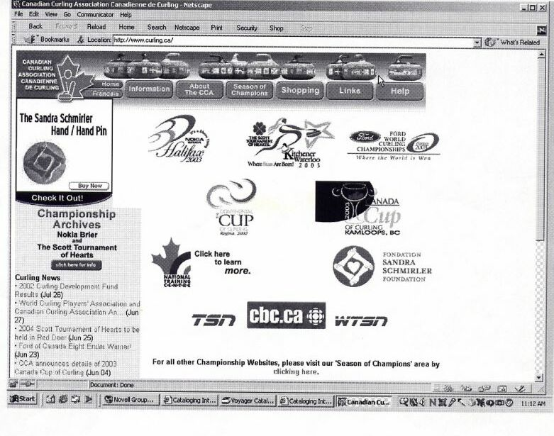

Description of resource:

Website sponsored by the Canadian Curling Association, containing information about the sport of curling, competition information, upcoming events, tournament results, and other information about the sport of curling in Canada. Very little of the site is devoted to information relating to the Association itself; therefore, it would receive a title main entry as cataloged per AACR2, and would have an AAP based on the title proper if cataloged according to RDA.
Title: Canadian Curling Association
Online integrating resource with changes over time (AACR2 RDA)

Figure 2: Website as viewed (and catalog record updated) on April 19, 2003



Description of resource:

Note that the title of this website has changed. When cataloged in AACR2, the record was updated to reflect the new title.
Title: Canadian Curling Association
Online integrating resource with changes over time (AACR2 RDA)

Bibliographic record (AACR2) cataloged for Figure 1, and later updated for Figure 2:

Type: |  | a |  | ELvl: | # | Srce: | c | GPub: | # | Ctrl: | # | Lang: | eng
BLvl: |  | i |  | Form: | o | Conf: | | | Freq: | u | MRec: | # | Ctry: | onc
S/L: |  | 2 |  | Orig: | | | EntW: | # | Regl: | u | Alph: | #
Desc: |  | a |  | SrTp: | w | Cont: | # | DtSt: | c | Dates: | 1999, | 9999
006 | ## |  | $a m d
007 | ## |  | $a c $b r
010 | ## |  | $a
040 | ## |  | $a XXX $b eng $c XXX $d XXX
041 | 0# |  | $a eng $a fre
042 | ## |  | $a pcc
043 | ## |  | $a n-cn---
050 | 14 |  | $a GV845
245 | 00 |  | $a Curling.ca $h [electronic resource] / $c Canadian Curling Association.
246 | 11 |  | $a Association canadienne de curling $f <June 15, 2002>
247 | 10 |  | $a Canadian Curling Association $f <June 15, 2002>
260 | ## |  | $a Cumberland, Ont. : $b Canadian Curling Association
362 | 1# |  | $a Began in 1999?
546 | ## |  | $a May be viewed in English or French.
500 | ## |  | $a Title from home page (viewed Apr. 19, 2003).
650 | #0 |  | $a Curling $z Canada.
650 | #0 |  | $a Curling $x Tournaments $x Canada.
710 | 2 |  | $a Canadian Curling Association.
856 | 40 |  | $u http://www.curling.ca/

Comments:

When the site was viewed again, the title proper had changed, so the earlier title proper was moved to a 247 field, and the existing 246 field for the parallel title was adjusted to reflect the fact that the parallel title was associated with an earlier iteration. It could also have been edited thus:

246 | 11 | $i Former parallel title: $a Association canadienne de curling $f <June 15, 2002>

The date viewed in the source of title note was updated to reflect the most recent iteration.

Note that this record reflects AACR2 cataloging conventions not carried over into RDA, for example, use of the general material designation (245 $h) and no “Description based on” note (588). The record also contains standard AACR2 abbreviations, and the former MARC tag 260, which is now 264, and more often seen in RDA records.

Title: Canadian Curling Association
Online integrating resource with changes over time (AACR2 RDA)

Figure 3: Website as viewed on January 24, 2014



From HTML source code:

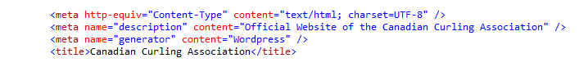

Description of resource:

Note that at some point this website returned to the original title, also reflected in the HTML title.
Title: Canadian Curling Association
Online integrating resource with changes over time (AACR2 RDA)

Bibliographic record updated for Figure 3:
(Converted to RDA)

Type: |  | a |  | ELvl: | # | Srce: | c | GPub: | # | Ctrl: | # | Lang: | eng
BLvl: |  | i |  | Form: | o | Conf: | | | Freq: | | | MRec: | # | Ctry: | onc
S/L: |  | 2 |  | Orig: | | | EntW: | # | Regl: | | | Alph: | #
Desc: |  | i |  | SrTp: | w | Cont: | # | DtSt: | c | Dates: | 1999, | 9999
006 | ## |  | $a m o d
007 | ## |  | $a c $b r
040 | ## |  | $a XXX $b eng $e rda $c XXX $d XXX
042 | ## |  | $a pcc
010 | ## |  | $a
022 | ## |  | $a
043 | ## |  | $a
050 | 14 |  | $a GV845
245 | 00 |  | $a Canadian Curling Association.
246 | 11 |  | $i Former parallel title: $a Association canadienne de curling $f <June 15, 2002>
247 | 10 |  | $a Curling.ca $f <April 19, 2003>
264 | 31 |  | $a Orleans, Ontario : $b Canadian Curling Association
300 | ## |  | $a 1 online resource
336 | ## |  | $a text $b txt $2 rdacontent
337 | ## |  | $a computer $b c $2 rdamedia
338 | ## |  | $a online resource $b cr $2 rdacarrier
362 | 1# |  | $a Began in 1999?
520 | ## |  | $a Links to competition events, news, and information about the winter sport of curling in Canada.
588 | ## |  | $a Description based on contents viewed on January 24, 2014; title from home page.
546 | ## |  | $a May be viewed in English or French.
650 | #0 |  | $a Curling $z Canada.
650 | #0 |  | $a Curling $x Tournaments $z Canada.
710 | 2 |  | $a Canadian Curling Association, $e issuing body.
856 | 40 |  | $u http://www.curling.ca/

Comments:
This catalog record had not been updated since the last iteration (April 19, 2003). Because of institutional policy and time constraints, the cataloger chose to redescribe in RDA, and retain already-recorded information about earlier iterations in the record.
Title: Rock’s back pages
Online integrating resource with text and audio files (original record, RDA)

Figure 1: Website as viewed on January 24, 2014

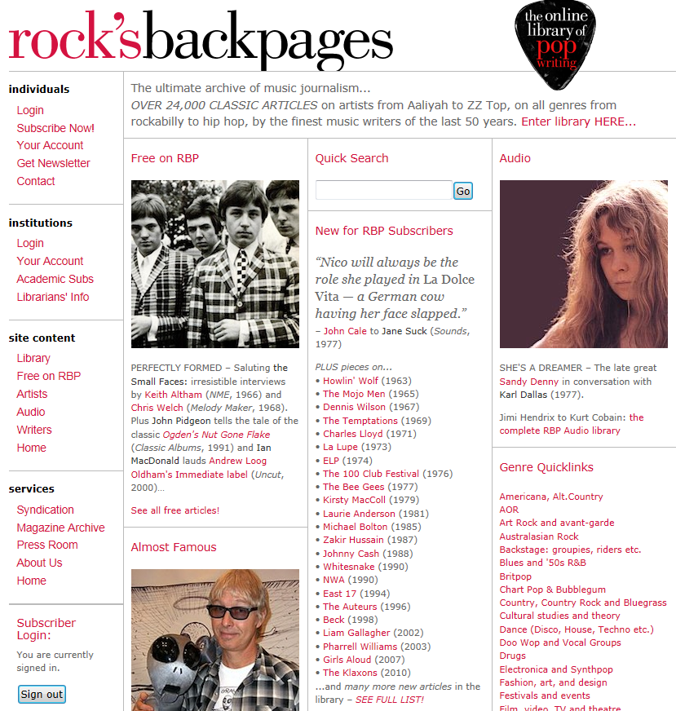

Description of resource:

Searchable archive of rock reviews, articles, and interviews (transcripts and audio recordings), from the late 1950s to the present day.
Title: Rock’s back pages
Online integrating resource with text and audio files (original record, RDA)

Bibliographic record created for Figure 1:

Type: |  | a |  | ELvl: | # | Srce: | c | GPub: | # | Ctrl: | # | Lang: | eng
BLvl: |  | i |  | Form: | o | Conf: | | | Freq: | w | MRec: | # | Ctry: | enk
S/L: |  | 2 |  | Orig: | | | EntW: | # | Regl: | r | Alph: | #
Desc: |  | i |  | SrTp: | d | Cont: | # | DtSt: | c | Dates: | 2000, | 9999
006 | ## |  | $a m o d
006 | ## |  | $a innnn o t n
007 | ## |  | $a c $b r
040 | ## |  | $a XXX $b eng $e rda $c XXX $d XXX
042 | ## |  | $a pcc
010 | ## |  | $a
050 | 14 |  | $a ML156.4
245 | 00 |  | $a Rock’s backpages
246 | 1# |  | $a Rock’s back pages
246 | 1# |  | $a Rock’sbackpages
246 | 1# |  | $a RBP
264 | 31 |  | $a London : $b Backpages Limited, $c [2000?]-
300 | ## |  | $a 1 online resource
310 | ## |  | $a Updated weekly
336 | ## |  | $a text $b txt $2 rdacontent
336 | ## |  | $a spoken word $b spw $2 rdacontent
337 | ## |  | $a computer $b c $2 rdamedia
338 | ## |  | $a online resource $b cr $2 rdacarrier
520 | ## |  | $a Searchable database of rock reviews, articles, and interviews from the late 1950s to the present day.
588 | ## |  | $a Description based on contents viewed on January 28, 2014; title from database home page.
650 | #0 |  | $a Rock music $v Databases.
650 | #0 |  | $a Rock music $v Reviews $v Databases.
650 | #0 |  | $a Rock musicians $v Interviews $v Databases.
710 | 2 |  | $a Backpages Limited, $e issuing body.
856 | 40 |  | $u http://www.rocksbackpages.com

Comments:

Multiple 246s were added for possible variants of the resource’s name, and an additional 336 field for the audio content was also added. As this is an updating database, SrTp in fixed field is coded “d.”
Title: Formation and financing of emerging growth companies
Updating loose-leaf with accompanying material (original record, RDA)

Figure 1: title page

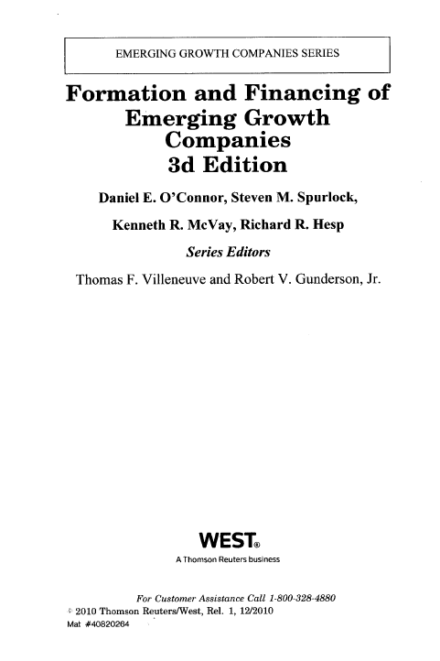

Title: Formation and financing of emerging growth companies
Updating loose-leaf with accompanying material (original record, RDA)

Figure 2: title page verso

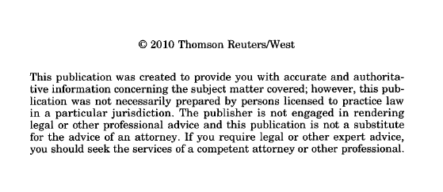

Description of resource (see also surrogate on following page):

This is an updating loose-leaf accompanied by a CD-ROM containing forms associated with the subject matter. The subscription to this title includes the CD-ROM; however, this is not always the case. Sometimes the publisher merely alerts subscribers to the availability of supplementary materials, which require separate ordering and payment. In the latter case, the CD-ROM would not be cataloged as part of the resource.

Title: Formation and financing of emerging growth companies
Updating loose-leaf with accompanying material (original record, RDA)

Figure 3: Accompanying CD-ROM and information sheet
(separate items; reproduced together here)

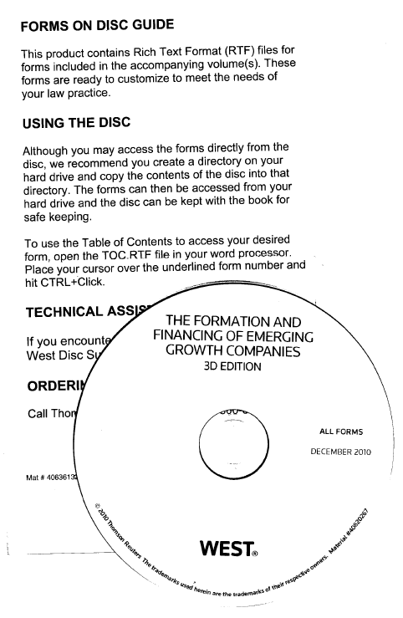

Title: Formation and financing of emerging growth companies
Updating loose-leaf with accompanying material (original record, RDA)

Bibliographic record created for Figures 1-3:

Type: |  | a |  | ELvl: | # | Srce: | c | GPub: | # | Ctrl: | # | Lang: | eng
BLvl: |  | i |  | Form: | # | Conf: | | | Freq: | a | MRec: | # | Ctry: | mnu
S/L: |  | 2 |  | Orig: | | | EntW: | # | Regl: | r | Alph: | #
Desc: |  | i |  | SrTp: | l | Cont: | # | DtSt: | c | Dates: | 2008, | 9999
040 | ## |  | $a XXX $b eng $e rda $c XXX $d XXX
010 | ## |  | $a
022 | ## |  | $a 2329-3810
042 | ## |  | $a pcc
043 | ## |  | $a n-us---
050 | 14 |  | $a KF1414 $b .F672
245 | 00 |  | $a Formation and financing of emerging growth companies / $c Daniel E. O’Connor, Steven M. Spurlock, Kenneth R. McVay, Richard R. Hesp ; series editors, Thomas F. Villeneuve and Robert V. Gunderson, Jr.
250 | ## |  | $a 3d edition.
264 | 31 |  | $a [Eagan, Minnesota] : $b West, $c [2008]-
300 | ## |  | $a volumes (loose-leaf): $b forms ; $c 26 cm + $e 1 CD-ROM
310 | ## |  | $a Updated annually
336 | ## |  | $a text $b txt $2 rdacontent
337 | ## |  | $a unmediated $b n $2 rdamedia
338 | ## |  | $a volume $b nc $2 rdacarrier
490 | 1# |  | $a Emerging growth companies series
500 | ## |  | $a “Mat #40820264.”
588 | ## |  | $a Description based on: Rel. 1, 12/2010.
650 | #0 |  | $a New business enterprises $x Law and legislation $z United States.
650 | #0 |  | $a New business enterprises $x Finance $x Law and legislation $z United States.
650 | #0 |  | $a Stocks $x Law and legislation $z United States.
700 | 1# |  | $a O’Connor, Daniel E., $d 1961- $e author.
830 | #0 |  | $a Emerging growth companies series.

Comments:

The cataloger chose to transcribe the entire statement of responsibility as found (including all the named authors). A 700 access point was added for the first named; other 700 fields could also have been added as well. Even though the first iteration was not available, the cataloger had firm information about when the publication began, and supplied that date in the 264 $c. A linking entry field could also have used to record the relationship to the prior edition.

Note also that SrTp in the fixed field is coded “l” (“ell”) for loose-leaf.
Title: Manning on estate planning
Updating loose-leaf with change of edition requiring a new record (AACR2 RDA)

Figure 1: Earlier edition, title page

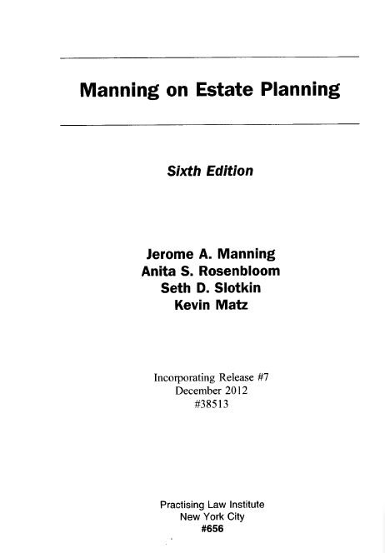

Title: Manning on estate planning
Updating loose-leaf with change of edition requiring a new record (AACR2 RDA)

Figure 2: Earlier edition, title page verso

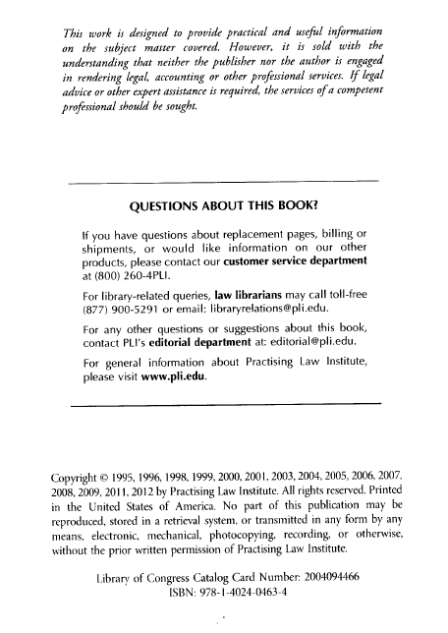

Description of resource:

This is a work that has undergone numerous editions, originally authored by Jerome A. Manning and now updated in regular editions by Manning and additional authors. As his name still appears on the title page, he is considered the primary author of the work.
Title: Manning on estate planning
Updating loose-leaf with change of edition requiring a new record (AACR2 RDA)

Bibliographic record for Figures 1-2 (earlier edition) – as found in database:

Type: |  | a |  | ELvl: | # | Srce: | c | GPub: | # | Ctrl: | # | Lang: | eng
BLvl: |  | i |  | Form: | # | Conf: | | | Freq: | | | MRec: | # | Ctry: | nyu
S/L: |  | 2 |  | Orig: | | | EntW: | # | Regl: | | | Alph: | #
Desc: |  | a |  | SrTp: | l | Cont: | # | DtSt: | c | Dates: | 2004, | 9999
040 | ## |  | $a XXX $b eng $c XXX $d XXX
010 | ## |  | $a
022 | ## |  | $a
042 | ## |  | $a pcc
043 | ## |  | $a n-us---
050 | 14 |  | $a KF749 $b .M363
100 | 1# |  | $a Manning, Jerome A.
245 | 10 |  | $a Manning on estate planning.
250 | ## |  | $a 6th ed. / Jerome A. Manning, Anita S. Rosenbloom, Seth D. Slotkin.
260 | ## |  | $a New York : $b Practicing Law Institute, $c c2004-
300 | ## |  | $a v. (loose-leaf); $c 26 cm.
504 | ## |  | $a Includes bibliographical references and index.
650 | #0 |  | $a Estate planning $z United States.
700 | 1# |  | $a Rosenbloom, Anita S.
700 | 1# |  | $a Slotkin, Seth D.
780 | 00 |  | $a Manning, Jerome A. $t Manning on estate planning. $b 5th ed. $z 0872240894 $w (DLC) xxxxxxxx $w (OCoLC)xxxxxxxx

Comments:

This is the catalog record based on the first iteration. Note that there are three authors associated with the 6th edition, and under AACR2’s “rule of three,” the authorized access point for the work (main entry in AACR2) would be constructed using Manning’s name. (Note: Specific authors are identified for specific editions, and are recorded in the 250 field and not the 245 $c.) At some point, an additional author was added (Kevin Matz), but the record was never updated to reflect this. The record now also needs to be updated to show that the resource is complete; the 6th edition has been continued by a 7th edition.
Title: Manning on estate planning
Updating loose-leaf with change of edition requiring a new record (AACR2 RDA)

Bibliographic record for Figures 1-2 (earlier edition) – updated for current iteration:

Type: |  | a |  | ELvl: | # | Srce: | c | GPub: | # | Ctrl: | # | Lang: | eng
BLvl: |  | i |  | Form: | # | Conf: | | | Freq: | | | MRec: | # | Ctry: | nyu
S/L: |  | 2 |  | Orig: | | | EntW: | # | Regl: | | | Alph: | #
Desc: |  | i |  | SrTp: | l | Cont: | # | DtSt: | d | Dates: | 2004, | 2012
040 | ## |  | $a XXX $b eng $e rda $c XXX $d XXX
010 | ## |  | $a
022 | ## |  | $a
042 | ## |  | $a pcc
043 | ## |  | $a n-us---
050 | 14 |  | $a KF749 $b .M363
100 | 1# |  | $a Manning, Jerome A.
245 | 10 |  | $a Manning on estate planning.
250 | ## |  | $a Sixth edition / Jerome A. Manning, Anita S. Rosenbloom, Seth D. Slotkin, Kevin Matz.
264 | #1 |  | $a New York City : $b Practicing Law Institute, $c [2004-2012].
300 | ## |  | $a 1 volume (loose-leaf); $c 26 cm.
500 | ## |  | $a “38513.”
336 | ## |  | $a text $b txt $2 rdacontent
337 | ## |  | $a unmediated $b n $2 rdamedia
338 | ## |  | $a volume $b nc $2 rdacarrier
504 | ## |  | $a Includes bibliographical references and index.
588 | ## |  | $a Description based on: Release #7, December 2012.
650 | #0 |  | $a Estate planning $z United States.
700 | 1# |  | $a Rosenbloom, Anita S.
700 | 1# |  | $a Slotkin, Seth D.
700 | 1# |  | $a Matz, Kevin.
780 | 02 |  | $a Manning, Jerome A. $t Manning on estate planning. $b 5th ed. $z 0872240894 $w (DLC) xxxxxxxx $w (OCoLC)xxxxxxxx
785 | 02 |  | $a Manning, Jerome A. $t Manning on estate planning. $b Seventh edition $z 9781402404634 $w (DLC) xxxxxxxx $w (OCLC)xxxxxxxx

Comments:

If the cataloger had chosen to keep this record AACR2 and update the description for the current iteration, the AAP (“main entry” in AACR2) would have changed to one based on the title, per the AACR2 “rule of three” (there are now four authors on the title page). Since both the preceding and succeeding resources would retain AAPs based on the primary author, the cataloger chose to recatalog the sixth edition in RDA to lessen the complication of linking (and displaying) the various editions together.
Title: Manning on estate planning
Updating loose-leaf with change of edition requiring a new record (AACR2 RDA)

Figure 3: Later edition, title page

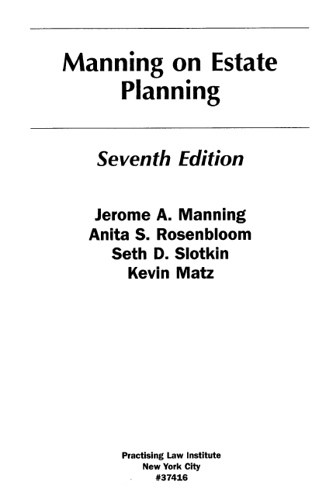

Title: Manning on estate planning
Updating loose-leaf with change of edition requiring a new record (AACR2 RDA)

Figure 4: Later edition, title page verso
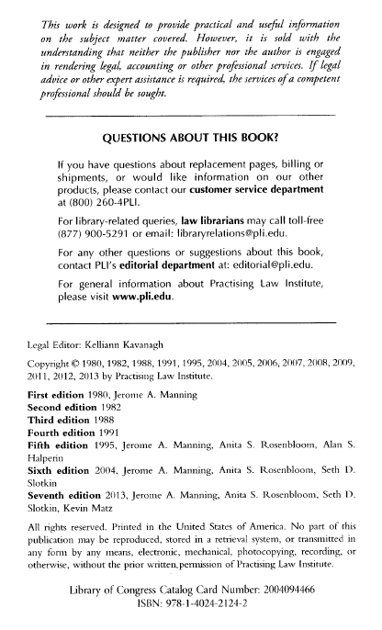
Description of resource:

Latest edition of this work, with same authors as the 6th ed. Copyright information is retained for all previous editions.

Title: Manning on estate planning
Updating loose-leaf with change of edition requiring a new record (AACR2 RDA)

Bibliographic record created for Figures 3-4 (later edition):

Type: |  | a |  | ELvl: | # | Srce: | c | GPub: | # | Ctrl: | # | Lang: | eng
BLvl: |  | i |  | Form: | # | Conf: | | | Freq: | | | MRec: | # | Ctry: | nyu
S/L: |  | 2 |  | Orig: | | | EntW: | # | Regl: | | | Alph: | #
Desc: |  | i |  | SrTp: | l | Cont: | # | DtSt: | c | Dates: | 2013, | 9999
040 | ## |  | $a XXX $b eng $e rda $c XXX $d XXX
010 | ## |  | $a
020 | ## |  | $a 9781402421242 (loose-leaf)
042 | ## |  | $a pcc
043 | ## |  | $a
050 | 14 |  | $a KF749 $b .M364
100 | 1# |  | $a Manning, Jerome A., $e author.
245 | 10 |  | $a Manning on estate planning.
250 | ## |  | $a Seventh edition / $c Jerome A. Manning, Anita S. Rosenbloom, Seth D. Slotkin, Kevin Matz.
264 | 31 |  | $a New York City : $b Practicing Law Institute, $c [2013]-
300 | ## |  | $a volumes (loose-leaf)
336 | ## |  | $a text $b txt $2 rdacontent
337 | ## |  | $a unmediated $b n $2 rdamedia
338 | ## |  | $a volume $b nc $2 rdacarrier
504 | ## |  | $a Includes bibliographical references and index.
650 | #0 |  | $a Estate planning $z United States.
650 | #0 |  | $a Gifts $x Taxation $x Law and legislation $z United States.
700 | 1# |  | $a Rosenbloom, Anita S., $e author.
700 | 1# |  | $a Slotkin, Seth D., $e author.
700 | 1# |  | $a Matz, Kevin, $e author.
780 | 02 |  | $a Manning, Jerome A. $t Manning on estate planning. $b 6th ed. $w (DLC) xxxxxxxx $w (OCoLC)xxxxxxxx

Comments:

The seventh edition is cataloged according to RDA, and links back to the (now RDA) record for the sixth edition. All authors are given access points with the relationship designator “author.” No note is required about the source of the description, because the first iteration is available.
Title: Law of confessions
Updating loose-leaf with change in mode of issuance requiring a new record
(AACR2 RDA)

Figure 1: Print integrating resource, title page

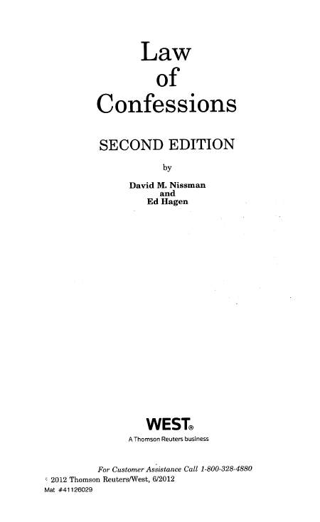

Title: Law of confessions
Updating loose-leaf with change in mode of issuance requiring a new record
(AACR2 RDA)

Figure 2: Print integrating resource, title page verso

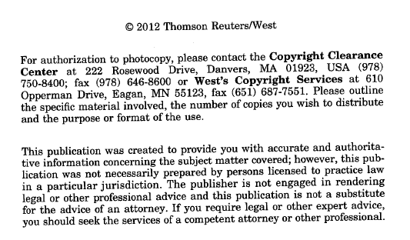

Description of resource:

This is a treatise by two authors, currently in its second edition. It is issued as an updating loose-leaf to allow for minor updates between editions.

Title: Law of confessions
Updating loose-leaf with change in mode of issuance requiring a new record
(AACR2 RDA)

Bibliographic record for Figures 1-2 (earlier edition) – as found in database:

Type: |  | a |  | ELvl: | # | Srce: | c | GPub: | # | Ctrl: | # | Lang: | eng
BLvl: |  | i |  | Form: | # | Conf: | | | Freq: | | | MRec: | # | Ctry: | ilu
S/L: |  | 2 |  | Orig: | | | EntW: | # | Regl: | | | Alph: | #
Desc: |  | a |  | SrTp: | l | Cont: | # | DtSt: | c | Dates: | 1994, | 9999
040 | ## |  | $a XXX $b eng $c XXX $d XXX
010 | ## |  | $a
022 | ## |  | $a
042 | ## |  | $a pcc
043 | ## |  | $a n-us---
050 | 14 |  | $a KF9664 $b .N57
100 | 1# |  | $a Nissman, David M.
245 | 10 |  | $a Law of confessions / $c David M. Nissman and Ed Hagen.
250 | ## |  | $a 2nd ed.
260 | ## |  | $a Deerfield, IL : $b Clark Boardman Callaghan, $c c1994-
300 | ## |  | $a 1 v. (loose-leaf); $c 25 cm.
504 | ## |  | $a Includes index.
650 | #0 |  | $a Confession (Law) $z United States.
700 | 1# |  | $a Hagen, Ed.

Comments:

This is the catalog record based on the first iteration. Comparing the bibliographic information with the current iteration, nothing has changed in the authorship; however, there is a change in the publication information.

Title: Law of confessions
Updating loose-leaf with change in mode of issuance requiring a new record
(AACR2 RDA)

Bibliographic record Bibliographic record updated for Figures 1-2 (updating loose-leaf):

Type: |  | a |  | ELvl: | # | Srce: | c | GPub: | # | Ctrl: | # | Lang: | eng
BLvl: |  | i |  | Form: | # | Conf: | | | Freq: | | | MRec: | # | Ctry: | mnu
S/L: |  | 2 |  | Orig: | | | EntW: | # | Regl: | | | Alph: | #
Desc: |  | i |  | SrTp: | l | Cont: | # | DtSt: | d | Dates: | 1994, | 2012
040 | ## |  | $a XXX $b eng $e rda $c XXX $d XXX
010 | ## |  | $a
022 | ## |  | $a
042 | ## |  | $a pcc
043 | ## |  | $a n-us---
050 | 14 |  | $a KF9664 $b .N57
100 | 1# |  | $a Nissman, David M., $e author.
245 | 10 |  | $a Law of confessions / $c David M. Nissman and Ed Hagen.
250 | ## |  | $a Second edition.
264 | #1 |  | $3 <1994->: $a Deerfield, IL : $b Clark Boardman Callaghan
264 | 31 |  | $3 <-2012>: $a Eagan, MN : $b West, $c [1994-2012]
300 | ## |  | $a 1 volume (loose-leaf); $c 25 cm
336 | ## |  | $a text $b txt $2 rdacontent
337 | ## |  | $a unmediated $b n $2 rdamedia
338 | ## |  | $a volume $b nc $2 rdacarrier
504 | ## |  | $a Includes index.
580 | ## |  | $a Continued by a serial publication with the same title.
650 | #0 |  | $a Confession (Law) $z United States.
700 | 1# |  | $a Hagen, Ed., $e author.
785 | 00 |  | $t Law of confessions (Eagan, Minn.) $b Second edition. $w (DLC) xxxxxxxx $w (OCoLC)xxxxxxxx

Comments:

The cataloger chose to convert this record to RDA, in the process of updating the publication information, closing the record, and linking it to the later (serial) title. Note the multiple 264 fields for the two publishers, and the 580 linking complexity note to explain the bibliographic situation, especially since the later serial title retains the same edition statement.

Title: Law of confessions
Updating loose-leaf with change in mode of issuance requiring a new record
(AACR2 RDA)

Figure 3: Serial, title page

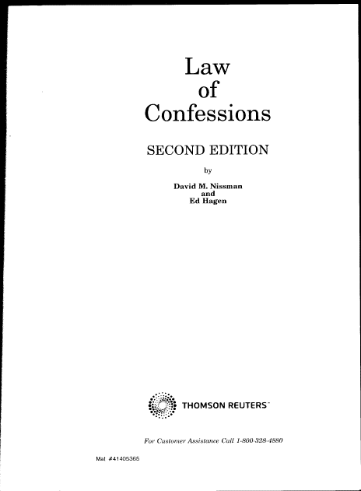

Title: Law of confessions
Updating loose-leaf with change in mode of issuance requiring a new record
(AACR2 RDA)

Figure 4: Serial, title page verso

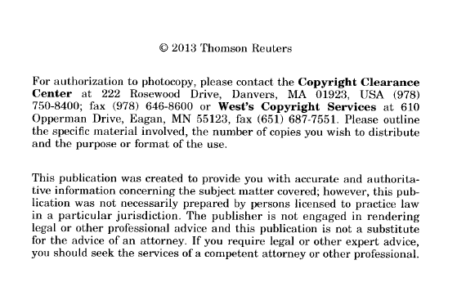
On front cover and spine:

SECOND EDITION
2013

Description of resource:

With the 2013 update, the publisher changed the format of this work to annual softbound editions, with each subsequent issue replacing the previous edition. Because the volumes are separate, discrete units, the new work is now considered a serial. Unfortunately, when frequently-issued editions are cataloged as serials, authorship is expected to change at some point, and becomes secondary to the ongoing “work.” Although there is a clear author statement on the title page, the authorized access point is taken from the title for the work.

Title: Law of confessions
Updating loose-leaf with change in mode of issuance requiring a new record
(AACR2 RDA)

Bibliographic record created for Figures 3-4 (serial):

Type: |  | a |  | ELvl: | # | Srce: | c | GPub: | # | Ctrl: | # | Lang: | eng
BLvl: |  | i |  | Form: | # | Conf: | | | Freq: | a | MRec: | # | Ctry: | mnu
S/L: |  | 2 |  | Orig: | | | EntW: | # | Regl: | r | Alph: | #
Desc: |  | i |  | SrTp: |  | Cont: | # | DtSt: | c | Dates: | 2013, | 9999
040 | ## |  | $a XXX $b eng $e rda $c XXX $d XXX
010 | ## |  | $a
022 | ## |  | $a
042 | ## |  | $a pcc
043 | ## |  | $a
050 | 14 |  | $a KF9664 $b .L39
130 | 0# |  | $a Law of confessions (Eagan, Minn.)
245 | 10 |  | $a Law of confessions.
250 | ## |  | $a Second edition.
264 | #1 |  | $a Eagan, MN : $b West, $c [2013]-
300 | ## |  | $a volumes ; $c 24 cm
310 | ## |  | $a Annual
336 | ## |  | $a text $b txt $2 rdacontent
337 | ## |  | $a unmediated $b n $2 rdamedia
338 | ## |  | $a volume $b nc $2 rdacarrier
362 | 1# |  | $a Began with issue for 2013.
500 | ## |  | $a Authors: David M. Nissman and Ed Hagen, 2013-
500 | ## |  | $a Includes index.
580 | ## |  | $a Continues a loose-leaf publication with the same title, published 1994-2012.
588 | ## |  | $a Description based on: 2013; title from title page.
588 | ## |  | $a Latest issue consulted: 2013.
650 | #0 |  | $a Confession (Law) $z United States.
700 | 1# |  | $a Nissman, David M., $e author.
700 | 1# |  | $a Hagen, Ed, $e author.
780 | 00 |  | $a Nismman, David M. $t Law of confessions. $b Second edition. $w (DLC) xxxxxxxx $w (OCoLC)xxxxxxxx

Comments:

Because the authorized access point for this serial title one for a different work in the shared database, the place of publication was added as a qualifier. The authors are both given access points, and the 580 linking complexity note explains the bibliographic situation.

Appendix A: Print integrating resources RDA MARC record cheat sheet
MARC tag | Instructions
006 (Add. material characteristics) | [Usually not applicable to print IRs]
007 (Physical characteristics) | [Usually not applicable to print IRs]
010 (LCCN) | Add if authenticating for CONSER. BIBCO participants do not add a LCCN. If there is an LCCN printed in the resource, record in $z of 010; record CONSER-supplied LCCN in $a.

008/22 Form of Original item (Orig) |  | [Usually not applicable to print IRs]
Fixed field : Common codes  Type: a (text)  BLvl: i (integrating resource)  SrTP: l (“ell”)  Srce: “c” (PCC) or “blank” (LC)  DtSt: c or d (current or dead)  Desc: i (RDA) |  | 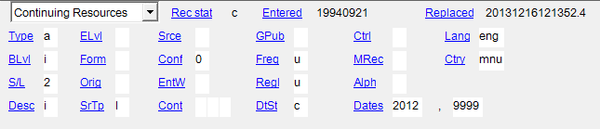
008/23 Form of item (Form) | Use “blank” for regular print IRs.
008/18-19 Freq/Regularity | Required in nsdp authenticated records. Although not required in other CONSER records, record if readily available.
008/29 Conference pub | [Not required to code]

020 (ISBN) | If applicable, record the print ISBN in $a.
022 (ISSN) | If applicable, record the print ISSN in $a.
040 (Cataloging source) | Add $e rda following $b.
042 pcc | Add if authenticating for CONSER or BIBCO.
050 (LC classification number) | Always provide a classification and cutter (call number) for print integrating resources.
130/240 (Preferred title)  CORE | The preferred title of the work may consist of other elements such as the form of work (RDA 6.3), date of work (RDA 6.4), place or origin of the work (RDA 6.5), content type (RDA 6.9), date of expression (RDA 6.10), language of expression (RDA 6.11) and/or other distinguishing characteristics (RDA 6.6). If 2 or more works would otherwise be represented by the same authorized access point, assign a parenthetical qualifier (see IR 5.3.2) to the resource being cataloged.

245 $a (Title proper)  CORE | The title proper should reflect the current iteration. If the title proper appears on the preferred source in full and in the form of an acronym or initialism, choose the full form as the title proper. Record the acronym or initialism as other title information. If the title proper changes on a subsequent iteration, change the title proper to reflect the current iteration, and give the earlier title proper in a 247 field.
245 $c (Statement of responsibility)  CORE | The first statement of responsibility is a core element. If a statement of responsibility is added, deleted, or changed on a subsequent iteration, change the 245 $c to reflect the current iteration. If considered important, give any earlier statement of responsibility in a note.
246 1_ (Variant title, other title) | Record variant titles if considered important for identification or access.  Parallel title: 246 11 $a.
247 10 (Earlier title proper) $f  CONSER CORE  (if applicable) | If the title proper changes on a subsequent iteration, change the title proper to reflect the current iteration, and give the earlier title proper in a 247 field. Use $f to designate the date(s) applicable for the former title proper. Use angle brackets for uncertain or incomplete data, e.g., 247 10 $a Handbook of corporate law $f 1994-<2012>
250 (Edition)  CORE (if applicable) | Always record for print IRs.
264 (Place of publication, publisher, and date)  Repeatable field  (Intervening publication statements are optional for IRs)  CORE | Record the first named place and publisher in the current iteration. If cataloging from the first iteration, also record the publication date, if present. If there is no publication date, use the copyright date to supply the date (or probable date) of publication (in brackets).  If the publisher changes on a subsequent iteration of an integrating resource, change the place of publication and publisher to reflect the current iteration (264 31) and move the earlier publishing information to an intervening publishing statement (e.g., 264 #1 or 264 21), if considered to be important for identification or access. Also update the Ctry code in the fixed field to reflect the current place of publication.
300 (Extent)  CORE  (if the resource is complete and total extent is known) | 300 ## $a volumes (loose-leaf)  Do not include number of units unless known, or IR is complete. Some one-volume print IRs expand to two or more volumes during the course of publication; best practice is to refrain from recording the number of units.  Record other physical characteristics of the work, if considered important (they are generally recorded).  300 ## $a volume (loose-leaf) : $b forms ; $c 25 cm
310 (Frequency)  CONSER CORE (if known) | Record the current frequency in a 310 field.
321 (Earlier frequency) | If the frequency of updates changes, move the earlier frequency information to a 321 field. Record the current frequency in a 310 field. Also, update the Freq/Regl codes in the fixed field to reflect the current frequency.
336 (Content Type) CORE | 336 ## $a text $b txt $2 rdacontent
337 (Media Type) CORE | 337 ## $a unmediated $b n $2 rdamedia
338 (Carrier Type) CORE | 338 ## $a volume $b nc $2 rdacarrier

362 (Dates of publication)  CORE | Record publication dates in 264 $c whenever possible. Use the 362 field to record beginning and ending dates if the first and/or latest iteration is not available and when the date information is better expressed in a note.  362 1# $a Began in 1990s?
440/490/830/890 (Series)  CONSER CORE  (if applicable) | If a series statement is added, deleted, or changed on a subsequent iteration of an integrating resource, change the series statement to reflect the current iteration. Make a note if the change is considered important.  CONSER practice: Do not give a series statement in the 490 field, unless the series information has changed in later iterations of the resource. Instead, when tracing the series, give only an authorized access point (AAP) for the series in the appropriate 8XX field.
500 (General note) | Make as needed.
500/550 (Note on publication statement) | Do not note commercial publishers as issuing bodies.
506 (Restrictions on access note) | [Generally not used for print IRs.]
530 (Related manifestations) | Prefer 776 $i for recording related manifestations.
546 (Language of the content)  CONSER CORE  (if applicable) | Record for some languages (see LC-PCC PS 7.13.2.3).
580 (Notes about related works and expressions) | Use to explain complex work, expression, and manifestation relationships that cannot be readily expressed with 7xx $i. (Commonly used for situations in which a change in the mode of issuance requires the creation of a new record, and the title is the same.)
500/588 (Description based on:, title source)  CORE | Always give these notes in a CONSER record for print IRs:  - Notes on title source of not taken from the title page (RDA 2.17.2.3)  - Note on the iteration used as the basis for identification, if it is not the first (2.17.13.4)  e.g., 588 ## $a Description based on: Update #9, August 2013.  500 ## $a Title from binder cover.
650 (LCSH and MeSH) | Assign LCSH and/or MeSH based on the current iteration.
655 (Genre/Form) | Add if applicable.
710/711/730 (Authorized access points) | Generally, do not add access points for names of commercial publishers. Add $e relationship designators as appropriate. May leave authorized access points in records for earlier iterations if considered important for access and identification.
76X-78X (Related works and expressions)  CONSER CORE  (if applicable) | Use for expressing relationships between the IR being cataloged and immediately preceding, succeeding, or simultaneously issued resources, regardless of mode of issuance of the related resource.
775 (Related manifestation: same carrier as the original)  CONSER CORE  (if applicable) | Use for related manifestations when the carrier of the manifestation is the same as the carrier of the original. Include the corresponding ISBN, ISSN, LC, and/or OCLC numbers when available.
776 (Related manifestation: different carrier than the original)  CONSER CORE  (if applicable) | Use for related manifestations when the carrier of the manifestation is different from the carrier of the original. Include the corresponding ISBN, ISSN, LC, and/or OCLC numbers when available.

Record Consolidation and Deleting Duplicates (see also IR.9.3 and 9.3.1)

If multiple records exist for a print integrating resource, one record should be selected for PCC authentication and others reported for deletion.

* Select one record to maintain: prefer a PCC record if one is available. If there are multiple PCC records, prefer a record authenticated by NSDP or ISSN Canada. Do not enhance DC (Dublin core 042 dc) records.

* If there is a converted LC monograph record in OCLC, add a new LCCN to 010 $a (retain other LCCN that are in $z), authenticate, and report to LC (see detailed instructions in IR.9.3.1)

*If there is a LC monograph record not yet converted by OCLC, create a new integrating resource record and report the duplicate to LC (see IR.9.3.1.)

* Authenticate the record if it is not a CONSER/BIBCO record; report the other records as duplicates (see IR.9.3).

Appendix B: Online integrating resources RDA MARC record cheat sheet
MARC tag | Instructions
006 (add. material characteristics) | Required only to code the first byte (e.g., 006 __m).  Additional 006s can be provided if the material characteristics are not already supplied in the 008 fixed fields (e.g., add 006 for seriality if cataloging a resource that is mostly numeric data)
007 (physical characteristics) | Required only to code $a “Category of material” and $b “Specific material designation” (e.g., 007__$a c $b r) per CONSER practice.
010 (LCCN) | Add if authenticating for CONSER. BIBCO participants do not add a LCCN.

008/22 Form of Original item (Orig) | Required only for original microforms. Not required to code for newspapers, eresources, etc. per CONSER practice.

Fixed fields  Common codes:  Type: a (text) or m (numeric data)  BLvl: i (integrating resource)  SrTP: d or w (If neither applies, use "blank”)  DtSt: c or d (current or dead)  Desc: i (RDA) | 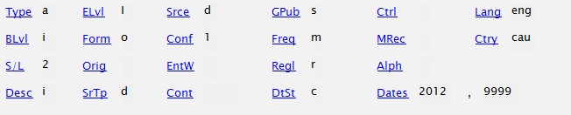

008/23 Form of item (Form) | Use “o” for online.
008/18-19 Freq/Regularity | Required in nsdp authenticated records. The fill character is the default; if updating copy with coded bytes, replace with updated code(s).
008/29 Conference pub | Not required to code.

022 (ISSN) | If applicable, record the e-ISSN in $a; record the print ISSN in $y.
040 (Cataloging source) | Add $e rda following $b. Add $e pn following $e rda if also a provider-neutral record.
042 pcc | Add if authenticating for CONSER or BIBCO.
050 (LC classification number) | Providing classification numbers for online integrating resources is optional, though for CONSER authenticated records, it is encouraged.
130/240 (Preferred title)  CORE | The preferred title of the work may consist of other elements such as the form of work (RDA 6.3), date of work (RDA 6.4), place or origin of the work (RDA 6.5), content type (RDA 6.9), date of expression (RDA 6.10), language of expression (RDA 6.11) and/or other distinguishing characteristics (RDA 6.6). If 2 or more works would otherwise be represented by the same authorized access point, assign a parenthetical qualifier (see IR 5.3.2) to the resource being cataloged.

245 $a (Title proper)  CORE | The title proper should reflect the current iteration. If the title proper appears on the preferred source in full and in the form of an acronym or initialism, choose the full form as the title proper. Record the acronym or initialism as other title information. If the title proper changes on a subsequent iteration, change the title proper to reflect the current iteration, and give the earlier title proper in a 247 field.
245 $c (Statement of responsibility)  CORE | The first statement of responsibility is a core element. If a statement of responsibility is added, deleted, or changed on a subsequent iteration, change the 245 $c to reflect the current iteration. If considered important, give any earlier statement of responsibility in a note.
246 1_ (Variant title, other title) | Record variant titles if considered important for identification or access.  Parallel title: 246 11 $a [title for German part of website].
247 10 (Earlier title proper) $f  CONSER CORE  (if applicable) | If the title proper changes on a subsequent iteration, change the title proper to reflect the current iteration, and give the earlier title proper in a 247 field. Use $f to designate the date that the former title proper was viewed.
250 (Edition)  CORE (if applicable) | Record only edition statements originating from the original publisher/society; ignore statements that pertain to specific provider versions.
264 (Place of publication, publisher, and date)  Repeatable, but intervening publication statements are optional for IRs  CORE | Record the first named place and publisher in the current iteration. The place/publisher should be applicable to all online versions and thus, should not reflect a particular digitizer, provider version, or interface. The publication date(s) if given, as much as possible, should be based on content from the original publisher/society and be applicable to all provider versions.  If the publisher changes on a subsequent iteration of an integrating resource, change the place of publication and publisher to reflect the current iteration (264 31) and move the earlier publishing information to an intervening publishing statement (e.g., 264 #1 or 264 21), if considered to be important for identification or access. Also update the Ctry code in the fixed field to reflect the current place of publication.
300 (Extent)  CORE  (if the resource is complete and total extent is known) | 300 ## $a 1 online resource  May also record other characteristics of the carrier, if considered important for identification or selection.  300 ## $a 1 online resource (200 streaming video files) …
310 (Frequency)  CONSER CORE (if known) | Record the current frequency in a 310 field. If the frequency of updates changes, move the earlier frequency information to a 321 field.
321 (Earlier frequency) | If the frequency of updates changes, move the earlier frequency information to a 321 field. Record the current frequency in a 310 field. If needed, update the Freq/Regl codes in the fixed field to reflect the current frequency.
336 (Content Type) CORE | 336 ## $a text $b txt $2 rdacontent
337 (Media Type) CORE | 337 ## $a computer $b c $2 rdamedia
338 (Carrier Type) CORE | 338 ## $a online resource $b cr $2 rdacarrier
362 (Dates of publication)  CORE | Record publication dates in 264 $c whenever possible. Use the 362 field to record beginning and ending dates if the first and/or latest iteration is not available and when the date information is better expressed in a note.  362 1# $a First posted on January 1, 2010.
440/490/830/890 (Series)  CONSER CORE  (if applicable) | Do not treat provider names as series statements. If a series statement is added, deleted, or changed on a subsequent iteration of an integrating resource, change the series statement to reflect the current iteration. Make a note if the change is considered important.  CONSER practice: Do not give a series statement in the 490 field, unless the series information has changed in later iterations of the resource. Instead, if tracing the series, give only an authorized access point (AAP) for the series in the appropriate 8XX field.
500 (General note) | General notes for the most part should be applicable to all providers.
500/550 (Note on publication statement) | Do not note providers as the digitizer.
506 (Restrictions on access note) | Do not use, unless restrictions apply to all versions and formats of the IR. An example is a "classified" government document for which access is always restricted. If specific access restrictions are considered useful, give in 856 $z.
530 (Related manifestations) | Prefer 776 $i for recording related manifestations.
538 (Equipment or system requirements note) | Provide a mode of access note only for access methods other than through the World Wide Web. Give system requirements notes only when all provider versions require special software or technical conditions.
546 (Language of the content)  CONSER CORE  (if applicable) | Record for some languages (see LC-PCC PS 7.13.2.3).
580 (Notes about related works and expressions) | Use to explain complex work, expression, and manifestation relationships that cannot be readily expressed with 7xx $i.
588 (Description based on:, title source)  CORE | Always give these notes in a CONSER record for online IRs (LC-PCC PS 2.17.2; 2.17.13):  - Notes on title source (RDA 2.17.2)*  - Note on the issue, part, or iteration used as the basis for identification (RDA 2.17.13; 2.17.13.4)  - Note identifying the date on which the resource was viewed (RDA 2.17.13.5).  e.g., 588 ## $a Description based on contents viewed on November 4, 2003 (Community of Science website); title from main search screen.  *Catalogers not following CONSER practice will use a title source note only when the title proper is not taken from one of the sources given in RDA 2.17.2.3; LC-PCC PS 2.17.2).
650 (LCSH and MeSH) | Assign LCSH and/or MeSH based on the current iteration.
655 (Genre/Form) | Add if applicable.
710/711/730 (Authorized access points) | Do not add access points for names of providers or digitizers. Add $e relationship designators as appropriate. May leave authorized access points in records for earlier iterations if considered important for access and identification.
76X-78X (Related works and expressions)  CONSER CORE  (if applicable) | Use for expressing relationships between the IR being cataloged and immediately preceding, succeeding, or simultaneously issued resources, regardless of mode of issuance of the related resource.
775 (Related manifestation: same carrier as the original)  CONSER CORE  (if applicable) | Use for related manifestations when the carrier of the manifestation is the same as the carrier of the original. Include the corresponding ISSN, LC, and/or OCLC numbers when available.
776 (Related manifestation: different carrier than the original)  CONSER CORE  (if applicable) | Use for related manifestations when the carrier of the manifestation is different from the carrier of the original. Include the corresponding ISSN, LC, and/or OCLC numbers when available. Also use for format changes $i Continued on CD-ROM …
856 (Electronic access & location)  CONSER CORE  (if applicable) | Give the applicable URLs for current iterations. The URL should be universal and match the granular level of the resource being cataloged to the extent that this is possible. Do not include an institution/consortia-specific or passworded URL in a bibliographic record contributed as shared cataloging unless it is the only URL you have and it serves as the basis of the description. Optionally, provider names may be given in $z.

Record Consolidation and Deleting Duplicates (see also IR.9.3)

If multiple records exist for an online integrating resource, one record should be selected for PCC authentication and others reported for deletion.

* Select one record to maintain: prefer a PCC record if one is available. If there are multiple PCC records, prefer a record authenticated by NSDP or ISSN Canada. Do not enhance DC (Dublin core 042 dc) records.

*If there is a CONSER serial record and a PCC authenticated integrating resource record for the same resource, check the URLs to verify whether the content is presented as a serial with discrete issues and/or an integrating resource before reporting these as possible duplicates. If in doubt, consult with the authenticating library to determine if the resource meets the definition of a serial or an integrating resource.

* Add the URL of the provider version for which you are providing access and/or copy 856 fields from the records you are reporting for deletion and record them on the record you are keeping.

* Remove fields that are provider specific, e.g. 710/730 or 440 for provider names; notes which only apply to one provider.
* Authenticate the record if it is not a CONSER/BIBCO record; report the other records as duplicates (see IR.9.3).

If adding a copyright date, and the resource has multiple copyright dates that apply to various aspects (e.g., text, sound, graphics), record any that are considered important for identification or selection. If the resource has multiple copyright dates that apply to a single aspect (e.g., text, sound, or graphics), record only the latest copyright date.
The LCRIs relating to series were largely carried over in the initial LC-PCC PSs. In fall 2013, a PCC series policy group began a systematic review of all PCC series documentation, including any relevant LC-PCC PS. This group expects to be making recommendations for policy changes to the PCC Standing Committee on Standards in spring or early summer 2014.
RDA covers notes relating to manifestations and items in Chapter 2.6; notes relating to artistic or intellectual content of works or expressions are covered in RDA Chapter 7.
International Standard Bibliographic Description (ISBD). Consolidated Edition. Munchen : De Gruyter Saur, c2011. Earlier draft (2010-05-10) freely available online at: http://www.ifla.org/files/assets/cataloguing/isbd/isbd_wwr_20100510_clean.pdf
This example shows CONSER practice for the title source note. Catalogers not following CONSER practice would omit the title source note here.
CONSER practice for title source note.
Catalogers should apply the most appropriate designator available. If there is no appropriate one listed in RDA Appendix J, a new one may be proposed by using the PCC relationship designator proposal form at http://www.loc.gov/aba/pcc/scs/RD-Requests.html
Under AACR2, PCC practice was to only make a one way related work AAP on the resource being indexed, etc., rather than reciprocal references on both records. Since RDA is so flexible in this regard, PCC guidelines would be useful here.
PCC practice is not to use $i in fields 780 and 785.
Additions and revisions to the list of relationship designators may be proposed via the online form at http://www.loc.gov/aba/pcc/scs/RD-Requests.html
Generally, use 780 02, 785 02, for sequential relationships between integrating resources and other integrating resources, or between integrating resources and monographs. For sequential relationships between integrating resources and serials, use either second indicator “2” or “0”. These instructions are based on the MARC 21 equivalents to the relationship designators given in RDA Appendices J.2.6 and J.3.6. These appendices do not yet specify the preferred relationship designators to sequentially link integrating resources or monographs with serials.
“Revised editions of monographs and integrating resources are usually expressions of the same work. They have both a derivative and a sequential relationship to each other. While PCC libraries have been using 780/785 for the linking entries, it is also acceptable to use instead 775 fields with $i ”Revision of” and “Revised as” relationship designators. However, field 775 should be restricted to expression level relationships.
The second example illustrates the use of field 580 to combine complex linking entry information typically given in a 580 field with information about the resource being available in additional physical formats, which is typically given in field 530. Rather than using both 530 and 580 fields, the information is usually combined in a single 580 field.
Typical examples of aggregator services would be EBSCO and JSTOR, both of which provide digital access to a large number of publications from various publishers.
OCLC WorldCat is an example of an online service.
BIBCO Participants’ Manual, B. Record Content, p. 28-30; CONSER Cataloging Manual, Module 15, by John Reimer.
Library of Congress. Cataloging Policy and Support Office. Subject Headings Manual. 2008 ed. Washington, D.C. : Library of Congress, Cataloging Policy and Support Office, 2008- (H 1520 and H 2070)
N.B. If a heading is used provisionally on a bibliographic record and the SACO proposal isn’t accepted or the proposed term is modified by LC, it is the responsibility of the cataloging agency proposing the heading to correct the existing bibliographic record(s) in OCLC to match the approved subject term, ensuring that all subject headings are under authority control.
Library of Congress. Cataloging Policy and Support Office. Subject Headings Manual. 2008 ed. Washington, D.C. : Library of Congress, Cataloging Policy and Support Office, 2008- (H 1520).
Ibid.
Ibid.
If the new base volume retains the revisions dates from the previous iteration in its headers or footers, generally do not consider it a new resource. Generally, consider the reissue to be a new resource if there is a new date in the header or footer that is consistent throughout; however, if there are other indications that the same or different publisher has merely reissued the content, do not create a new record. Take into account publisher’s statements in the shipping material, cover letter, or other accompanying documentation that is issued with the latest iteration.
If field 012 is already present, add only $z d. This overrides the record status on output to LC whenever LC deletes a record from the LC distribution data base. For more information, see CEG, Section E.
When an integrating resource is first cataloged, and there is only one 264 field, the first indicator may also be coded as “blank” per MARC 21 guidelines. Since integrating resources are cataloging based on the latest iteration, a first indicator of “3” is also appropriate. Examples in this manual use both coding practices, which are both correct.

